**Cloud Practitioner**

Spis treści

**Exam Guide Walkthrough** 4

**Cloud Computing** 4

**Cloud Hosting** 5

**What is Amazon Web Services (AWS)?** 6

**What is a Cloud Service Provider?** 6

**Landscape of CSPs** 7

**Common Cloud Services** 8

**Technology Overview** 9

**The Evolution of Computing​** 9

**Types of Cloud Computing** 11

**Cloud Computing Deployment Models** 12

**Innovation Waves​** 13

**Evolution of Computing Power​** 13

**The Benefits of Cloud** 14

**Six Advantages and Benefits of Cloud Computing** 14

**Benefits of Cloud Computing​** 15

**AWS Global Infrastructure** 16

**Regions** 17

**Availability Zones** 17

**Global Infrastructure – Availability Zones** 18

**Global Infrastructure - Fault Tolerance** 19

**AWS Global Network** 20

**Points of Presence** 21

**AWS Direct Connect** 22

**Global Infrastructure - Wavelength Zones** 24

**Global Infrastructure – Data Residency** 24

**Global Infrastructure - AWS for Government** 25

**GovCloud** 25

**Global Infrastructure – AWS in China** 26

**Global Infrastructure – Sustainability** 26

**Global Infrastructure – AWS Ground Station** 27

**Global Infrastructure – AWS Outposts** 28

**Cloud Architecture Terminologies** 28

**High Availability** 29

**High Scalability** 29

**High Elasticity** 30

**Fault Tolerance** 30

**High Durability** 31

**Business Continuity Plan** 32

**Disaster Recovery Options** 32

**AWS API** 34

**AWS Management Console** 35

**AWS Management Console - Service Console** 35

**AWS Account ID** 35

**AWS Tools for PowerShell** 36

**Amazon Resource Name (ARNs)** 36

**AWS Command Line Interface (CLI)** 37

**AWS Software Development Kit (SDK)** 38

**AWS CloudShell** 39

**Infrastructure as Code (IaC)** 39

**CloudFormation** 40

**Cloud Development Kit** 41

**AWS Toolkit for VSCode** 41

**Access Keys** 42

**AWS Documentation** 42

**Shared Responsibility Model** 43

**Shared Responsibility Model - Compute** 44

**Shared Responsibility Model** 47

**Shared Responsibility Model - Architecture** 47

**Computing Services** 48

**Containers** 49

**Higher Performance Computing** 50

**What is Edge Computing?​** 51

**Cost managemant** 52

**Types of Storage Services** 53

S3 Object 54

**S3 Storage Classes** 54

**AWS Snow Family** 55

**Storage Services:** 56

**What is a Database?** 57

**What is Data Warehouse?** 58

**What is a Key / Value store?** 59

**What is a Document store?** 59

**NoSQL** 60

**Relational Database Service (RDS)** 60

**Other databases** 61

**Cloud-Native Networking Services** 62

**Enterprise/Hybrid Networking Services** 63

**Virtual Private Cloud (VPC) & Subnets** 64

**Security Groups vs NACLs** 64

**Introduction to EC2** 65

**EC2 Instance Families** 66

**EC2 Instance Types** 67

**EC2 – Dedicated Host** 68

**EC2 Tenancy** 68

**EC2 - Pricing Model** 69

**On Demand** 70

**EC2- Reserved Instances (RI)** 71

**Reserved Instances (RI) — RI Attributes** 72

**Regional and Zonal RI** 73

**RI Limits** 73

**Capacity Reservations** 74

**Standard vs Convertible RI** 74

**RI Marketplace** 75

**Spot Instances** 76

Dedicated Host Instances 77

AWS Savings Plan 78

**Cheat Sheet** 79

**Zero Trust Model** 80

**Zero Trust on AWS** 81

**Zero Trust on AWS with Third Parties** 82

**Directory Service** 82

# **Exam Guide Walkthrough**

Here we will go over the Exam Guide Outline, I want to highlight the most important information for you so you have an idea of what we're trying to study for. We have four domains here.

We have: **Cloud Concepts** 28% | **Security** 24% | **Technology** 36% | **Billing and Pricing** 12%

The largest portion of the exam is Technology at 36% and Billing and Pricing is the lowest which is funny because I find it to be the most valuable information in the entire course. With **Cloud Concepts** we need to be able to define the AWS Cloud in its proposition, we need to be able to identify aspects of AWS Cloud Economics and list the different Cloud Architectural Principles.

For **Security** you will learn a variety of AWS Security Services and shared responsibility models. For **Technology** you will learn all core AWS Services and other AWS Services and Global Infrastructures.

**Billing and Pricing** is how we know how much things cost and how we can save money on AWS, how to compare and contrast various pricing models for AWS, how to recognize the various account structures in relation to ASW Billing and Pricing and how to Identify Resources for Billing Support. When you do take this exam it has 65 questions and you have both multiple choice and multiple response. For multiple choice you're going to choose one out of four, or multiple response where you choose two or more out of five or more options but generally it's two out of five or three out of six.

I just want to highlight one more thing, which is the white papers. Any time you study for an exam, AWS always has suggestion's to study these white papers first. At the CCP level it's not so important because we definitely cover the content here. When you study for harder exams however, especially the Professionals and Specialties, you have to read the white papers, but again at this level, it's not so important.

Reference: [**AWS Certified Cloud Practitioner (CLF-C01) Exam Guide**](https://d1.awsstatic.com/training-and-certification/docs-cloud-practitioner/AWS-Certified-Cloud-Practitioner_Exam-Guide.pdf)

# **Cloud Computing**

The "text-book" definition of **Cloud Computing**: **Cloud Computing** is the practice of using a network of remote servers hosted on the Internet to store, manage, and process data, rather than on a local server or personal computer. Cloud computing allows companies or individuals to rent the resources they need for their companies or personal projects like storage space.

Companies no longer have to purchase physical hardware with expensive IT departments. This has helped a lot of smaller companies launch their projects or services quickly. Companies can adjust the types of services they need on demand instead of waiting weeks or longer for new servers or other equipment to scale their businesses. Individuals no longer need a computer with a huge hard drive for photos or files. They can now store these on services like Google Drive.

**On-premise vs Cloud Providers**

**On-premise**

* You own the servers
* You hire the IT people
* You pay or rent the real-estate
* You take all the risk.

**Cloud Providers**

* Someone else owns the servers
* Someone else hires the IT people
* Someone else pays or rents the real-estate
* You are responsible for configuring your cloud services and code, someone else takes care of the rest

# **Cloud Hosting**

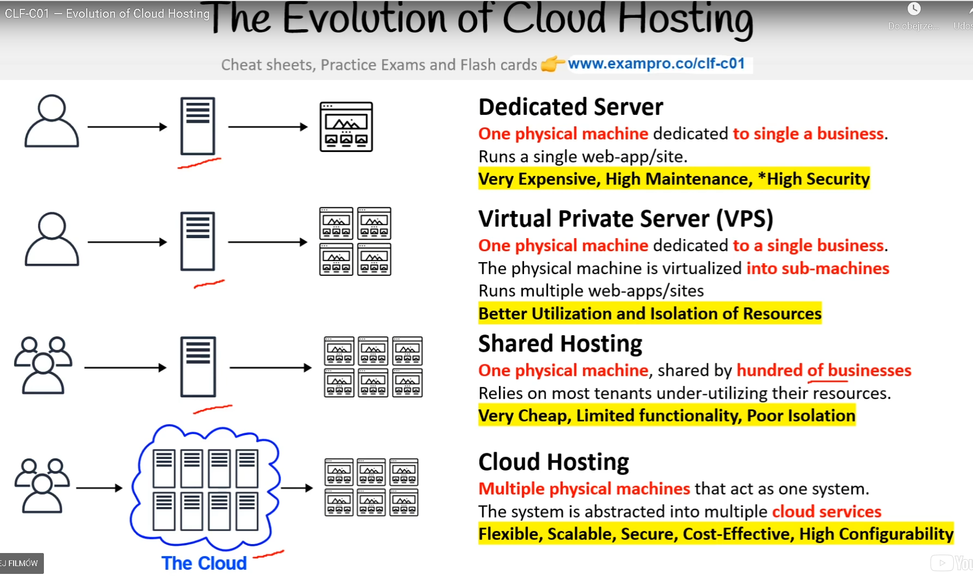

**Types of Hosting**

**Dedicated Server​ - One physical machine dedicated to single a business​**

* Runs a single web-app/site.​
* Very Expensive, High Maintenance, *High Security​
* Virtual Private Server​

**The physical machine is virtualized into sub-machines**

* Runs multiple web-apps/sites​
* Better Utilization and Isolation of Resources​

Shared Hosting​ - **One physical machine, shared by hundred of businesses​**

* Relies on most tenants under-utilizing their resources.​
* Very Cheap, Limited functionality, Poor Isolation​

**Cloud Hosting​ - Multiple physical machines that act as one system ​**

* The system is abstracted into multiple cloud services​
* Flexible, Scalable, Secure, Cost-Effective, High Configurability​

# **What is Amazon Web Services (AWS)?**

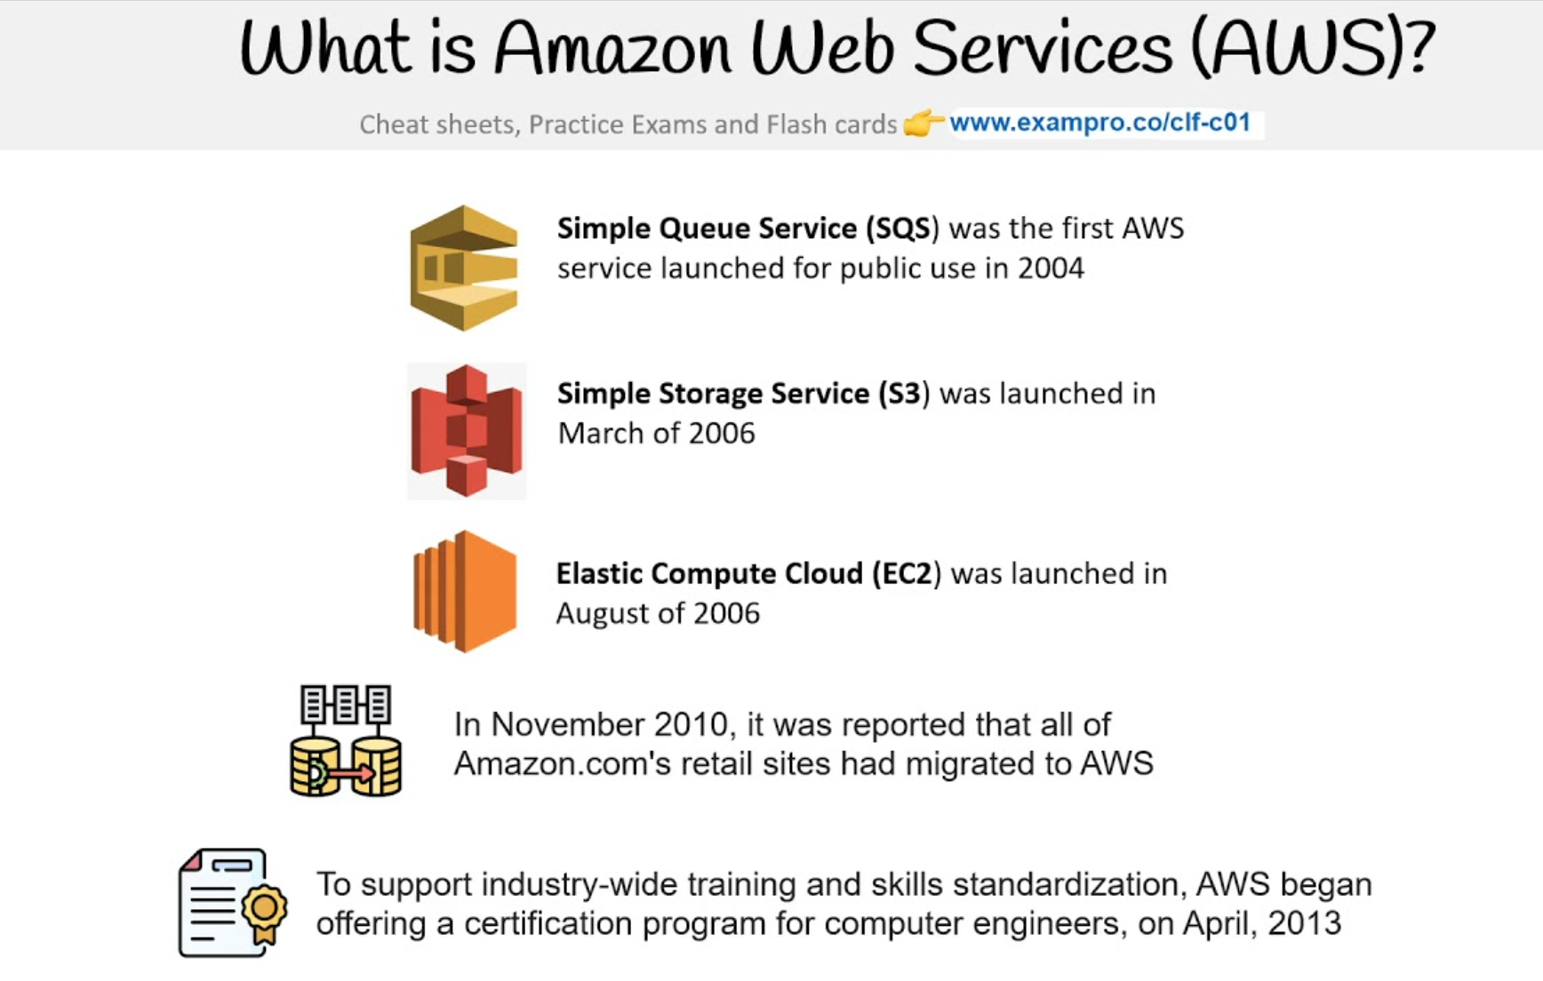

**Amazon** is an American multinational computer technology corporation headquartered in Seattle, Washington. Amazon was founded in 1994 by Jeff Bezos and the company started as an online store for books and expanded to other products. Amazon many products include: - Amazon e-commerce - cloud computing - digital streaming - artificial intelligence. ​

Amazon calls their cloud provider service ​**Amazon Web Services​** (Commonly referred to just AWS) AWS was launched in 2006 is the leading **Cloud Service Provider** in the world.​ **Simple Queue Service (SQS)** was the first AWS service launched for public use in 2004

**Simple Storage Service (S3)** was launched in March of 2006 **Elastic Compute Cloud (EC2)** was launched in August of 2006 **Note:** Cloud Service Providers can be initialized as CSPs.

# **What is a Cloud Service Provider?**

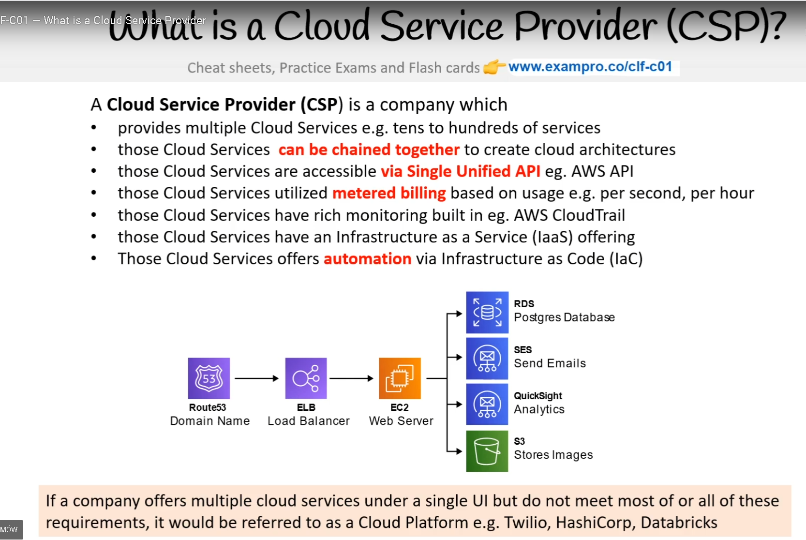

A [**Cloud Service Provider**](https://docs.aws.amazon.com/general/latest/gr/glos-chap.html#C) - is a company which provides multiple **Cloud Services**, ​and those Cloud Services can be chained together to create cloud architectures​ Most commonly through internet-hosted computing, storage, and software services.

**The Big Three Service Providers -** There are three main cloud service providers that own the market share. These providers and their market share are:

* Amazon Web Services (AWS) - 32.4% ($9.8B)​
* Microsoft Azure - 7.6% ($5.3B)
* Google Cloud Platform - 6% ($1.8B)

**Common Cloud Services**

* **Compute​** - Imagine having a virtual computer that​ can run applications, programs, and code.
* **Networking​** - Imagine having a virtual network that allows you to define internet connections or network isolations
* **Storage​**- Imagine having a virtual hard-drive that​ can store files
* **Databases​** - Imagine a virtual database for storing and reporting data or a database for general-purpose web-application

**Note:** - AWS has over 200+ cloud services The term **“Cloud Computing”** can be used to refer to all categories, even though it has **“compute”** in the name.

# **Landscape of CSPs**

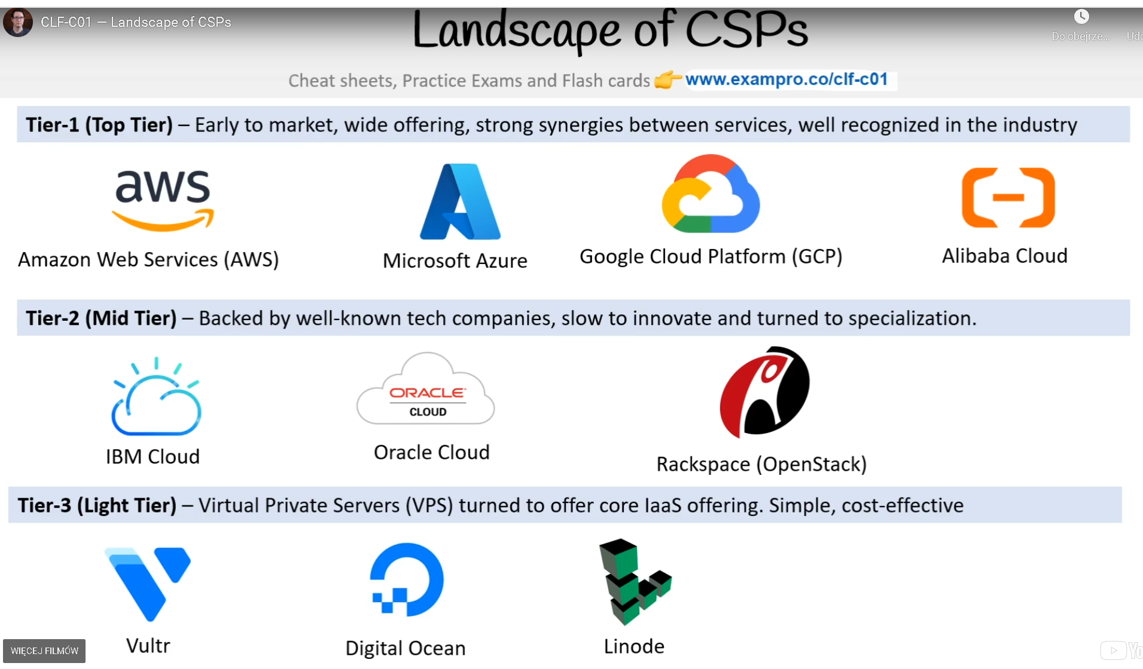

**Tier-1 (Top Tier)** – Early to market, wide offering, strong synergies between services, well recognized in the industry

* Amazon Web Services (AWS)
* Microsoft Azure
* Google Cloud Platform (GCP)
* Alibaba Cloud

**Tier-2 (Mid-Tier)** – Backed by well-known tech companies, slow to innovate and turned to specialization.

* IBM Cloud
* Oracle Cloud
* Rackspace (OpenStack)

**Tier-3 (Light Tier)** – Virtual Private Servers (VPS) turned to offer core IaaS offering. Simple, cost-effective

* Vultr
* Digital Ocean
* Linode

# **Common Cloud Services**

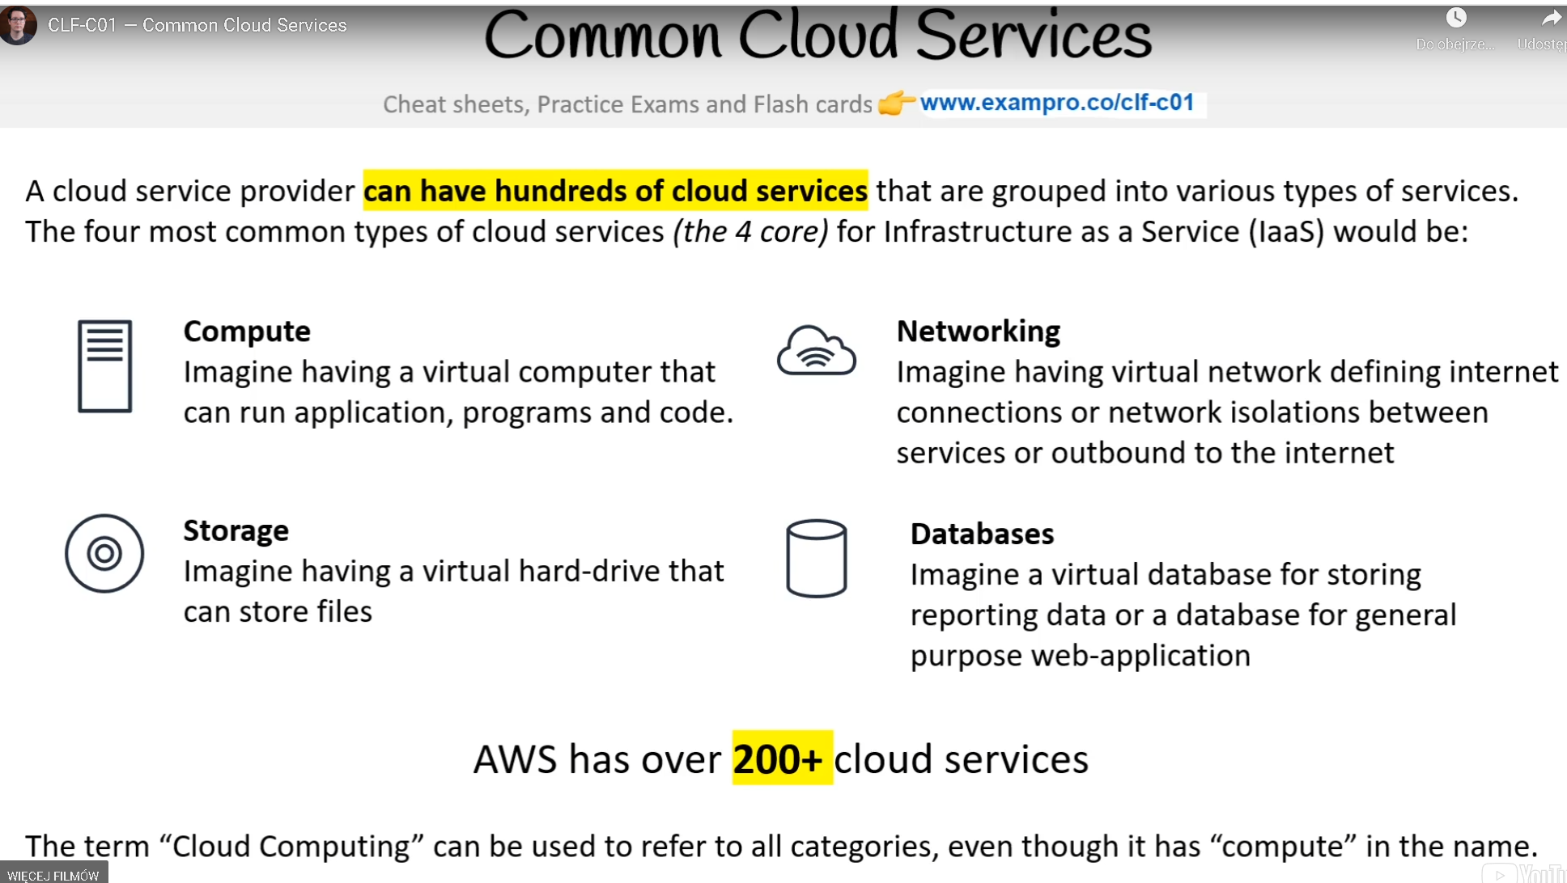

A cloud provider can have hundreds of cloud services that are grouped into various types of services. The four most common types of cloud services for Infrastructure as a Service (IaaS) would be:

* **Compute​** - Imagine having a virtual computer that​ can run applications, programs, and code.
* **Networking​** - Imagine having a virtual network that allows you to define internet connections or network isolation
* **Storage​**- Imagine having a virtual hard drive that​ can store files
* **Databases​** - Imagine a virtual database for storing and reporting data or a database for general-purpose web-application

**Note:** - AWS has over 200+ cloud services

The term **“Cloud Computing”** can be used to refer to all categories, even though it has **“compute”** in the name.

# **Technology Overview**

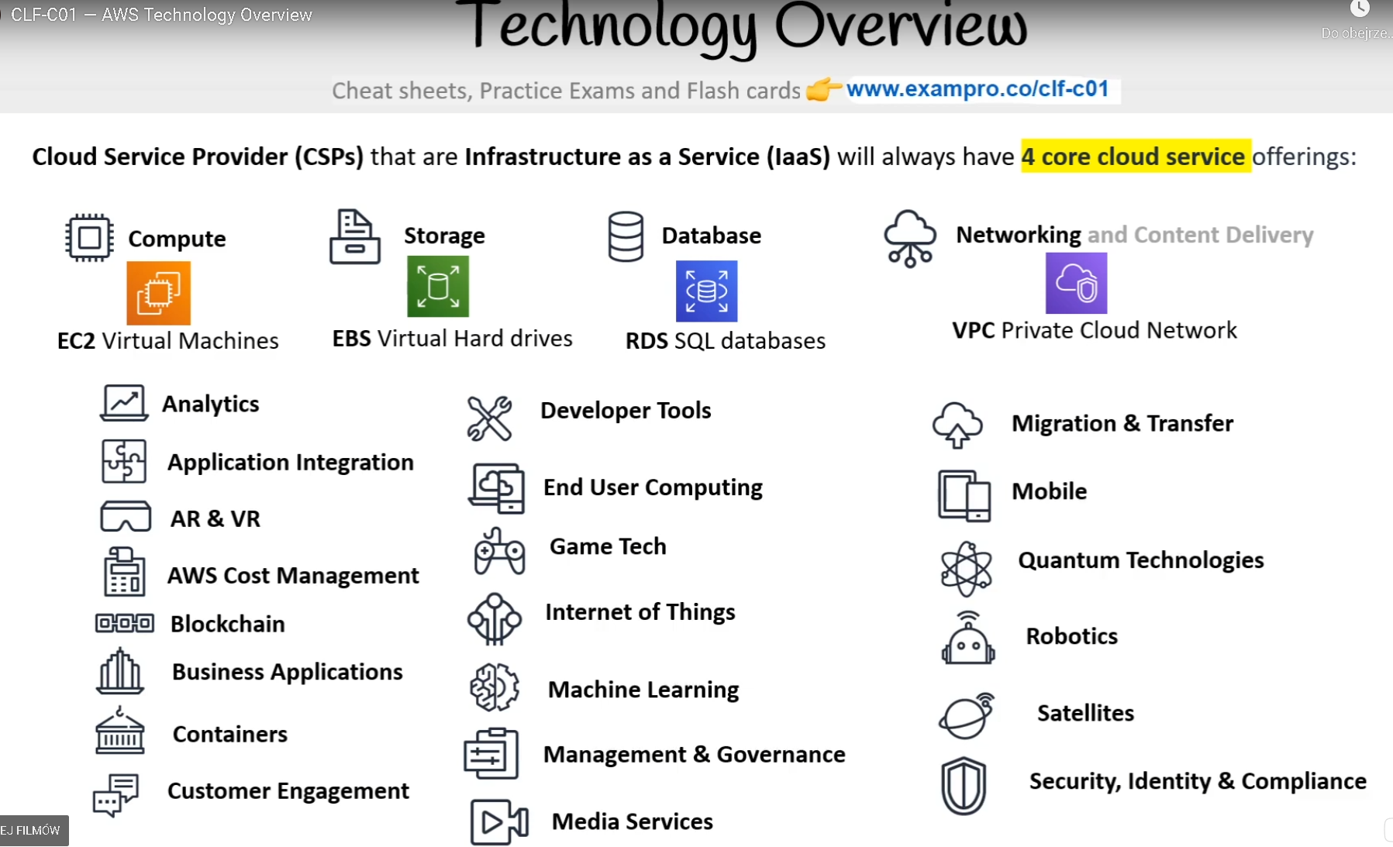

**Cloud Service Providers (CSPs)** that are **Infrastructure as a Service (IaaS)** will always have **4 core cloud service** offerings:

**Compute** -EC2 Virtual Machines

**Storage** - EBS Virtual Hard drives

**Database** - RDS SQL databases

**Networking and Content Delivery** - VPC Private Cloud Network

# **The Evolution of Computing​**

**Dedicated**

* A physical server **​wholly utilized by a single customer**​.
* You have to guess your capacity​
* You’ll overpay for an underutilized server ​
* You can’t vertical scale, you need a manual migration​
* Replacing a server is very difficult​
* You are limited by your Host Operating System​
* Multiple apps can result in conflicts in resource sharing​
* You have a **​guarantee of security, privacy, and full utility of underlying resources**​

**VMs**

* You can run **​multiple Virtual Machines on one machine.**​​
* **​Hypervisor**​ is the software layer that lets you run the VMs​
* A physical server shared by multiple customers​
* You are to pay for a fraction of the server​
* You’ll overpay for an underutilized Virtual Machine ​
* You are limited by your Guest Operating System​
* Multiple apps on a single Virtual Machine can result in conflicts in resource sharing​
* Easy to export or import images for migration​
* Easy to Vertically or Horizontally scale​

**Containers**

* Virtual Machine running multiple containers​
* **​Docker Deamon**​ is the name of the software layer that lets you run multiple containers.​
* You can maximize the utilization of the available capacity which is more cost-effective​
* Your containers share the same underlying OS so containers are more efficient than multiple VMs​
* Multiple apps can run side by side without being limited to the same OS requirements and will not cause conflicts during resource sharing​

**Functions**

* Functions are managed VMs running managed containers.​
* Known as **​Serverless Compute​**​
* You upload a piece of code, choose the amount of memory and duration. ​
* Only responsible for code and data, nothing else​
* Very cost-effective, only pay for the time code is running, VMs only run when there is code to be executed​
* Cold Starts is a side-effect of this setup​

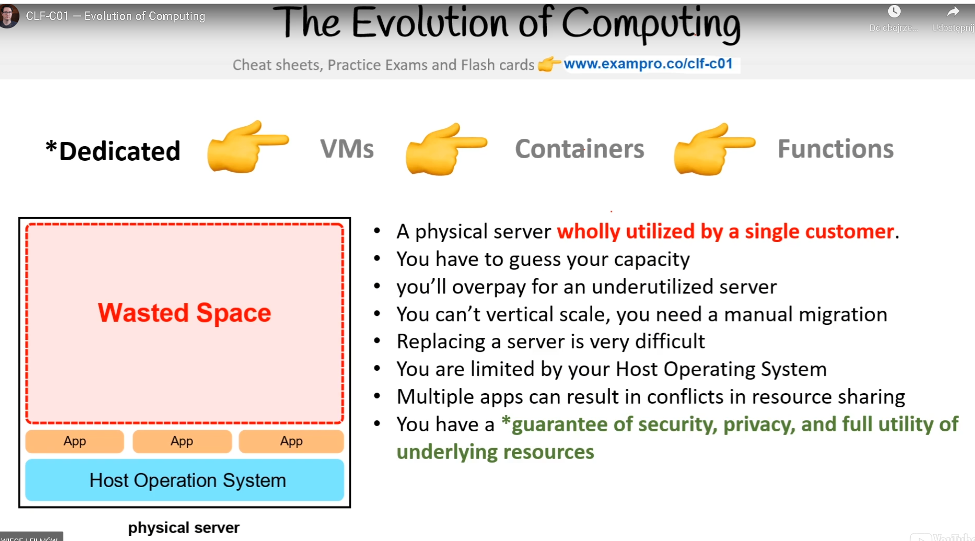

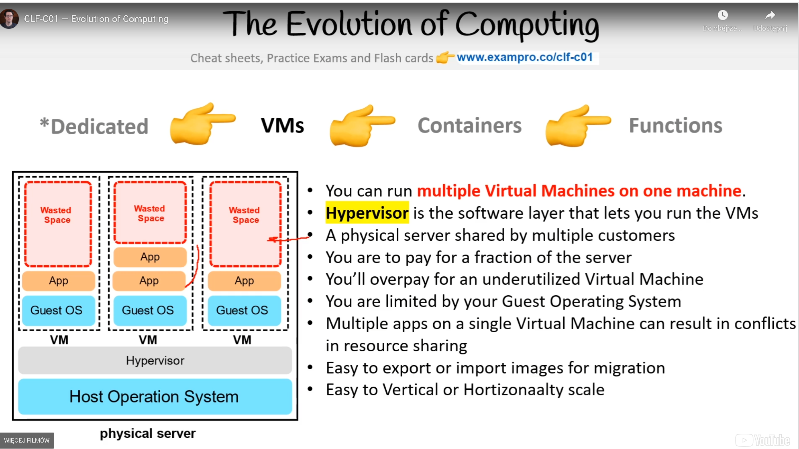

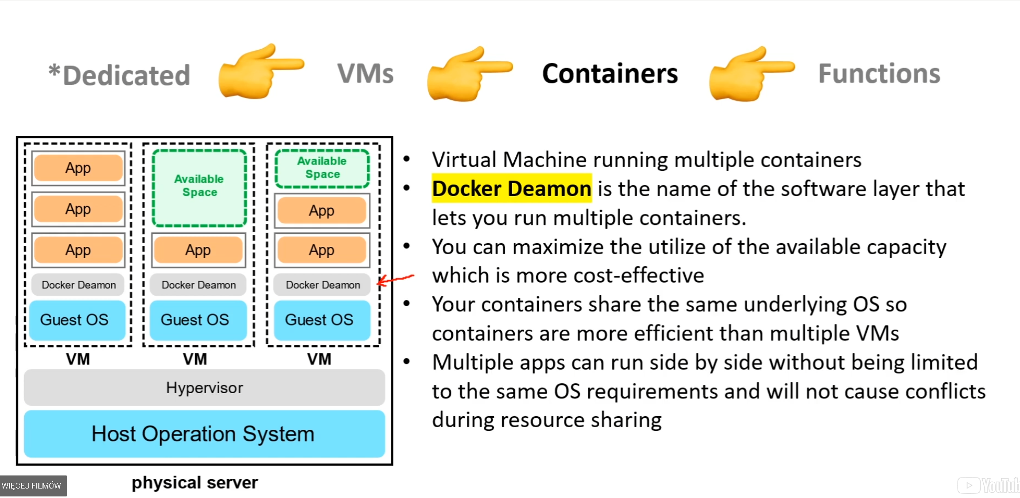

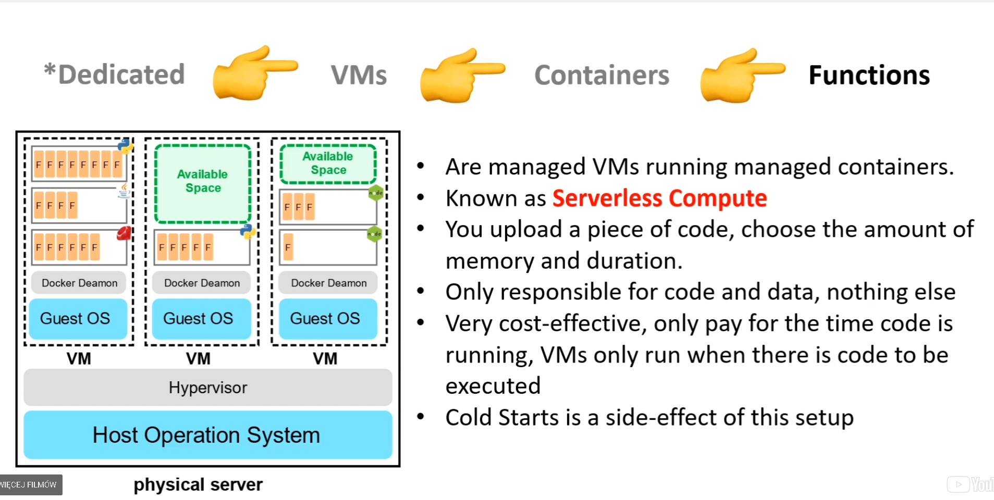

# **Types of Cloud Computing**

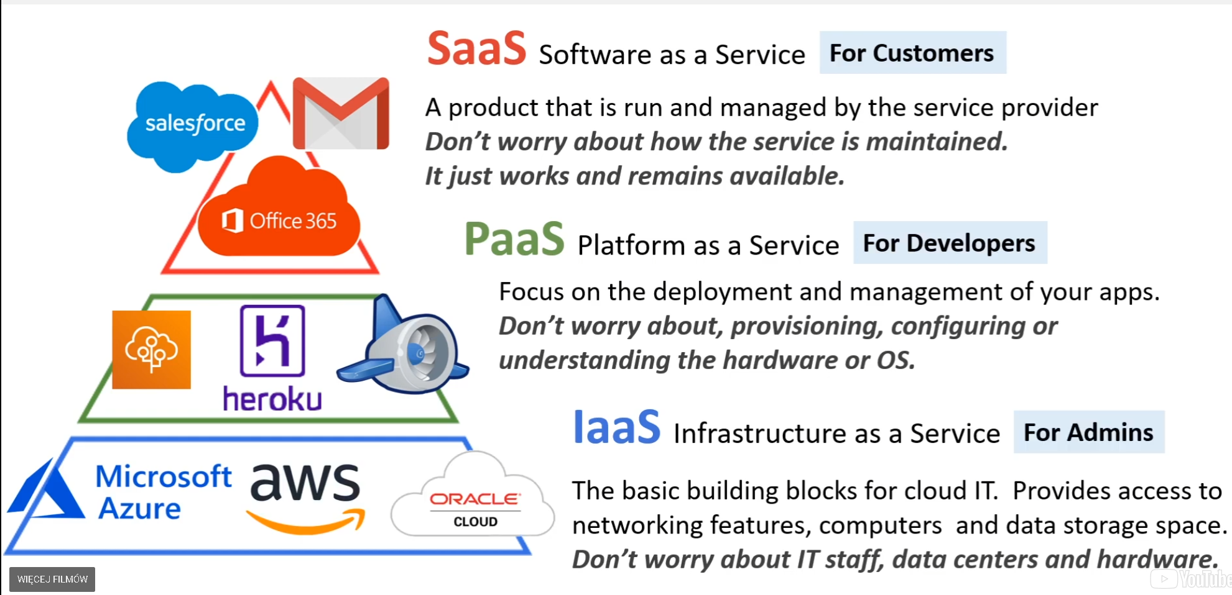

**There are three main models of Cloud Computing:**

1. SaaS - Software as a Service
2. PaaS- Platform as a Service
3. IaaS- Infrastructure as a Service

**IaaS- Infrastructure as a Service (Host) -** Most basic building blocks of cloud IT infrastructure. It has the most flexibility and management control of all the different cloud computing models. It is the closest to having a traditional on-premises data center.

**Examples:** Amazon Web Services | Microsoft Azure | Google Cloud

**PaaS- Platform as a Service (Build) -** Provides a platform allowing customers to develop, run, and manage applications without the complexity of building and maintaining the infrastructure typically associated with developing and launching an app. Less flexibility than IaaS because of pre-constructed packages. Examples: AWS Elastic Beanstalk | Windows Azure | Heroku | Google App Engine

**SaaS- Software as a Service (Consume) -** Completed projects managed by a service provider. Easy to use and comes complete with a user interface. Least flexibility Examples: Gmail | Adobe Creative Cloud

# **Cloud Computing Deployment Models**

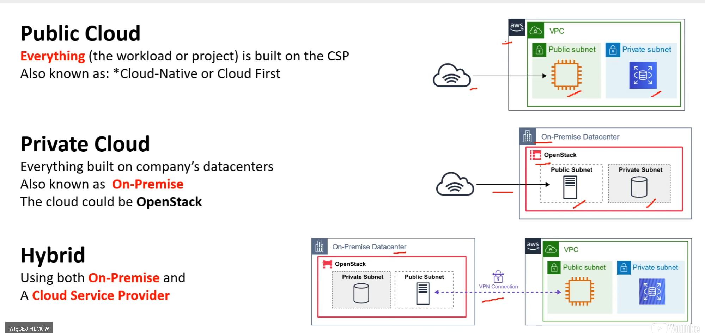

Cloud - When you think of **Cloud**, think of **small startups. -** Cloud Deployment

* 100% of IT infrastructure is on the cloud.
* All of a company’s applications were migrated to or created on the cloud.
* Helps to remove roadblocks of costly and time consuming procurement processes for on-premises infrastructure (big servers and data centers!).
* Great for small businesses and start-ups.

Hybrid – When you think of **Hybrid**, think of **Fin Tech Companies -** Hybrid Deployment

* Connects on-premises technology with cloud-based resources
* Great for established companies that had a dedicated data center but also wants to migrate processes over to the cloud
* Data is partially on the cloud, and partially in the on-premises
* Popular in the Fin Tech space

On-Premise - When you think of **On-premise**, think of **large old companies** or companies that are beholden to **Government Regulations**. - On-premises(Private cloud) Deployment

* Use virtualization to deploy resources in their on-premises data centers.
* Resembles traditional IT infrastructure with big servers, data centers, etc.
* Do not get the same benefits of cloud computing (ability to easily scale up and down on demand)
* Company has dedicated resources that are not shared with others(good for security)
* Resources cannot be accessed using the internet
* Typically older large companies or owned by Government organizations

Reference**:** [What are public, private, and hybrid clouds?](https://docs.microsoft.com/en-us/learn/modules/fundamental-azure-concepts/types-of-cloud-computing)

# **Innovation Waves​**

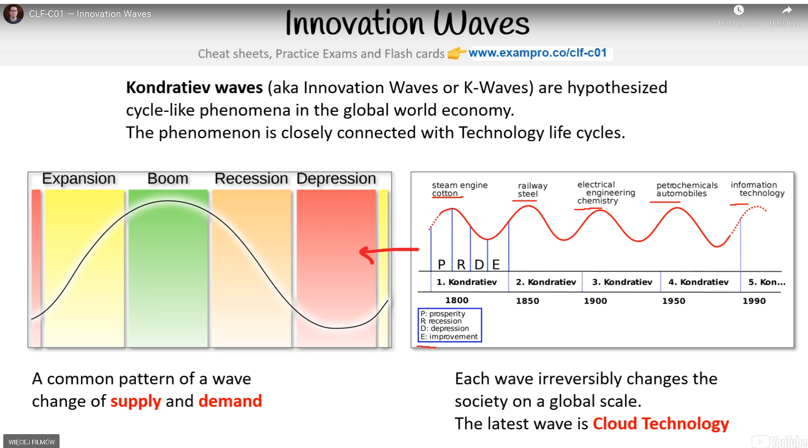

**Kondratiev waves** - (also known as Innovation Waves) are hypothesized cycle-like phenomena in the global world economy. ​ The phenomenon is closely connected with Technology life cycles.​ A common pattern of a wave change of **supply** and **demand​** Each wave irreversibly changes society on a global scale.​ The latest wave is **Cloud Technology​**

**Reference** : [Kondratiev wave](https://en.wikipedia.org/wiki/Kondratiev_wave)

**Burning platform** - is a term used **when a company abandons old technology for new technology** with the **uncertainty of success and can be motivated by fear** that the organization future survival hinges on its **digital transformation​**

# **Evolution of Computing Power​**

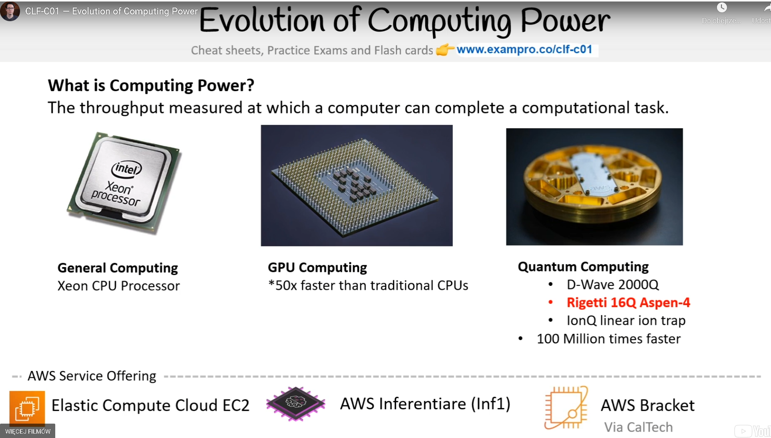

**What is Computing Power?​** - The throughput is measured at which a computer can complete a computational task.​

**General Computing​** - Xeon CPU Processor​

**Tensor Computing​** -Tensor Processing Unit 3.0 (TPUs)​ 50x faster than traditional CPUs​

**Quantum Computing​ -** 100 Million times faster​

**Google’s Cloud Service Offering:** Compute Engine​ Cloud TPU​ Google Quantum AI​

# **The Benefits of Cloud**

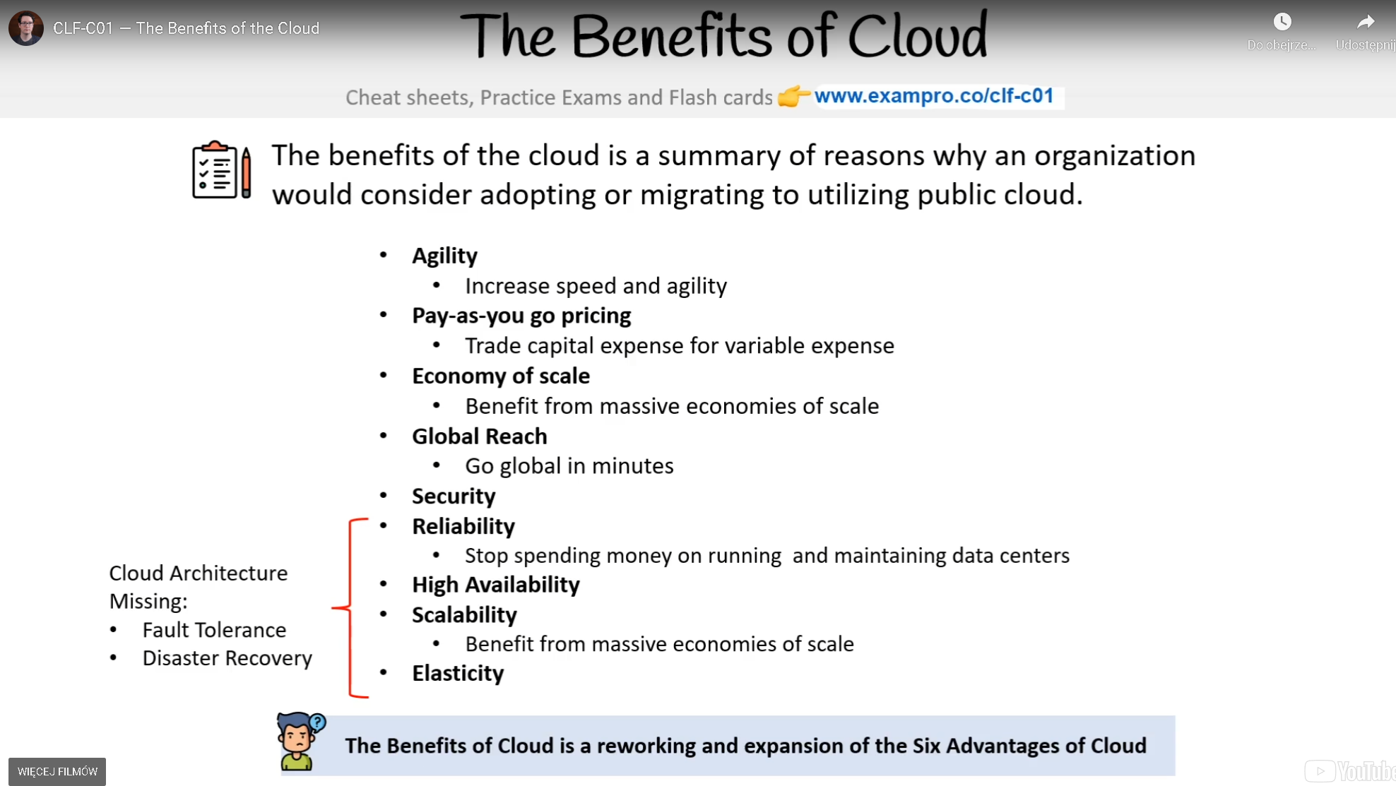

The benefits of the cloud are a summary of reasons why an organization would consider adopting or migrating to utilizing the public cloud.

* **Agility -** Increase speed and agility
* **Pay-as-you-go pricing -** Trade capital expense for variable expense
* **Economy of scale -** Benefit from massive economies of scale
* **Global Reach -** Go global in minutes
* **Security**
* **Reliability -** Stop spending money on running and maintaining data centers
* **High Availability**
* **Scalability -** Stop guessing capacity
* **Elasticity -** Cloud Architecture

**Missing:** Fault Tolerance, Disaster Recovery

**The Benefits of Cloud is reworking and expansion of the Six Advantages of Cloud**

# **Six Advantages and Benefits of Cloud Computing**

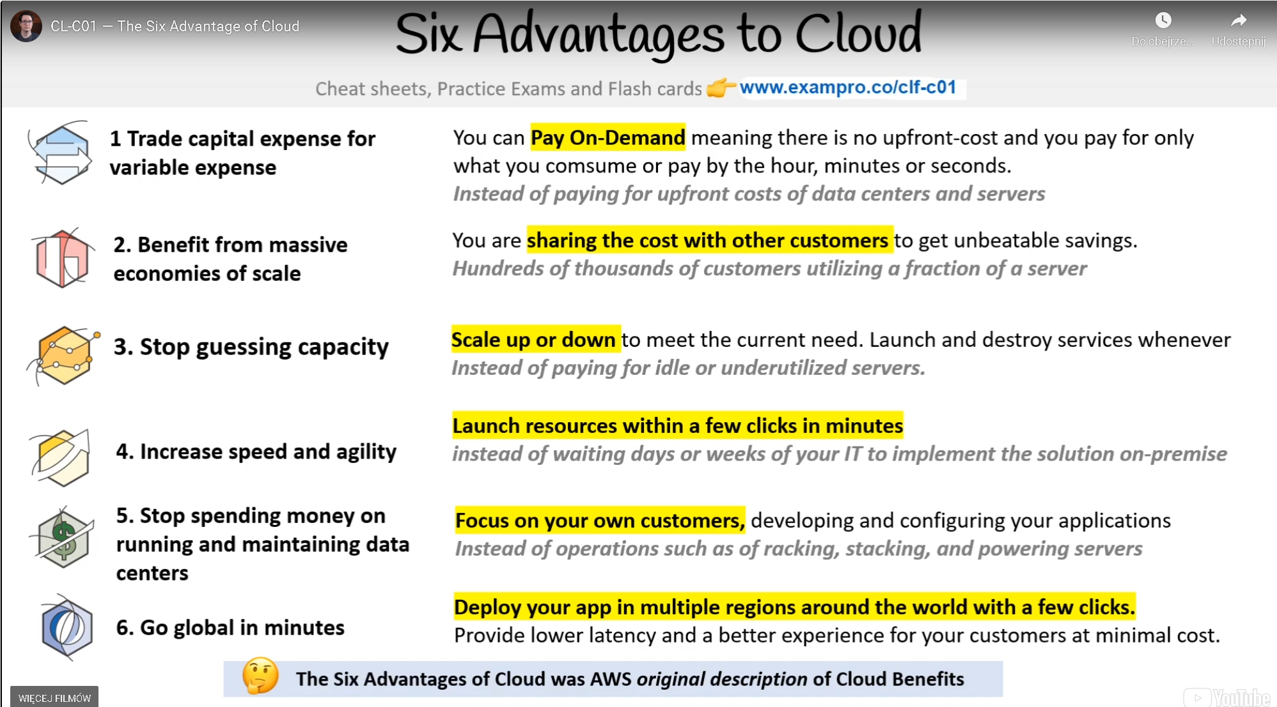

1. Trade capital expense for variable expense
2. Benefit from massive economies
3. Stop guessing capacity
4. Increase speed and agility
5. Stop spending money on running and maintaining data centers
6. Go global in minutes

You can Pay On-Demand meaning there is no upfront cost and you pay for only what you consume or pay by the hour, minutes, or seconds. Instead of paying for upfront costs of data centers and servers You are sharing the cost with other customers to get unbeatable savings. Hundreds of thousands of customers utilize a fraction of a server Scale up or down to meet the current need. Launch and destroy services whenever

Instead of paying for idle or underutilized servers. Launch resources within a few clicks in minutes instead of waiting days or weeks of your IT to implement the solution on-premise Focus on your own customers, developing and configuring your applications Instead of operations such as racking, stacking, and powering servers Deploy your app in multiple regions around the world with a few clicks. Provide lower latency and a better experience for your customers at a minimal cost.

# **Benefits of Cloud Computing​**

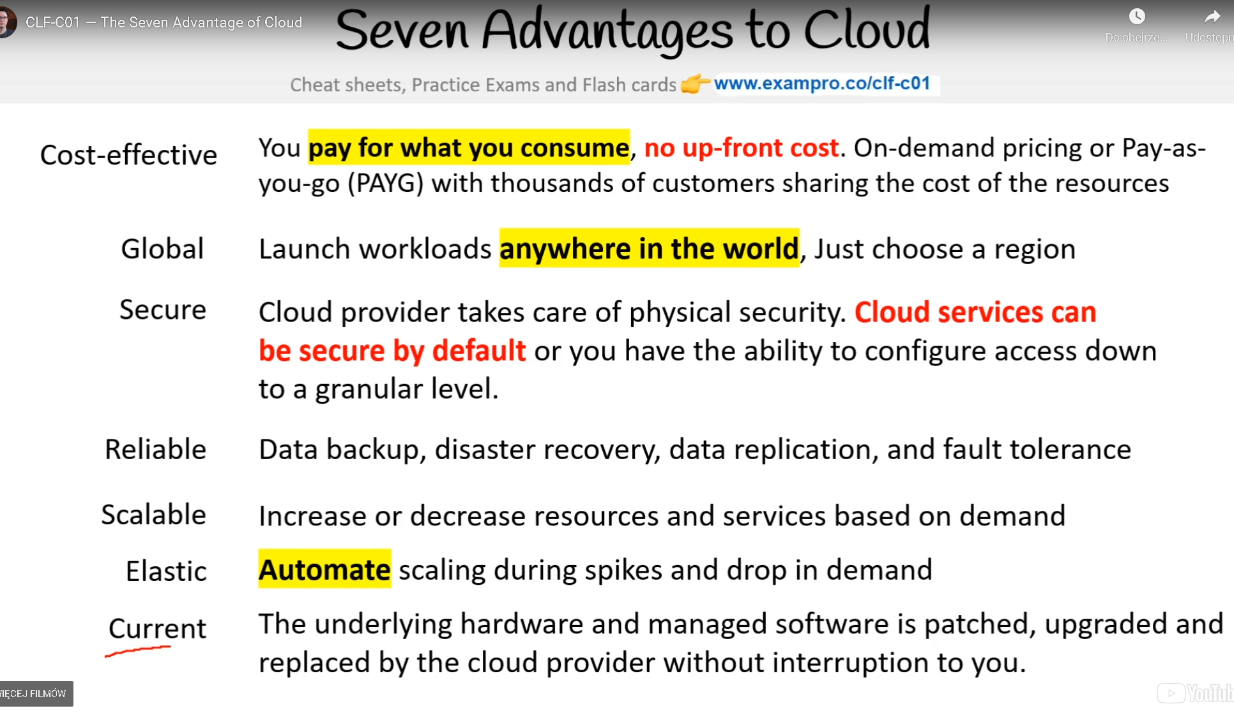

**Cost-effective​** - You pay for what you consume, with no up-front cost. On-demand pricing or Pay-as-you-go (PAYG) with thousands of customers sharing the cost of the resources​

**Global** - Launch workloads anywhere in the world, Just choose a region​

**Secure​** - Cloud provider takes care of physical security. Cloud services can be secure by default or you have the ability to configure access down to a granular level.​

**Reliable​** - Data backup, disaster recovery, data replication, and fault tolerance​

**Scalable​** - Increase or decrease resources and services based on demand ​

**Elastic​** - Automate scaling during spikes and drop in demand​

**Current​**- The underlying hardware and managed software are patched, upgraded, and replaced by the cloud provider without interruption to you.​

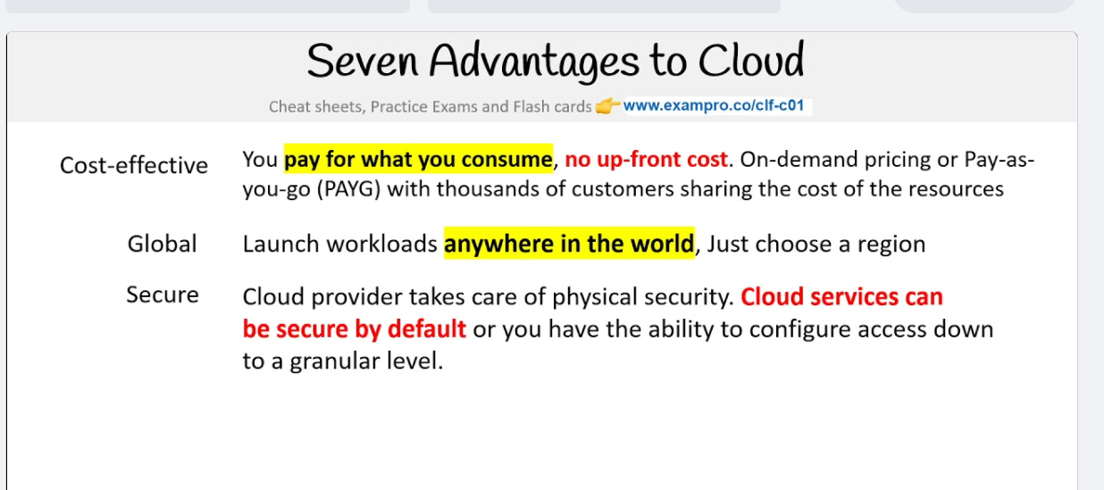

# **AWS Global Infrastructure**

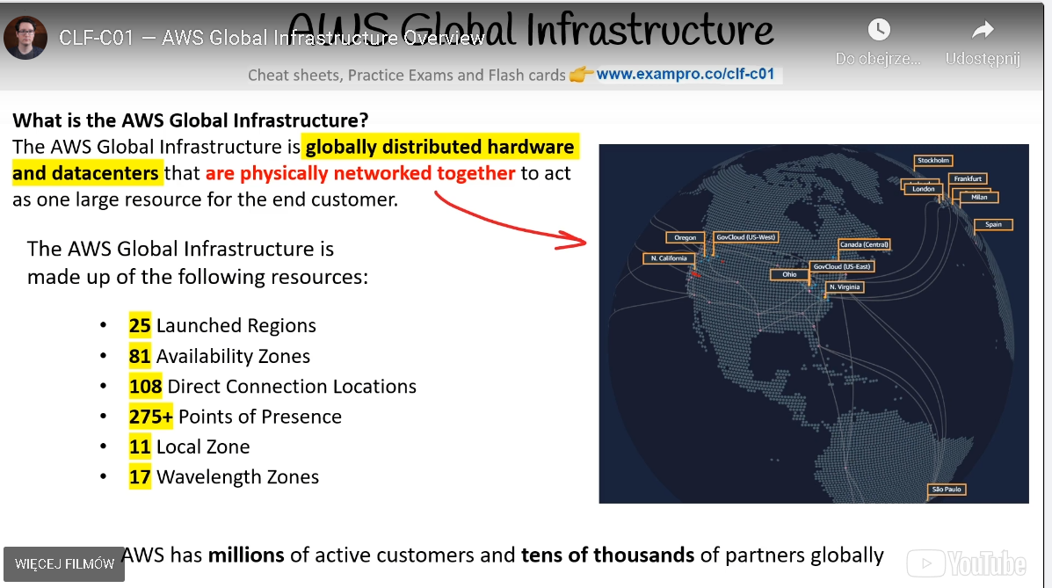

**What is the AWS Global Infrastructure?​** - The AWS Global Infrastructure is globally distributed hardware and data centers that are physically networked together to act as one large resource for the end customer. This is so you, the customer, can access their services no matter where you are located around the globe.

The AWS Global Infrastructure is made up of the following resources*:

* 25 Launched Regions​
* 81 Availability Zones​
* 108 Direct Connection Locations​
* 275+ Points of Presence​
* 14 Local Zones

*as of November 2, 2021

**References:** <https://infrastructure.aws/> | [Global Infrastructure](https://aws.amazon.com/about-aws/global-infrastructure/)

# **Regions**

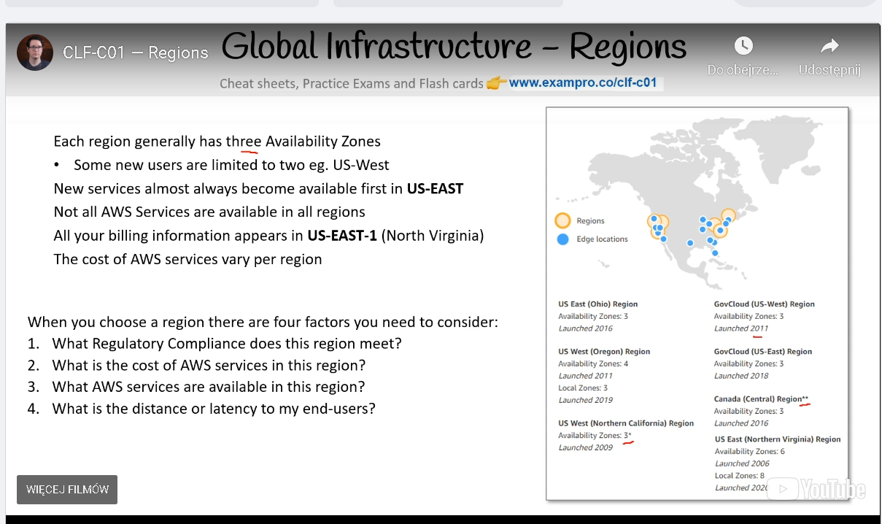

Region: a Geographically Distinct Location, which has multiple datacentres(AZs).

**Every region is physically isolated from and independent of every other region in terms of location, power, water supply**

* Each region has at least two Availability Zones (AZs) ​
* AWS US-EAST-1 (North Virginia) is the largest region​
* New services almost always become available first in US-EAST​
* Not all AWS Services are available in all regions​
* All your billing information appears in US-EAST-1 (North Virginia)​
* AWS is always looking to expand their foot-print so new regions could be added in the upcoming years.​

You can head over to [AWS's Global Infrastructure](https://aws.amazon.com/about-aws/global-infrastructure/regions_az/?p=ngi&loc=2) page to learn more about Regions and see maps of their locations.

* In the AWS Console you can change AWS Regions. Whatever AWS resources you launch will be in that region.​
* Some AWS Services such as CloudFront operate in multiple regions and you’ll see the region change to Global​

# **Availability Zones**

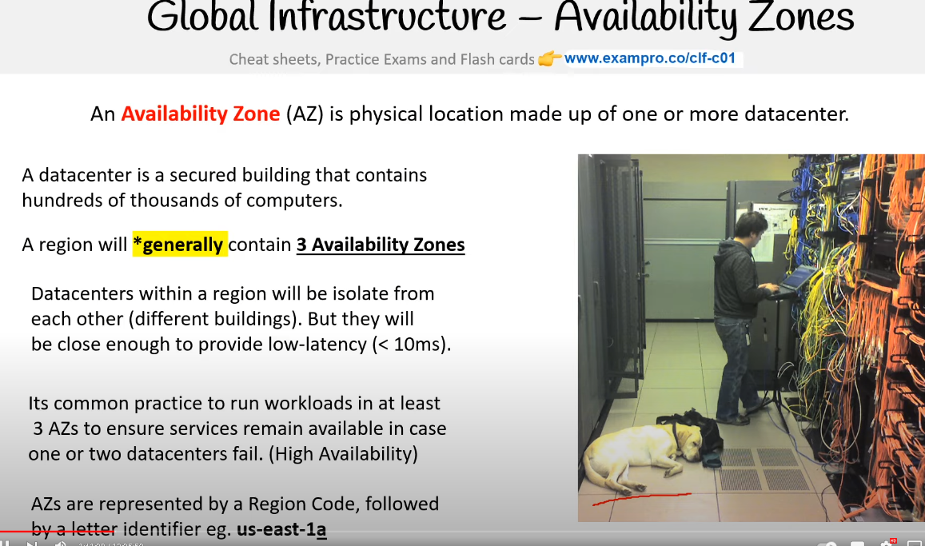

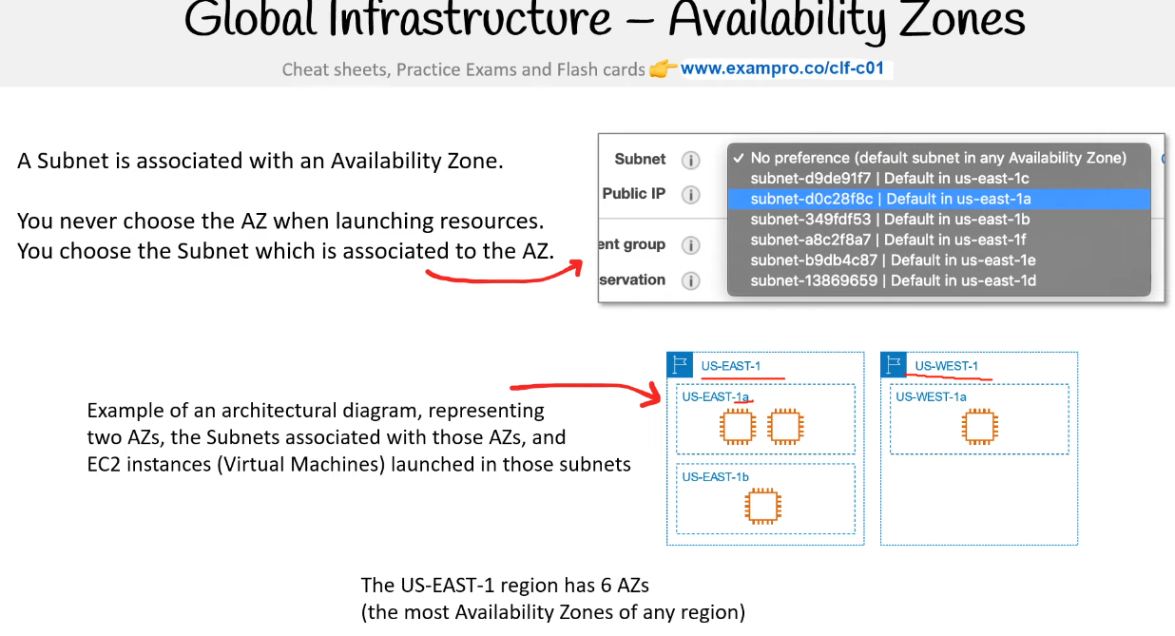

Availability Zones are often referred to as AZs. An Availability Zone (AZ) is a physical location made up of one or more datacenters.​ A datacenter is a secured building that contains​ hundreds or thousands of computers. Datacenters within a region will be isolate from​ each other (different buildings). But they will​ be close enough to provide low-latency (< 10ms).​ A region will generally contain 3 Availability Zones​. The use of AZ’s give customers the ability to operate production applications and databases that are more:

* Highly available
* Fault tolerant
* Scalable

Its common practice to run workloads in at least​ 3 AZs to ensure services remain available in case ​one or two datacenters fail **(High Availability)**. **A subnet is associated with an Availability Zone**.​ So to launch an AWS resource into a specific AZ you need to launch your resource in a subnet that resides in that AZ.

# **Global Infrastructure – Availability Zones**

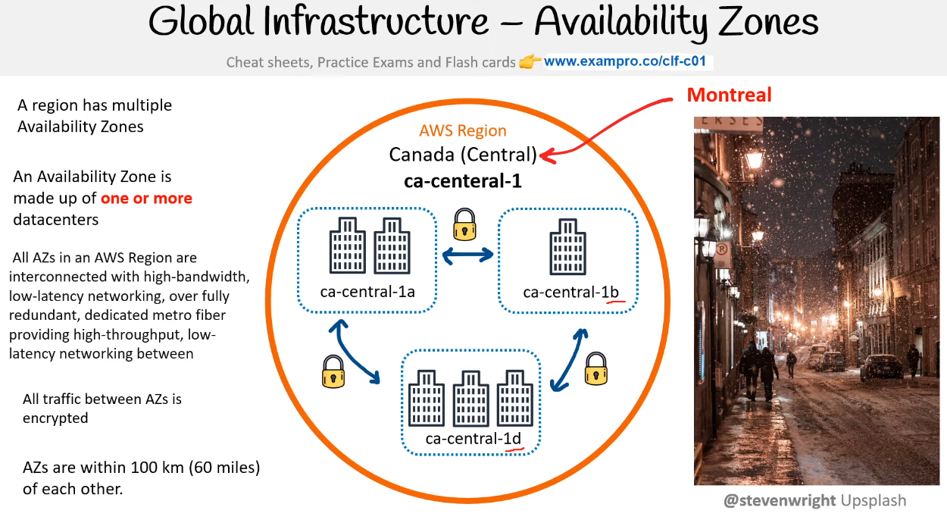

A region has multiple Availability Zones. An Availability Zone is made up of **one or more** data centers. All AZs in an AWS Region are interconnected with high-bandwidth, low-latency networking, over fully redundant, dedicated metro fiber providing high-throughput, low-latency networking between  All traffic between AZs is encrypted. AZs are within 100 km (60 miles) of each other.

Reference: [Global Infrastructure](https://aws.amazon.com/about-aws/global-infrastructure/)

# **Global Infrastructure - Fault Tolerance**

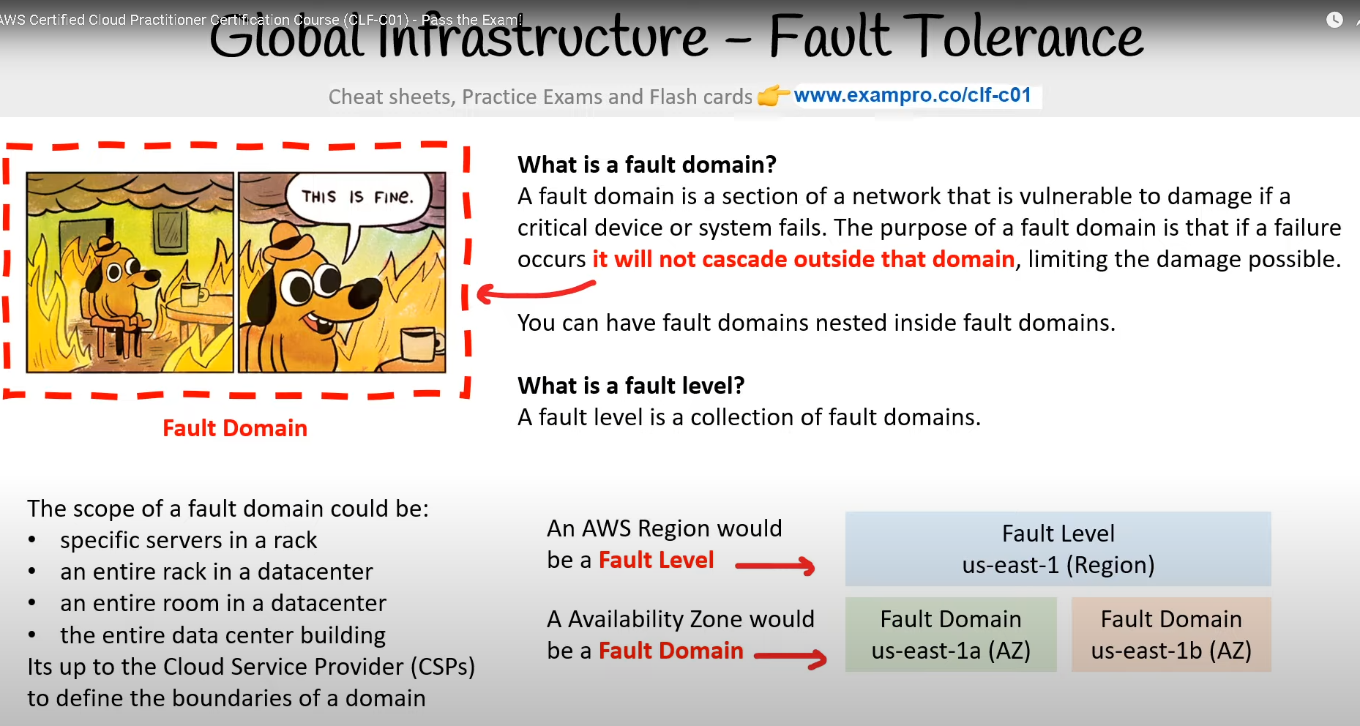

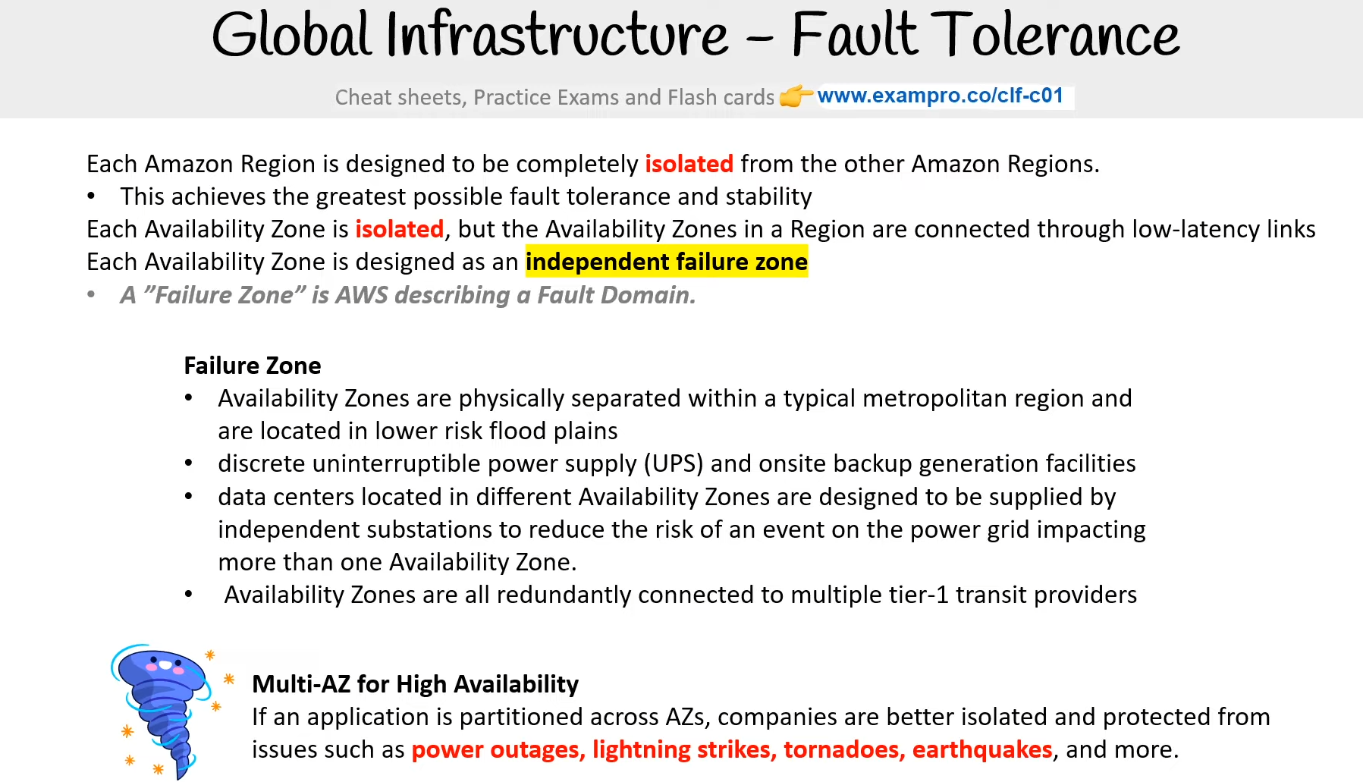

**What is a fault domain?** A fault domain is a section of a network that is vulnerable to damage if a critical device or system fails. The purpose of a fault domain is that if a failure occurs it will not cascade outside that domain, limiting the damage possible. You can have fault domains nested inside fault domains.

**What is a fault level?** - A fault level is a collection of fault domains. The scope of a fault domain could be:

* specific servers in a rack
* an entire rack in a datacenter
* an entire room in a datacenter
* the entire data center building

It's up to the Cloud Service Provider (CSPs) to define the boundaries of a domain An AWS Region would be a **Fault Level** → Fault Level us-east-1 (Region) An Availability Zone would be a **Fault Domain** Fault Domain us-east-1a (AZ). Fault Domain us-east-1b (AZ) Each Amazon Region is designed to be completely **isolated** from the other Amazon Regions.

* This achieves the greatest possible fault tolerance and stability

Each Availability Zone is isolated, but the Availability Zones in a Region are connected through low-latency links. Each Availability Zone is designed as an independent failure zone

* A ”Failure Zone” is AWS describing a Fault Domain.

**Failure Zone**

* Availability Zones are physically separated within a typical metropolitan region and are located in lower risk flood plains
* discrete uninterruptible power supply (UPS) and onsite backup generation facilities
* data centers located in different Availability Zones are designed to be supplied by independent substations to reduce the risk of an event on the power grid impacting more than one Availability Zone.
* Availability Zones are all redundantly connected to multiple tier-1 transit providers

**Multi-AZ for High Availability** - If an application is partitioned across AZs, companies are better isolated and protected from issues such as **power outages, lightning strikes, tornadoes, earthquakes**, and more.

Reference - [Global Infrastructure](https://docs.aws.amazon.com/whitepapers/latest/aws-overview/global-infrastructure.html) | [Describing fault domains.](https://lethain.com/fault-domains/) | [Fault Domain Awareness](https://mesosphere.github.io/marathon/docs/fault-domain-awareness.html) | [Fault Domains and the Vegas Rule](https://m.subbu.org/fault-domains-and-the-vegas-rule-923fc037119)

# **AWS Global Network**

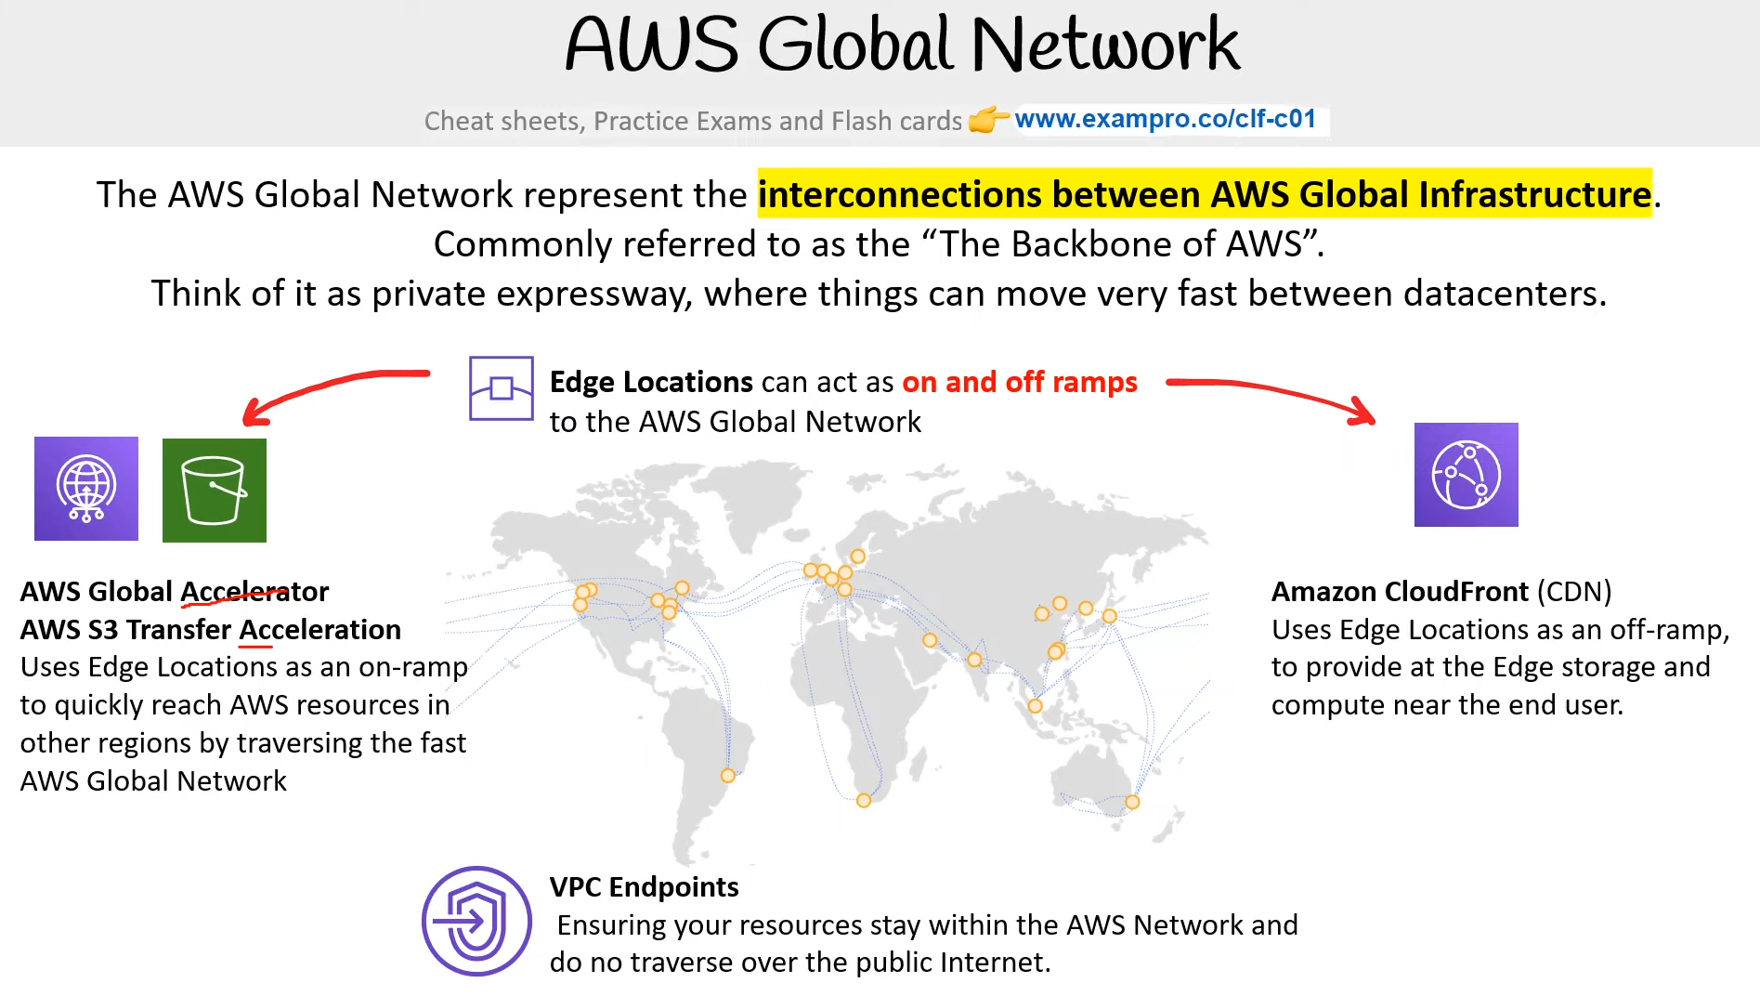

The AWS Global Network represents the interconnections between AWS Global Infrastructure. Commonly referred to as the “The Backbone of AWS”. Think of it as a private expressway, where things can move very fast between datacenters.

**Edge Locations** - can act as on and off-ramps to the AWS Global Network

**AWS Global Accelerator**

**AWS S3 Transfer Acceleration** - Uses Edge Locations as an on-ramp to quickly reach AWS resources in other regions by traversing the fast AWS Global Network

**Amazon CloudFront (CDN)** - Uses Edge Locations as an off-ramp, to provide at the Edge storage and compute near the end-user.

**VPC Endpoints** - Ensuring your resources stay within the AWS Network and do not traverse over the public Internet.

**Reference** - [Global Network](https://aws.amazon.com/about-aws/global-infrastructure/global_network/)

# **Points of Presence**

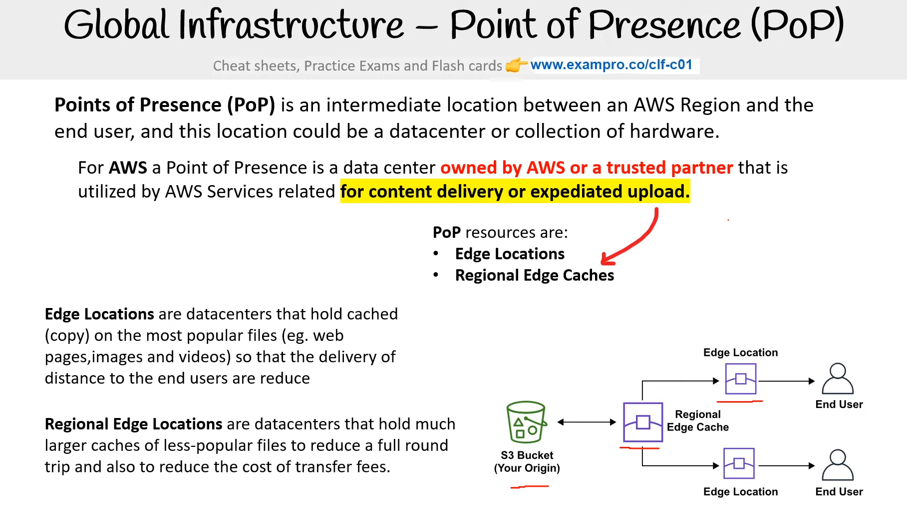

**Points of Presence (PoP)** are intermediate locations between an AWS Region and the end-user, and this location could be a datacenter or collection of hardware.​

* For AWS a Point of Presence is a data center owned by AWS or a trusted partner that is utilized by AWS Services related for content delivery or expediated upload.​

[**Edge Locations**](https://aws.amazon.com/cloudfront/features/) - are datacenters that hold cached (copy) on the most popular files (eg. web pages, images and videos) so that the delivery of distance to the end users are reduce

[**Regional Edge Cache**](https://docs.aws.amazon.com/AmazonCloudFront/latest/DeveloperGuide/HowCloudFrontWorks.html#CloudFrontRegionaledgecaches) - are datacenters that hold much larger caches of less-popular files to reduce a full round trip and also to reduce the cost of transfer fees.​

The following AWS Services use PoPs for content delivery or expediated upload:

[**AWS CloudFront**](https://docs.aws.amazon.com/AmazonCloudFront/latest/DeveloperGuide/Introduction.html) - is a Content Delivery Network (CDN) service that:​

* You point your website to CloudFront so that it will route requests to the nearest Edge Location cache​
* Allows you to choose an origin (such as a web-server or storage) that will be a source of cached​
* Caches the contents of what origin would be returned to various Edge Locations around the world​

[**AWS S3 Transfer Acceleration**](https://aws.amazon.com/s3/transfer-acceleration/) - allows you to generate a special URL that can be used by end users to upload files to a nearby Edge Location. Once a file is uploaded to an Edge Location, it can move much faster within the AWS Network to reach S3.​

[**AWS Global Accelerator**](https://aws.amazon.com/global-accelerator/?blogs-global-accelerator.sort-by=item.additionalFields.createdDate&blogs-global-accelerator.sort-order=desc&aws-global-accelerator-wn.sort-by=item.additionalFields.postDateTime&aws-global-accelerator-wn.sort-order=desc) - can find the optimal path from the end user to your web-servers. Global Accelerators are deployed within Edge Locations so you send user traffic to an Edge Location instead of directly to your web-application.​

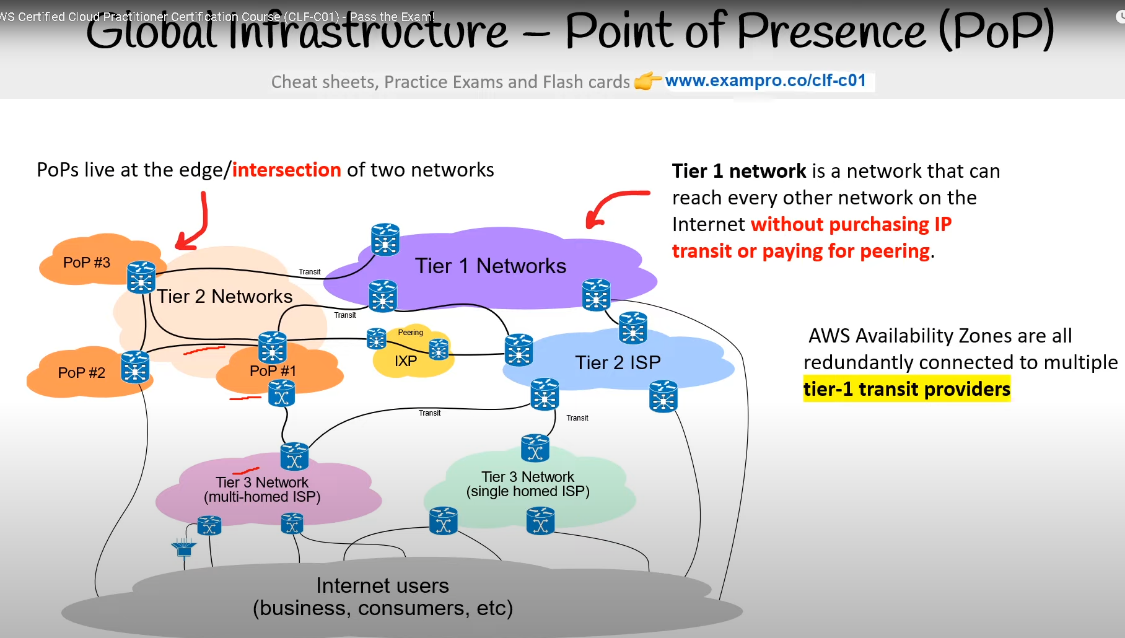

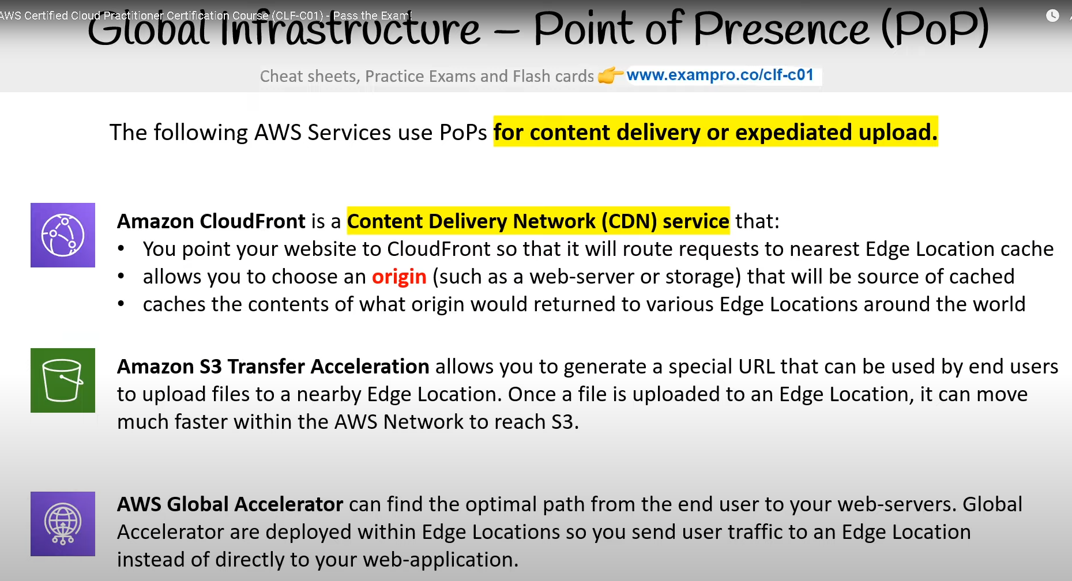

# **AWS Direct Connect**

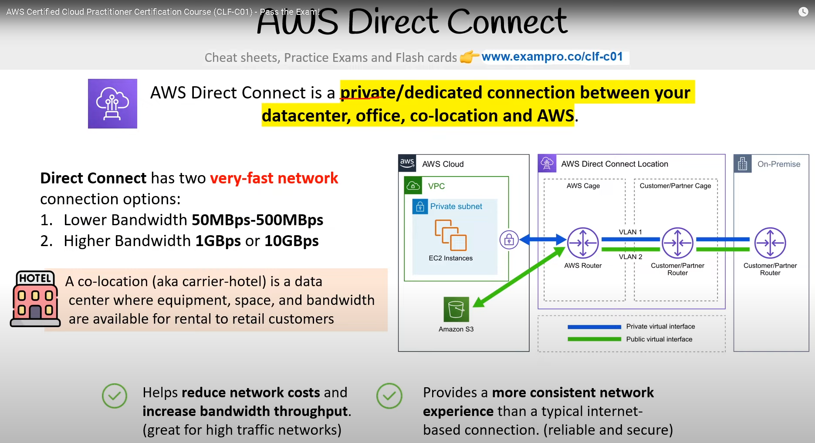

AWS Direct Connect is a **private/dedicated connection between your data center, office, co-location, and AWS.** **Direct Connect** has two **very-fast network** connection options:

* Lower Bandwidth 50MBps-500MBps
* Higher Bandwidth 1GBps or 10GBps

A co-location (aka carrier-hotel) is a data center where equipment, space, and bandwidth are available for rental to retail customers. Helps **reduce network costs and increase bandwidth throughput**. (great for high traffic networks). Provides a **more consistent network experience** than a typical internet-based connection. (reliable and secure)

**Reference** - [AWS Direct Connect](https://aws.amazon.com/directconnect/)

[**Direct Connect Locations**](https://aws.amazon.com/directconnect/features/#AWS_Direct_Connect_Locations) - are trusted third-party datacenters that you can establish a dedicated high speed, low-latency connection from your on-premise to the AWS network.​

* DirectConnect connections are always established through a third-party provider. These APN (Amazon Partner Network) Partners can help you establish network circuits between an AWS Direct Connect location and your datacenter, office, or colocation environment, or assist you in constructing a hybrid environment.

[**Local Zones**](https://aws.amazon.com/about-aws/global-infrastructure/localzones/) - are datacenters located very close to a density populated area to provide *single-digit millisecond low latency performance* (eg. 7ms) for that area.

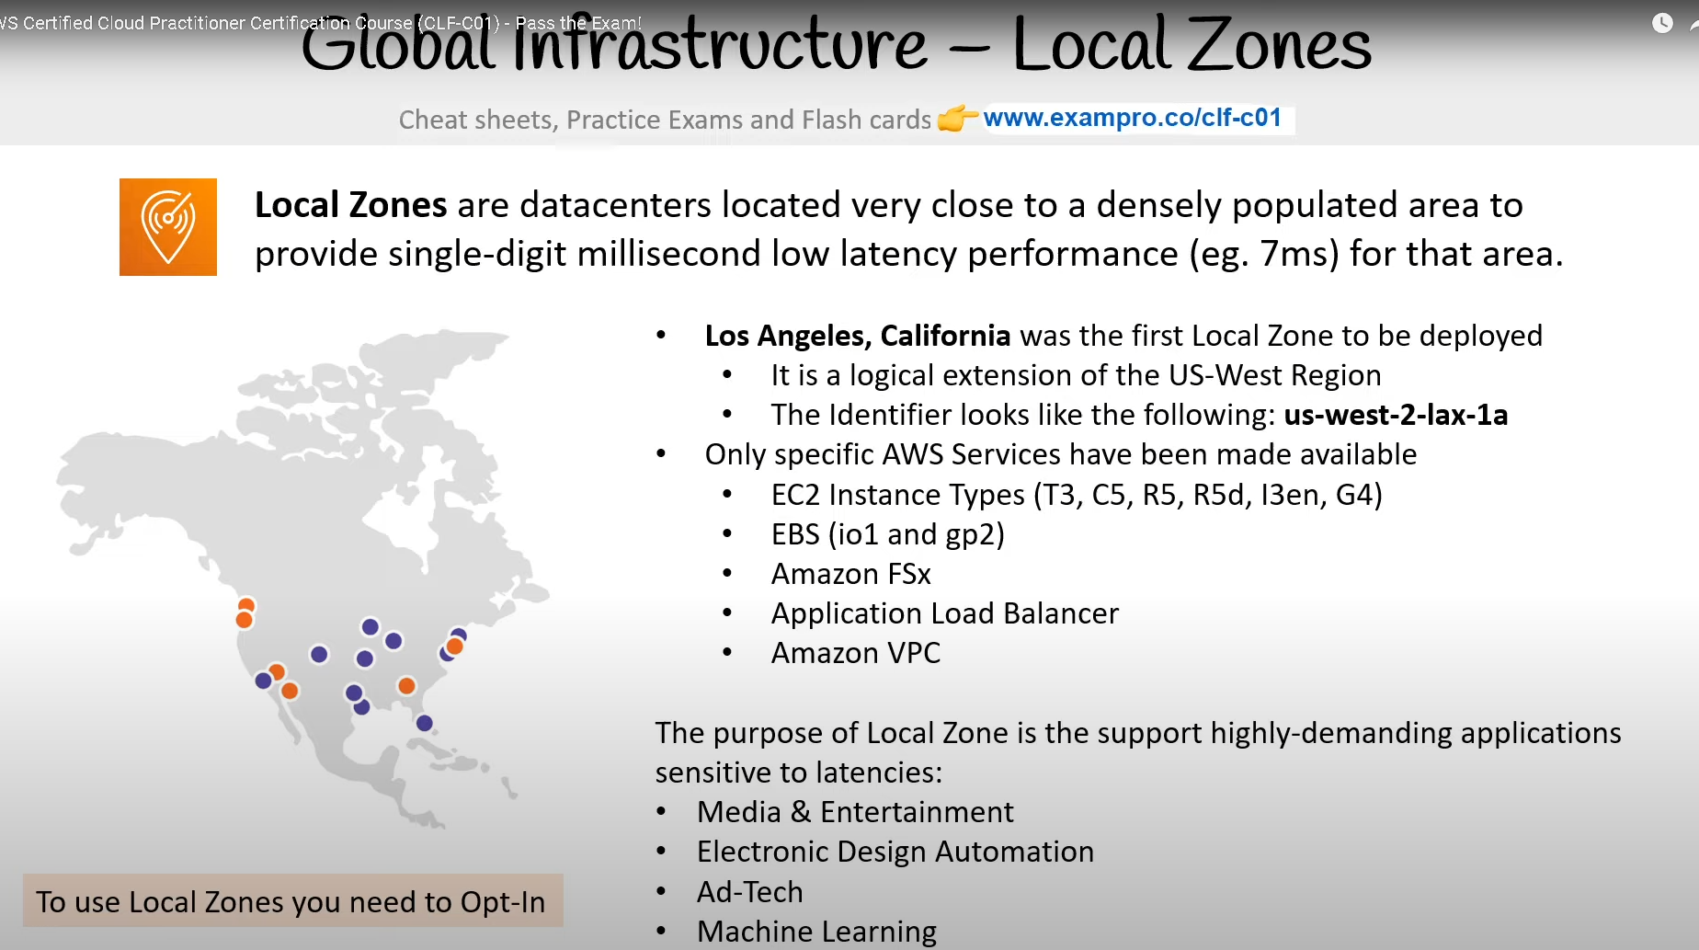

**Los Angeles, California** was the first Local Zone to be deployed​

* It is a logical extension of the US-West Region​
* The Identifier looks like the following: us-west-2-lax-1a​
* Only specific AWS Services have been made available​
  + EC2 Instance Types (T3, C5, R5, R5d, I3en, G4)​
  + EBS (io1 and gp2)​
  + Amazon FSx​
  + Application Load Balancer​
  + Amazon VPC​

**The purpose of Local Zone is to support highly-demanding applications sensitive to latency:​**

* Media & Entertainment​
* Electronic Design Automation​
* Ad-Tech​
* Machine Learning

# **Global Infrastructure - Wavelength Zones**

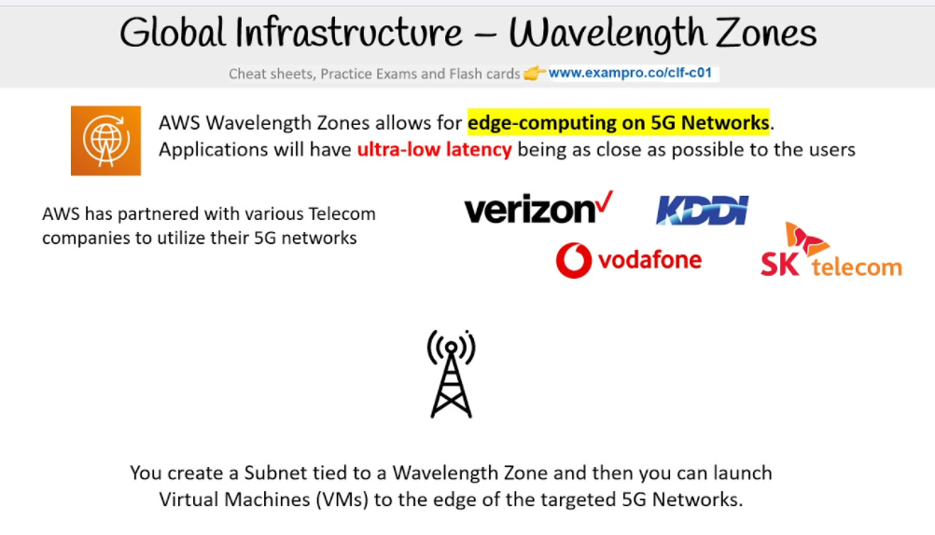

AWS Wavelength Zones allow for **edge-computing on 5G Networks**. Applications will have **ultra-low latency** being as close as possible to the users. AWS has partnered with various Telecom companies to utilize their 5G networks Verizon, KDDI, vodafone, SK telecom - You can create a Subnet tied to a Wavelength Zone and then you can launch Virtual Machines (VMs) to the edge of the targeted 5G Networks.

# **Global Infrastructure – Data Residency**

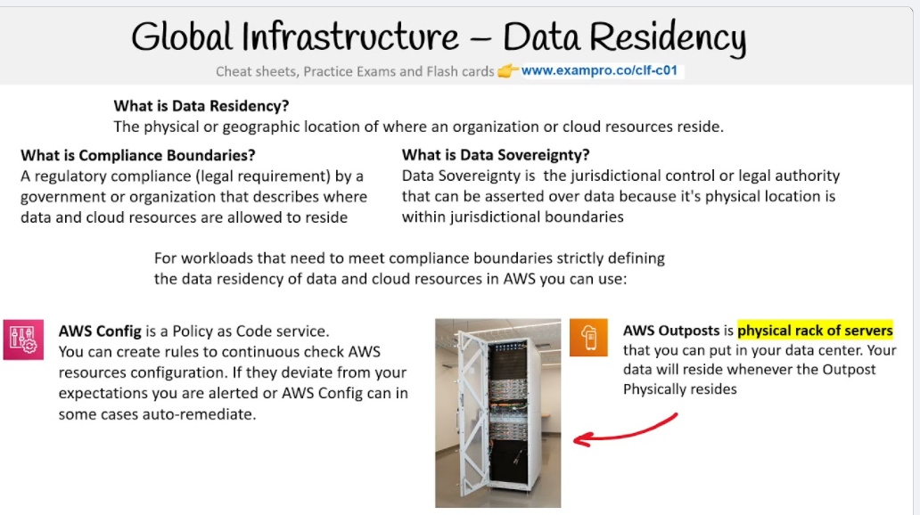

**What is Data Residency?** - The physical or geographic location of where an organization or cloud resources reside.

**What is Compliance Boundaries?** - A regulatory compliance (legal requirement) by a government or organization that describes where data and cloud resources are allowed to reside

**What is Data Sovereignty?** - Data Sovereignty is the jurisdictional control or legal authority that can be asserted over data because its physical location is within jurisdictional boundaries For workloads that need to meet compliance boundaries strictly defining the data residency of data and cloud resources in AWS you can use:

**AWS Config** is a Policy as Code service. - You can create rules to continuously check AWS resources configuration. If they deviate from your expectations you are alerted or AWS Config can in some cases auto-remediate.

**IAM Policies** can be written explicitly to deny access to specific AWS Regions. A Service Control Policy (SCP) are permissions applied organization-wide.

**AWS Outposts** is a **physical rack of servers** that you can put in your data center. Your data will reside whenever the Outpost Physically resides.

**Reference**: [Addressing Data Residency with AWS](https://aws.amazon.com/blogs/security/addressing-data-residency-with-aws/)

# **Global Infrastructure - AWS for Government**

**What is Public Sector?** - Public sectors include public goods and governmental services such as:

* Military | law enforcement | infrastructure | public transit | public education | health care | the government itself

AWS can be utilized by the public sector or organizations developing cloud workloads for public sector. AWS achieve this by meeting **regulatory compliance programs** along with specific governance and security controls. AWS has special regions for US regulation called **GovCloud**

# **GovCloud**

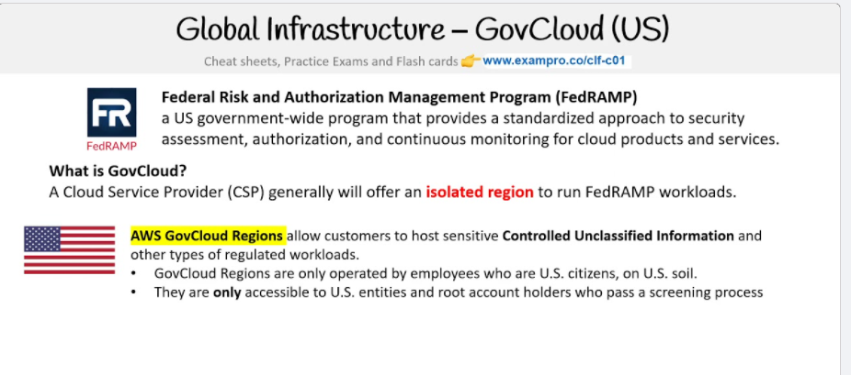

[**AWS GovCloud**](https://docs.aws.amazon.com/govcloud-us/latest/UserGuide/whatis.html) Regions allow customers to host sensitive **Controlled Unclassified Information** and other types of regulated workloads.

* GovCloud Regions are only operate by employees who are U.S. citizens on U.S. soil.
* Only accessible to U.S. entities and account state holders who pass a screening process.
* Customers can architect secure cloud solutions that comply with:
  + Fed**RAMP** High baseline
  + DOJ's Criminal Justice Information Systems (CJIS) Security Policy
  + U.S. International Traffic in Arms Regulations (TAR)
  + Export Administration Regulations (EAR)
  + Department of Defense (DoD) Cloud Computing Security Requirements Guide

**GovCloud Regions are currently only in the US.**

* You can view their regions on [AWS Map of Regions and Edge Networks.](https://aws.amazon.com/about-aws/global-infrastructure/regions_az/?p=ngi&loc=2)
* You can view more about GovCloud on the official [AWS GovCloud page.](https://aws.amazon.com/govcloud-us/?whats-new-ess.sort-by=item.additionalFields.postDateTime&whats-new-ess.sort-order=desc)

# **Global Infrastructure – AWS in China**

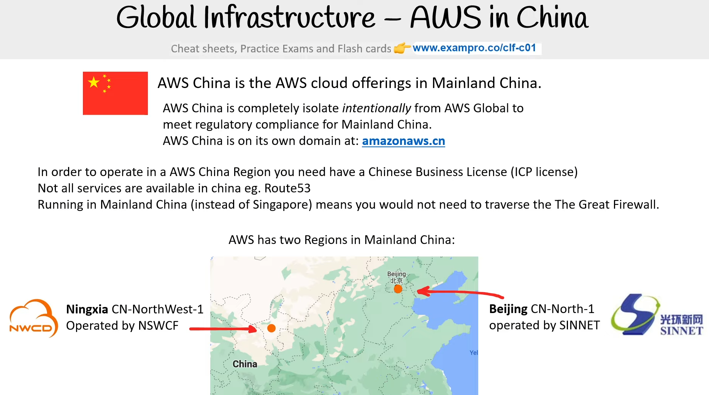

AWS China is the AWS cloud offerings in Mainland China. AWS China is completely isolate intentionally from AWS Global to meet regulatory compliance for Mainland China. AWS China is on its own domain at: amazonaws.cn. In order to operate in a AWS China Region you need have a Chinese Business License (ICP license) Not all services are available in china eg. Route53 Running in Mainland China (instead of Singapore) means you would not need to traverse the The Great Firewall.

AWS has two Regions in Mainland China: **Ningxia** CN-NorthWest-1 Operated by NSWCF **Beijing** CN-North-1 operated by SINNET

**Reference** | [My experience with AWS China](https://www.teracloud.io/single-post/2019/10/24/My-experience-with-AWS-China) | [AWS China](https://www.amazonaws.cn/en/)

# **Global Infrastructure – Sustainability**

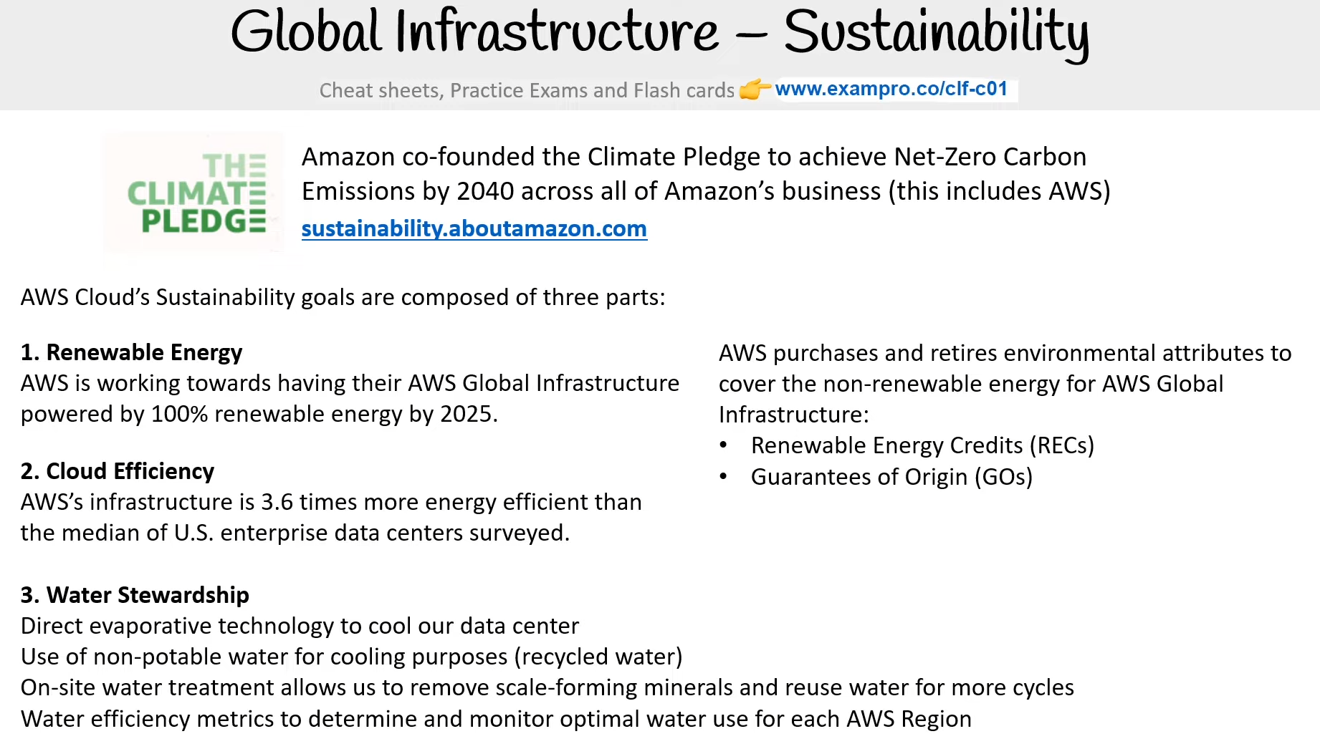

Amazon co-founded the Climate Pledge to achieve Net-Zero Carbon Emissions by 2040 across all of Amazon’s business (this includes AWS) - sustainability.aboutamazon.com. AWS Cloud’s Sustainability goals are composed of three parts:

**1.** Renewable Energy - AWS is working towards having its AWS Global Infrastructure powered by 100% renewable energy by 2025. AWS purchases and retires environmental attributes to cover the non-renewable energy for AWS Global Infrastructure:

* Renewable Energy Credits (RECs)
* Guarantees of Origin (GOs)

**2. Cloud Efficiency** - AWS’s infrastructure is 3.6 times more energy-efficient than the median of U.S. enterprise data centers surveyed.

**3. Water Stewardship** - Direct evaporative technology to cool our data center Use of non-potable water for cooling purposes (recycled water). On-site water treatment allows us to remove scale-forming minerals and reuse water for more cycles Water efficiency metrics to determine and monitor optimal water use for each AWS Region

# **Global Infrastructure – AWS Ground Station**

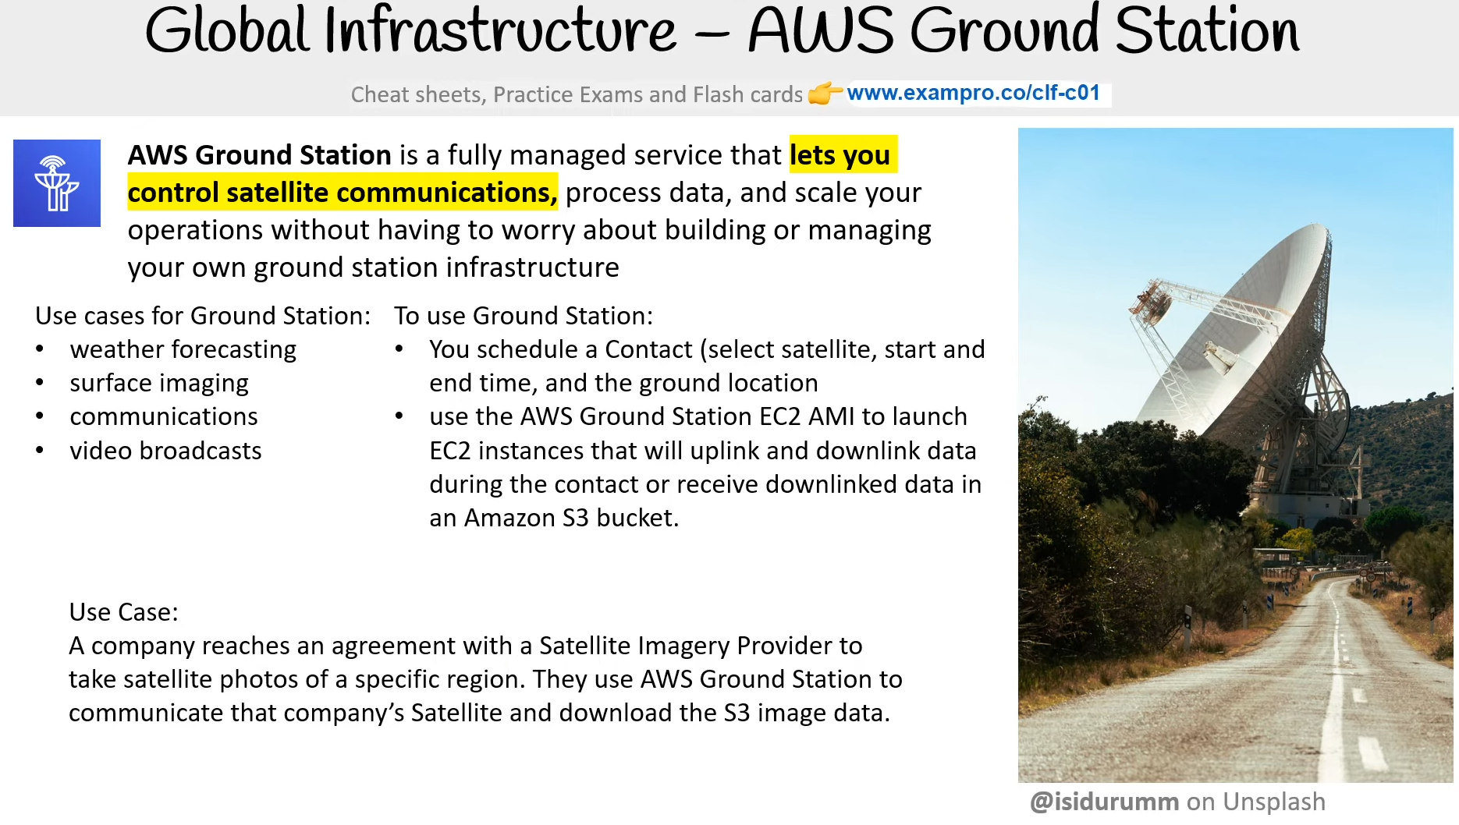

**AWS Ground Station** is a fully managed service that **lets you control satellite communications**, process data, and scale your operations without having to worry about building or managing your own ground station infrastructure

**Use cases for Ground Station**:

* weather forecasting
* surface imaging
* communications
* video broadcasts

**To use Ground Station:**

* You schedule a Contact (select satellite, start and end time, and the ground location
* use the AWS Ground Station EC2 AMI to launch EC2 instances that will uplink and downlink data during the contact or receive downlinked data in an Amazon S3 bucket.

**Use Case**: - A company reaches an agreement with a Satellite Imagery Provider to take satellite photos of a specific region. They use AWS Ground Station to communicate that company’s Satellite and download the S3 image data.

**Reference** [AWS Ground Station](https://aws.amazon.com/ground-station/)

# **Global Infrastructure – AWS Outposts**

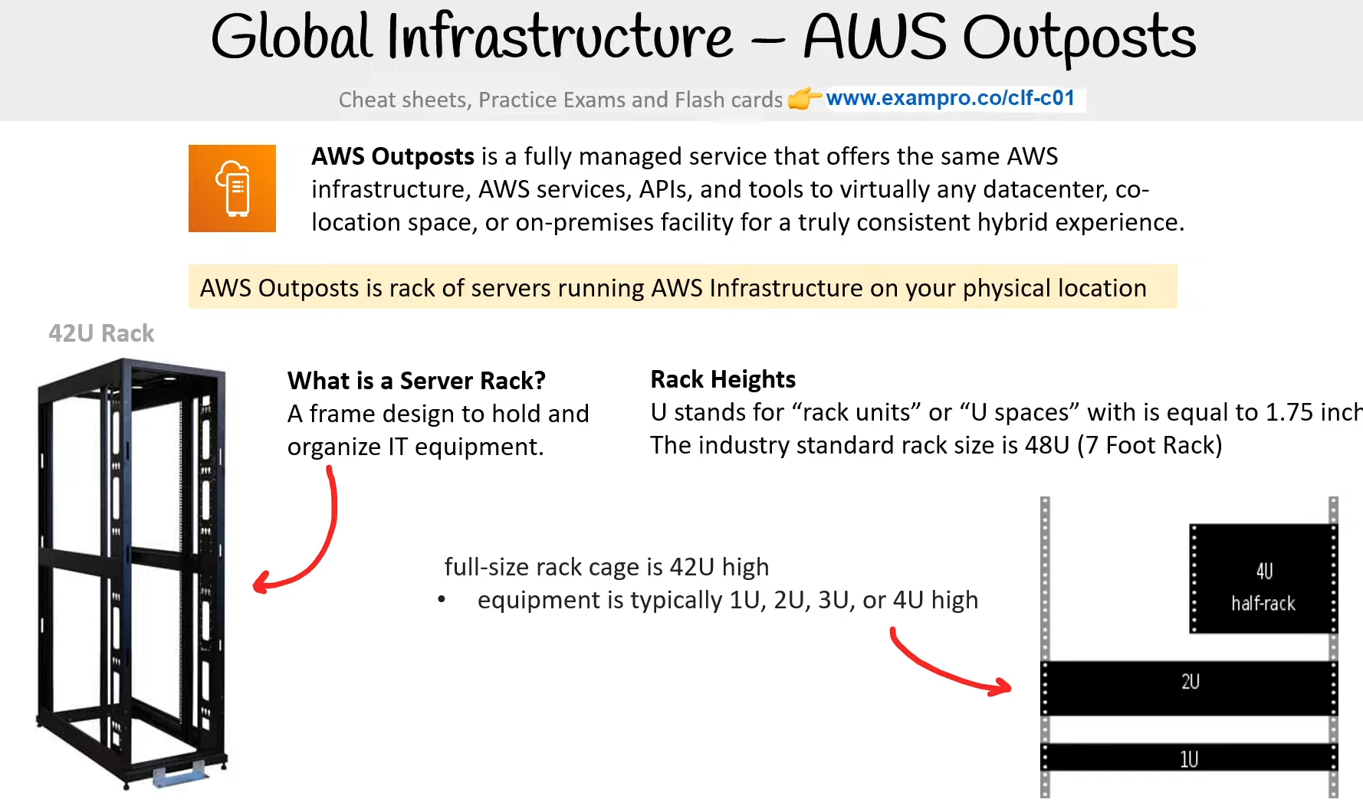

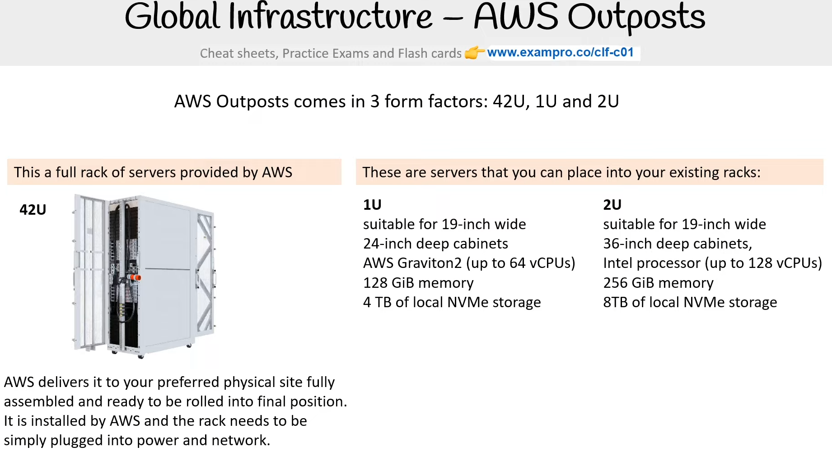

**AWS Outposts** is a fully managed service that offers the same AWS infrastructure, AWS services, APIs, and tools to virtually any datacenter, co-location space, or on-premises facility for a truly consistent hybrid experience. AWS Outposts is a rack of servers running AWS Infrastructure on your physical location

**What is a Server Rack?** - A frame design to hold and organize IT equipment.

**Rack Heights** - U stands for “rack units” or “U spaces” with is equal to 1.75 inches. The industry standard rack size is 48U (7 Foot Rack)  full-size rack cage is 42U high

* equipment is typically 1U, 2U, 3U, or 4U high

**Reference** - [AWS Outposts](https://aws.amazon.com/outposts)

# **Cloud Architecture Terminologies**

**What is a Solutions Architect?** - A role in a technical organization that architects a technical solution using multiple systems via researching, documentation, experimentation.

**What is a Cloud Architect**? -A solutions architect that is focused solely on architecting technical solutions using cloud services. A cloud architect needs to understand the following terms and factor them into their design architecture based on the business requirements.

* **Availability** - Your ability to ensure service remains available e.g. **Highly Available (HA)**
* **Scalability** - Your ability to grow rapidly or unimpeded
* **Elasticity** - Your ability to shrink and grow to meet the demand
* **Fault Tolerance** - Your ability to prevent a failure
* **Disaster Recovery** - Your ability to recover from a failure e.g. **High Durable (DR)**

**A Solutions Architect needs to always consider the following business factors:**

* (Security) How secure is this solution?
* (Cost) How much is this going to cost?

# **High Availability**

What is High Availability (HA)?

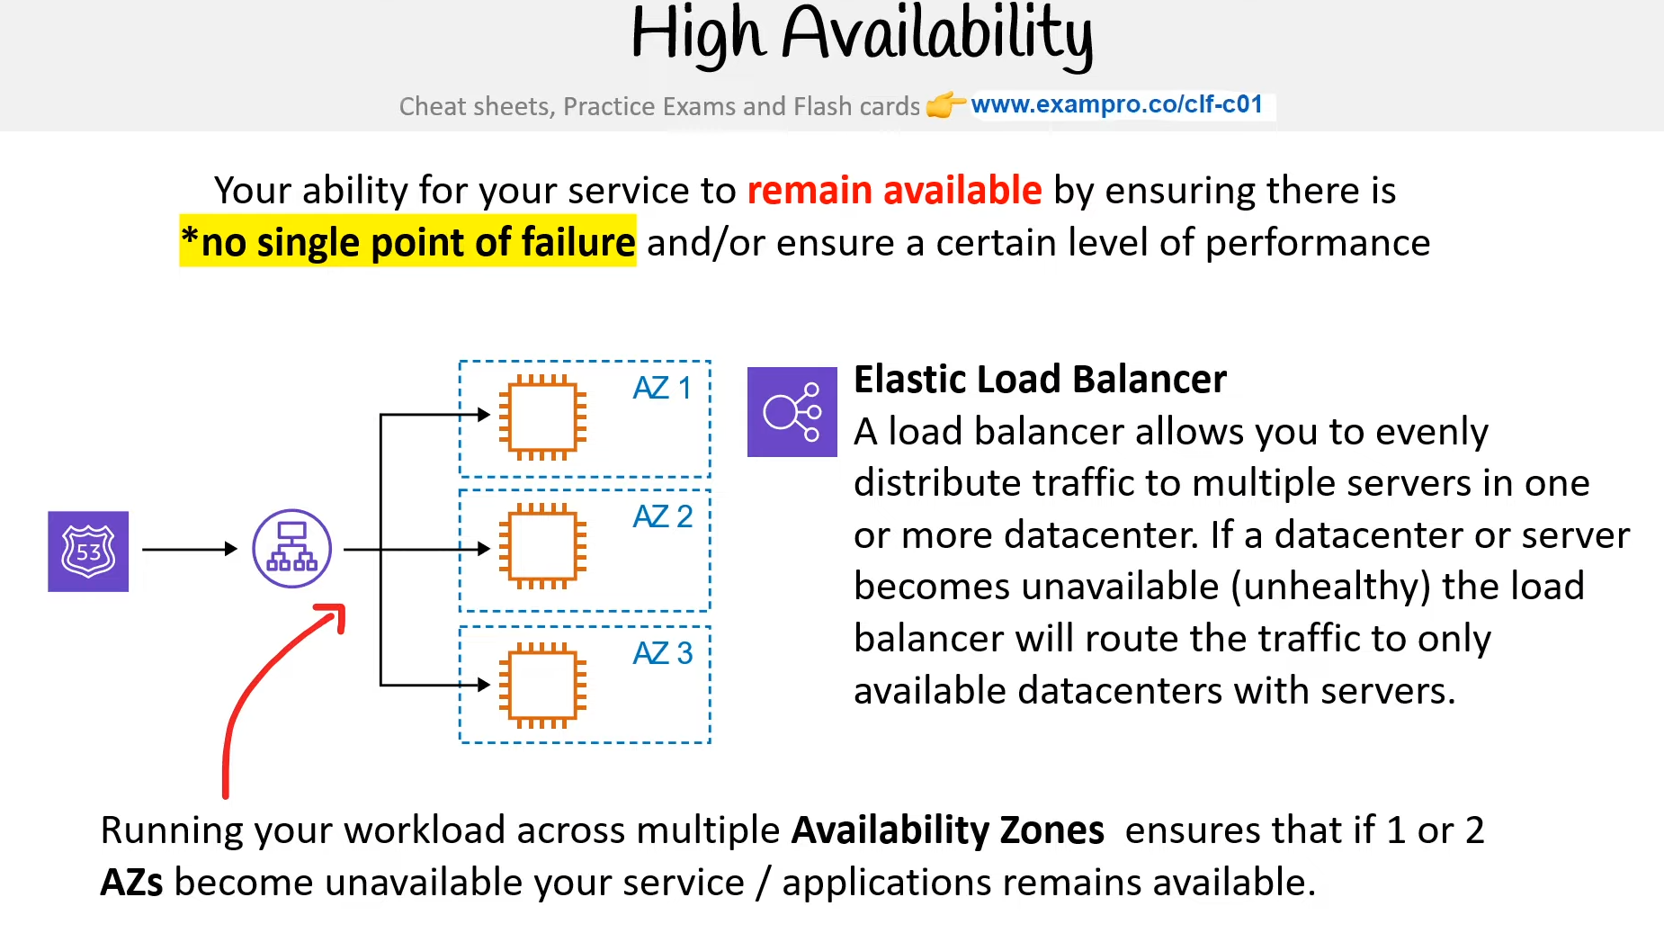

Your ability for your service to remain available by ensuring there is no single point of failure and/or ensure a certain level of performance

How can you achieve High Availability? - Running your workload across multiple **Availability Zones** ensures that if 1 or 2 AZs become unavailable your service/applications remain available.

How can High Availability be implemented on AWS? - Using **Elastic Load Balancer** would assist in implementing High Availability

**Elastic Load Balancer** ​ - A load balancer allows you to evenly distribute traffic to multiple servers in one or more data center. If a data center or server becomes unavailable (unhealthy) the load balancer will route the traffic to only available data centers with servers.

# **High Scalability**

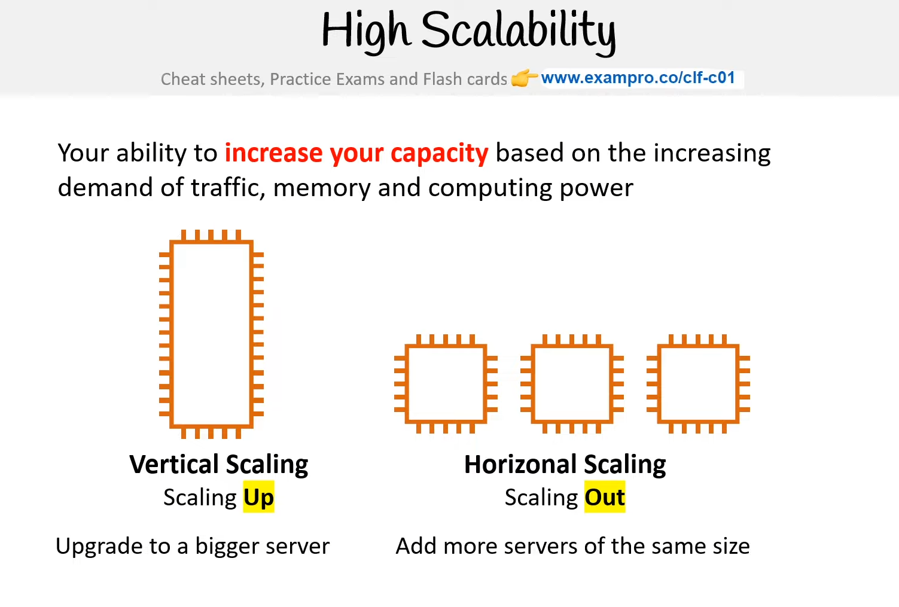

What is High Scalability? - Your ability to increase your capacity based on the increasing demand of traffic, memory and computing power

How is High Scalability defined?

* Vertical Scaling is known as **Scaling Up** (When Upgrade to a bigger server)
* Horizontal Scaling is known as **Scaling Out** (When Add more servers of the same size)

# **High Elasticity**

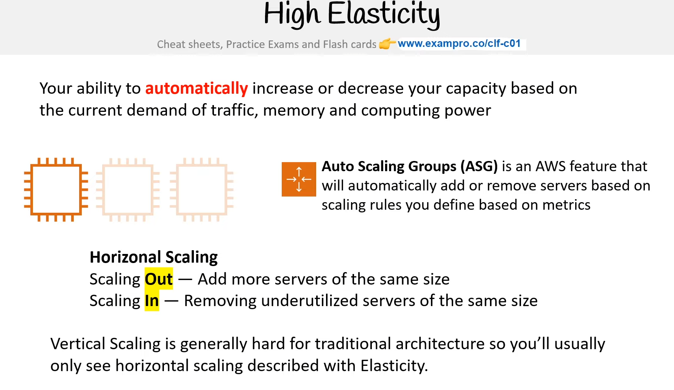

What is High Elasticity? Your ability to automatically increase or decrease your capacity based on the current demand of traffic, memory and computing power

How is Elasticity achieved? Elasticity relies on **Horizontal Scaling**. **Vertical Scaling** is generally hard for traditional architecture so you’ll usually only see horizontal scaling described with **Elasticity**.

**Scaling Out** — Add more servers of the same size

**Scaling In** — Removing more servers of the same size

How can Elasticity be implemented in AWS? - [**Auto Scaling Groups (ASG)**](https://docs.aws.amazon.com/autoscaling/ec2/userguide/AutoScalingGroup.html) - are an AWS feature that will automatically add or remove servers based on scaling rules you define.

# **Fault Tolerance**

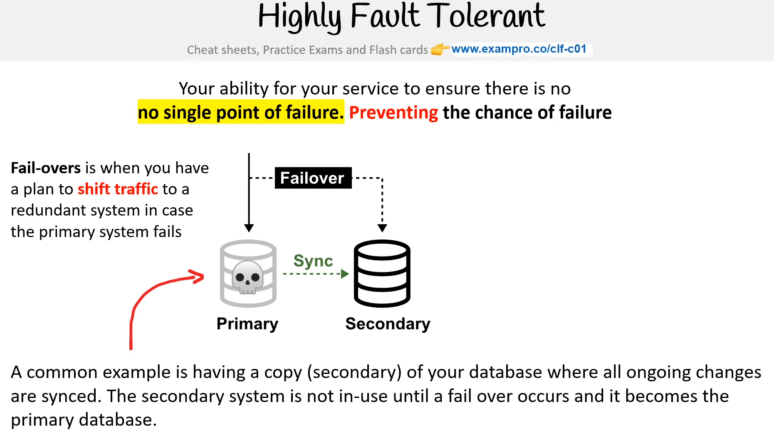

What is Highly Fault Tolerant? - The ability for your service to ensure there is no single point of failure. Preventing the chance of failure

What is a Fail-over? - Fail-overs are when you have a plan to shift traffic to a redundant system in case the primary system fails

How can Fault Tolerance be achieved? A common example is having a copy (secondary) of your database where all ongoing changes are synced. The Secondary is not in-use until a failover occurs and it becomes the primary database.

How can Fault Tolerance be implemented using AWS? - [**RDS Multi-AZ**](https://aws.amazon.com/rds/features/multi-az/) - is when you run a duplicate standby database in another Availability Zone in case your primary database fails.

# **High Durability**

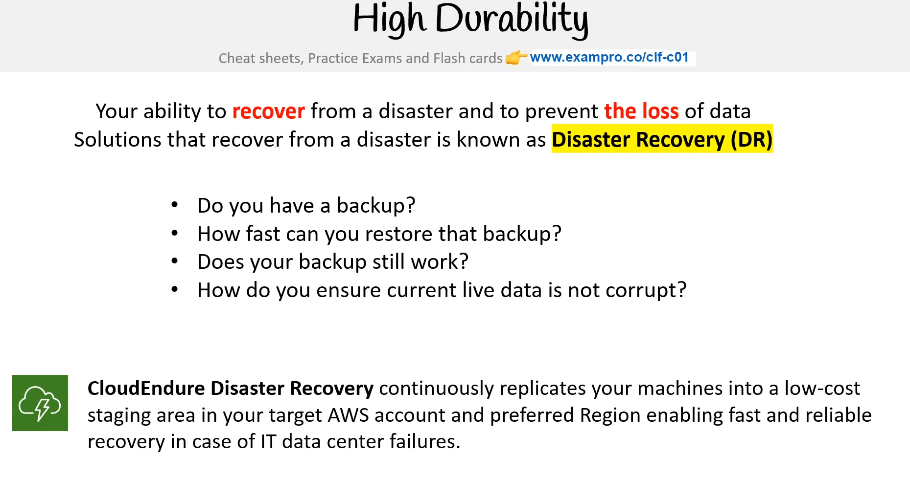

Your ability to recover from a disaster and to prevent the loss of data solutions that recover from a disaster is known as **Disaster Recovery** (DR). **Questions you should be asking about your Disaster Recovery procedures:**

* Do you have a backup?
* How fast can you restore that backup?
* Does your backup still work?
* How do you ensure current live data is not corrupt?

[CloudEndure Disaster Recovery](https://aws.amazon.com/cloudendure-disaster-recovery/) continuously replicates your machines into a low-cost staging area in your target AWS account and preferred Region enabling fast and reliable recovery in case of IT data center failures.

# **Business Continuity Plan**

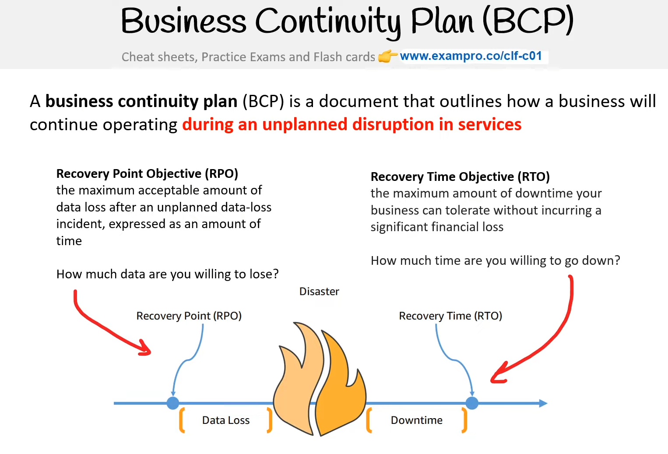

A **Business Continuity Plan (BCP)** is a document that outlines how a business will continue operating **during an unplanned disruption in services**

**Recovery Point Objective (RPO)** - The maximum acceptable amount of data loss after an unplanned data-loss incident, expressed as an amount of time. How much data are you willing to lose?

**Recovery Time Objective (RTO)** - The maximum amount of downtime your business can tolerate without incurring a significant financial loss. How much time are you willing to go down?

# **Disaster Recovery Options**

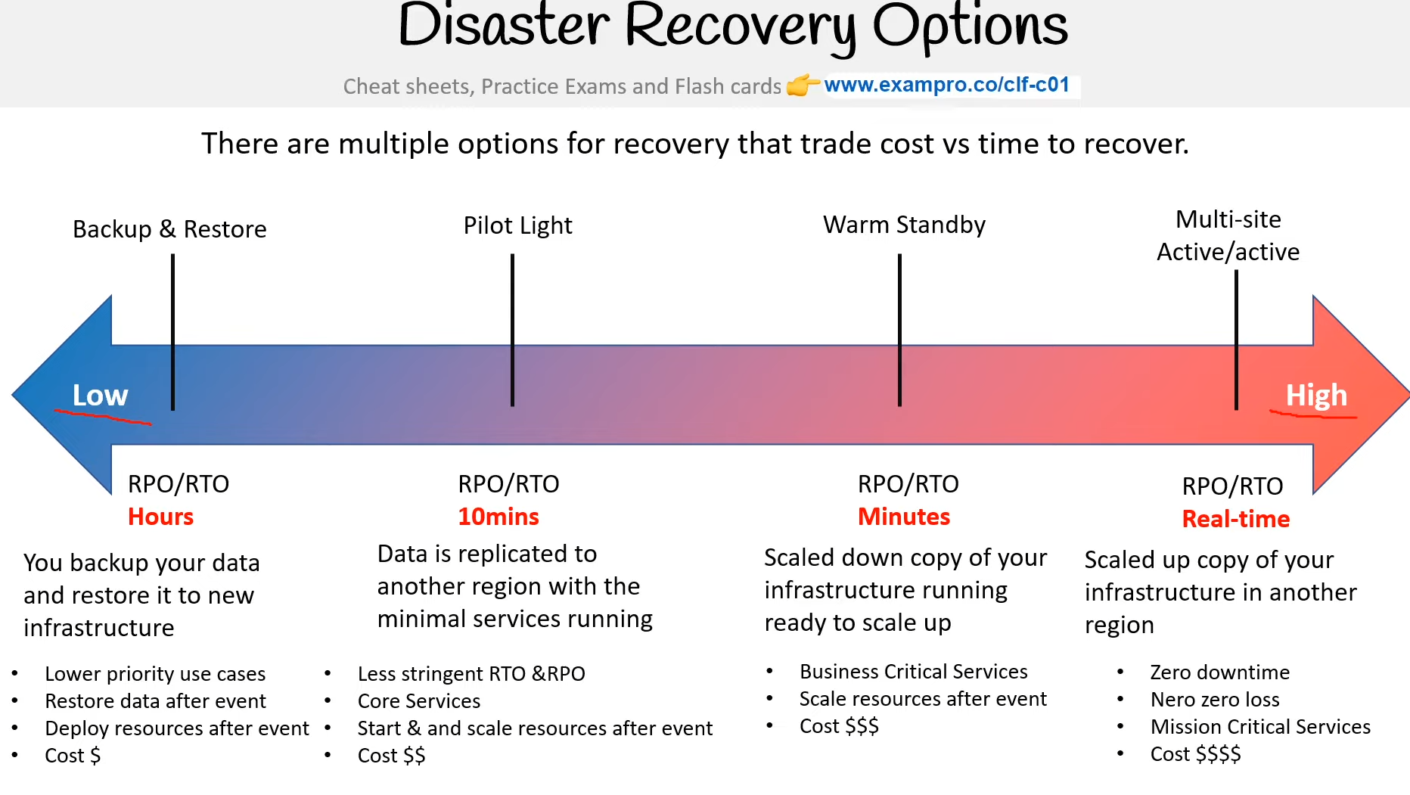

There are multiple options for recovery that trade cost vs time to recover.

**Backup & Restore** - RPO/RTO (Hours). You back up your data and restore it to new infrastructure

* Lower priority use cases
* Restore data after the event
* Deploy resources after the event
* Cost $

**Pilot Light** RPO/RTO (10 mins). Data is replicated to another region with minimal services running

* Less stringent RTO & RPO
* Core Services
* Start & scale resources after the event
* Cost $$

**Warm Standby** - RPO/RTO (Minutes) - Scaled-down copy of your infrastructure running ready to scale up

* Business Critical Services
* Scale resources after the event
* Cost $$$

**Multi-site Active/active** - RPO/RTO (Real-time) - Scaled up copy of your infrastructure in another region

* Zero downtime
* Near-zero loss
* Cost $$$$

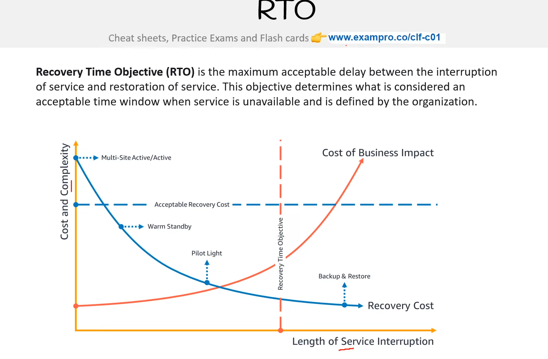

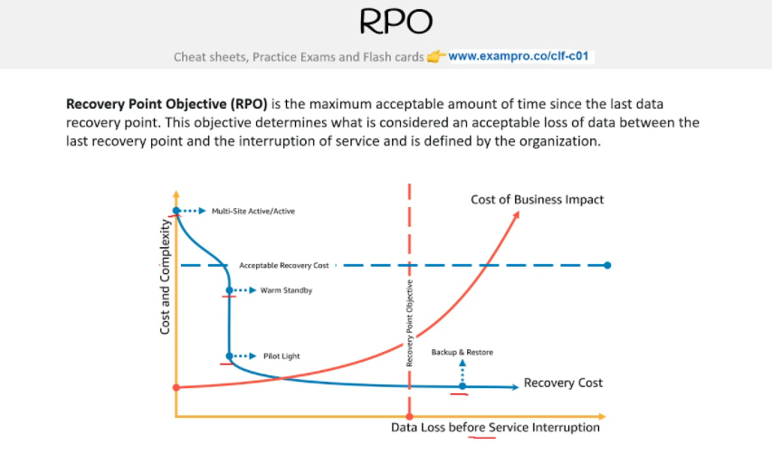

# **AWS API**

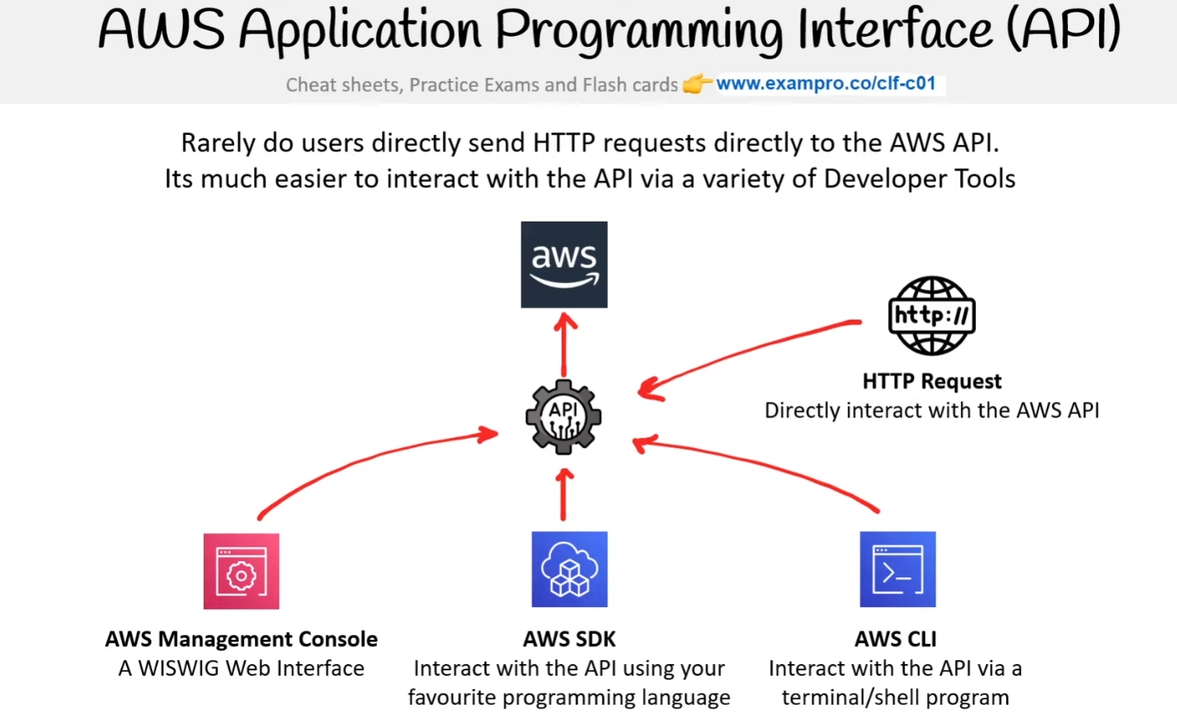

**What is an Application Programming Interface (API)?** - An API is software that allows two applications/services to talk to each other. The most common type of API is via HTTP/S requests.

**AWS API** is an HTTP API and you can interact by sending HTTPS requests, using an application interacting with APIs like Postman. Each AWS Service has its own Service Endpoint which you send requests

GET / HTTP/1.1  
host: monitoring.us-east-1.amazonaws.com  
x-amz-target: GraniteServiceVersion20100801.GetMetricData  
x-amz-date: 20180112T092034Z  
Authorization: AWS4-HMAC-SHA256 Credential=REDACTEDREDACTED/20180411/…..  
Content-Type: application/json  
Accept: application/json  
Content-Encoding: amz-1.0  
Content-Length: 45  
Connection: keep-alive

To authorize use you will need generate a signed request You make a separate request with your AWS credentials and get back a token. You need to also provide an ACTION and accompanying parameters as the payload Rarely do users directly send HTTP requests directly to the AWS API. Its much easier to interact with the API via a variety of Developer Tools

**HTTP Request** - Directly interact with the AWS API

**AWS Management Console** - A WISWIG Web Interface

**AWS SDK** Interact with the API using your favourite programming language

**AWS CLI** Interact with the API via a terminal/shell program

**Reference** - <https://en.wikipedia.org/wiki/API>

<https://docs.aws.amazon.com/AmazonCloudWatch/latest/APIReference/making-api-requests.html>

<https://docs.aws.amazon.com/IAM/latest/UserGuide/programming.html>

<https://docs.aws.amazon.com/general/latest/gr/aws-apis.html>

# **AWS Management Console**

The AWS Management Console is a **web-based** unified console. **Build, manage, and monitor everything** from simple web apps to complex cloud deployments. Point and Click to manually launch and configure AWS resources with limited programming knowledge. This is known as “ClickOps” since you can perform all your system operations via clicks. The AWS Management Console is located at: console.aws.amazon.com

# **AWS Management Console - Service Console**

AWS Service each have their own customized console. You can access these consoles by **searching** the service name Some AWS Services Console will act as an umbrella console containing many AWS Services: e.g.

* VPC Console
* EC2 Console
* Systems Manager Console
* SageMaker Console
* CloudWatch Console

# **AWS Account ID**

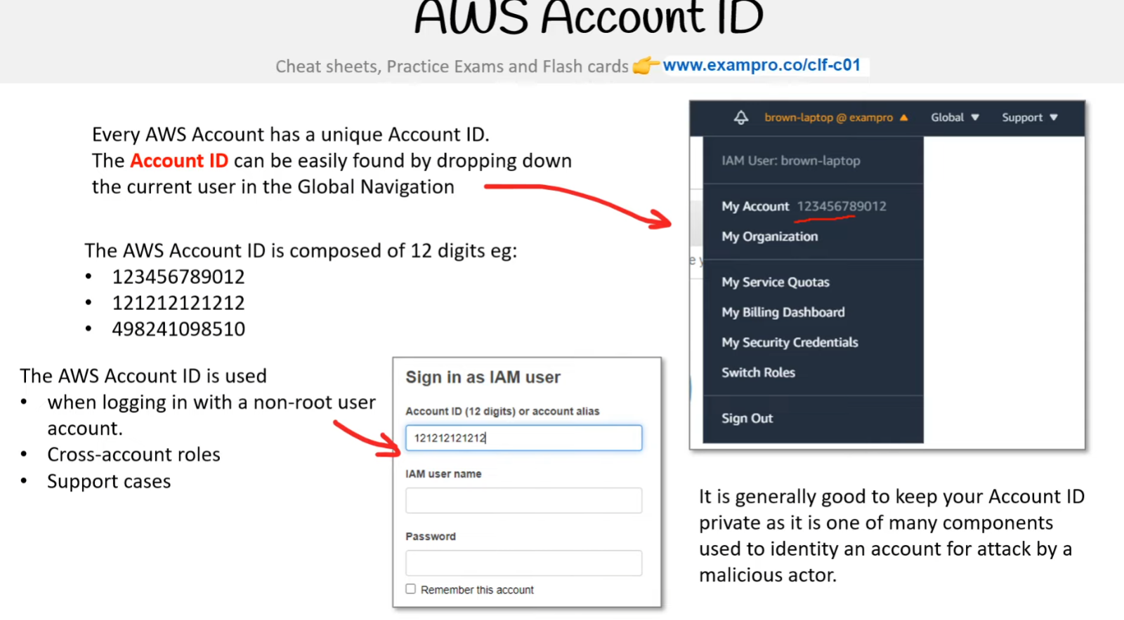

Every AWS account has a unique Account ID. The **Account ID** can be easily found by dropping down the current user in the Global Navigation. **The AWS Account ID is composed of 12 digits eg:**

* 123456789012
* 121212121212
* 498241098510

**The AWS Account ID is used**

* when logging in with a non-root user account
* Cross-account roles
* Support cases

It is generally good to keep your Account ID private as it is one of many components used to identify an account for the attack by a malicious actor.

# **AWS Tools for PowerShell**

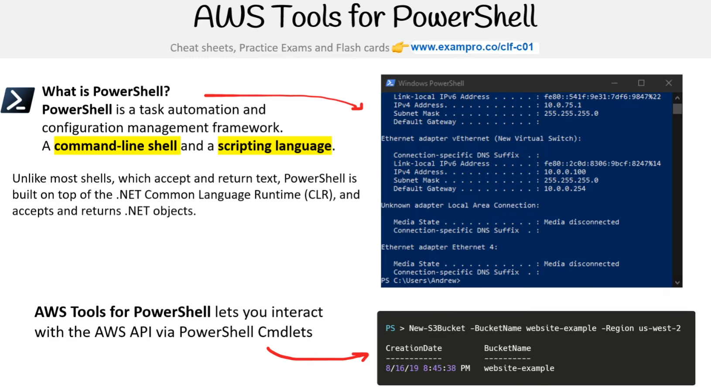

**What is PowerShell?** - **PowerShell** is a task automation and configuration management framework.

A **command-line shell** and a **scripting language** - Unlike most shells, which accept and return text, PowerShell is built on top of the .NET Common Language Runtime (CLR), and accepts and returns .NET objects. **AWS Tools for PowerShell** lets you interact with the AWS API via PowerShell Cmdlets. Cmdlet is a special type of command in PowerShell in the form of capitalized verb-and-noun e.g. New-S3Bucket

# **Amazon Resource Name (ARNs)**

**Amazon Resource Names (ARNs)** uniquely identify AWS resources. ARNs are required to specify a resource unambiguously across all of AWS The ARN has the following **format variations**

arn:**partition:service:region:account-id:resource-id**  
arn:**partition:service:region:account-id:resource-type/resource-id**  
arn:**partition:service:region:account-id:resource-type:resource-id**

**Partition**

* aws - AWS Regions
* aws-cn - China Regions
* aws-us-gov - AWS GovCloud (US) Regions

**Service – Identifies the service**

* ec2
* s3
* iam

**Region – which AWS resource**

* us-east-1
* ca-central-1

**Account ID**

* 121212121212
* 123456789012

***Resource ID -*** Could be a number name or path:

* user/Bob
* instance/i-1234567890abcdef0

In the AWS Management Console its common to be able to copy the ARN to your clipboard

arn:aws:s3:::my-bucket

**Paths in ARNs** - Resource ARNs can include a path Paths can include a wildcard character, namely an asterisk (*)

**IAM Policy ARN Path** - arn:aws:iam::123456789012:user/Development/product_1234/*

**S3 ARN Path** - arn:aws:s3:::mycorporatebucket/Development/*

**Reference** - [Amazon Resource Names (ARNs)](https://docs.aws.amazon.com/general/latest/gr/aws-arns-and-namespaces.html)

# **AWS Command Line Interface (CLI)**

**What is a CLI?** - A Command Line Interface (CLI) **processes commands to a computer program in the form of lines of text**. Operating systems implement a command-line interface in a shell.

**What is a Terminal?** - A terminal is a text only interface (input/output environment)

**What is a Console?** - A console is a physical computer to physically input information into a terminal

**What is a Shell?** - A shell is the command line program that users interact with to input commands. Popular shell programs:

* **Bash**
* Zsh
* PowerShell

People commonly (erroneously) use Terminal, Shell or Console to generally describe interacting with a Shell. AWS Command Line Interface (CLI) allows users to programmatically interact with the AWS API via entering **single or multi-line commands** into a shell or terminal

The AWS CLI is a Python executable program.

* Python is required to install AWS CLI

The AWS CLI can be installed on Windows, Mac or Linux/Unix. The name of the CLI program is **aws**

**Reference** - [What is the difference between Terminal, Console, Shell, and Command Line?](https://askubuntu.com/questions/506510/what-is-the-difference-between-terminal-console-shell-and-command-line)

# **AWS Software Development Kit (SDK)**

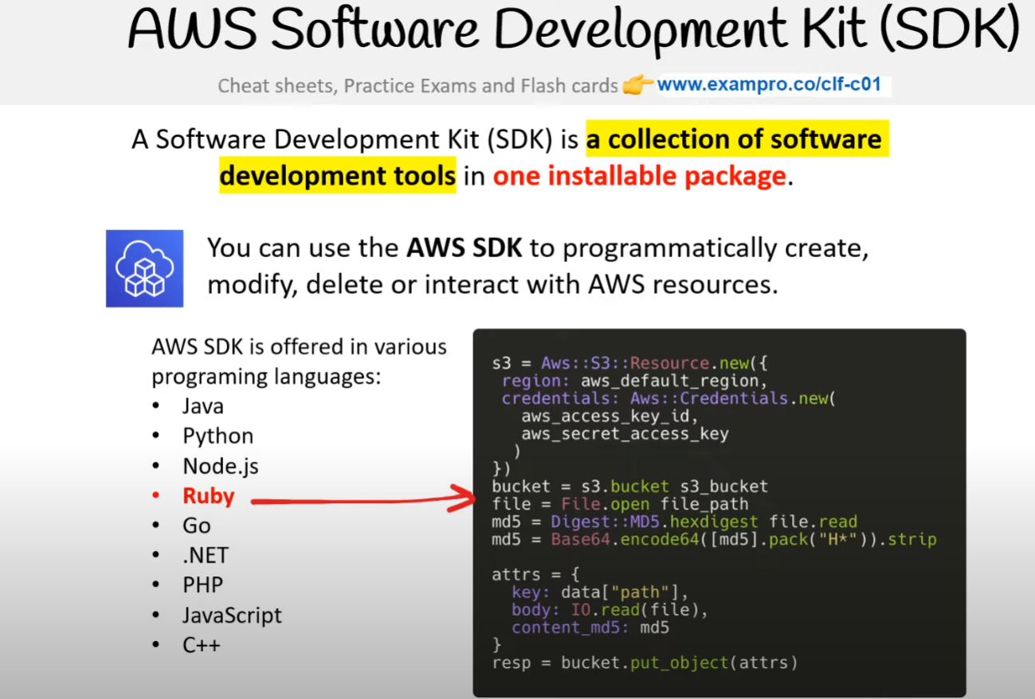

A Software Development Kit (SDK) is a **collection of software development tools** in **one installable package**. You can use the **AWS SDK** to programmatically create, modify, delete or interact with AWS resources. AWS SDK is offered in various programming languages:

* Java
* Python
* Node.js
* Ruby
* Go
* .NET
* PHP
* JavaScript
* C++

**Reference** - [Software Development Kit (SDK)](https://en.wikipedia.org/wiki/Software_development_kit)

# **AWS CloudShell**

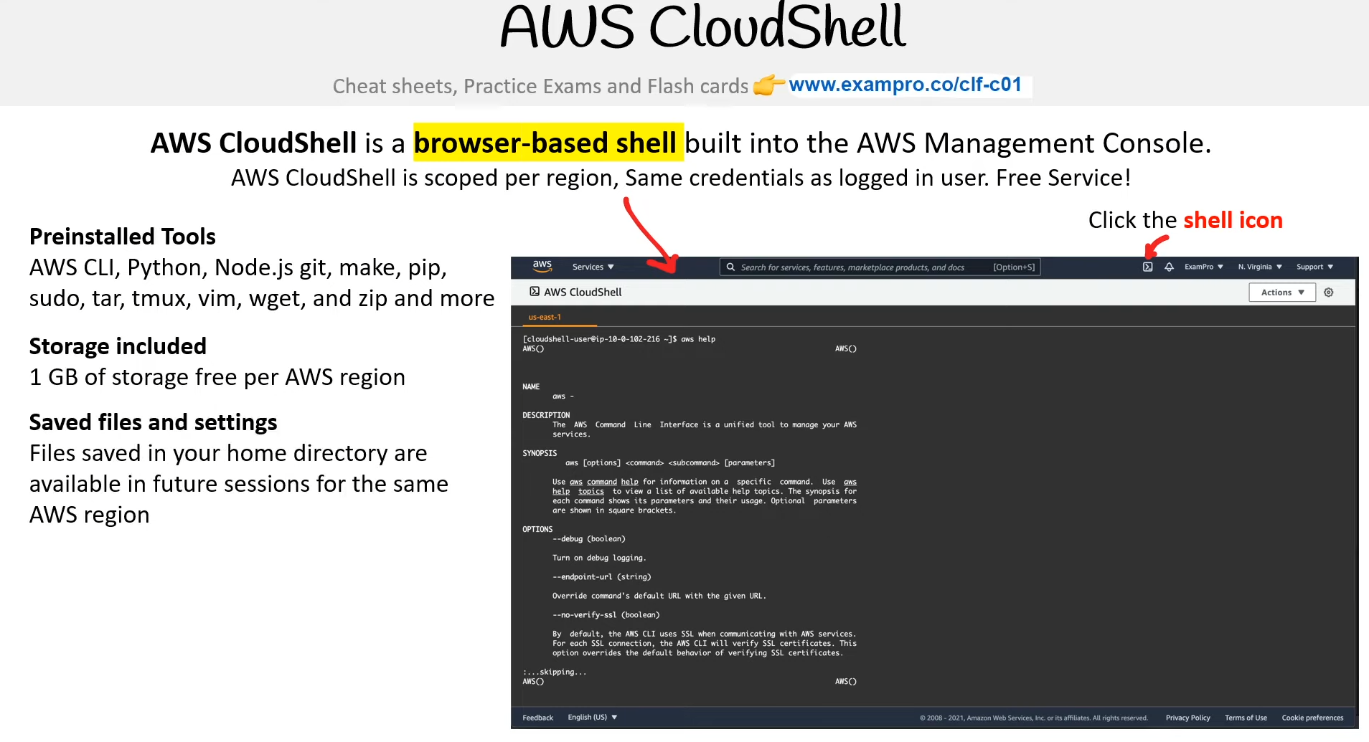

**AWS CloudShell** is a **browser-based shell** built into the AWS Management Console. AWS CloudShell is scoped per region, Same credentials as logged in user. Free Service!

**Preinstalled Tools** - AWS CLI, Python, Node.js git, make, pip, sudo, tar, tmux, vim, wget, and zip and more

**Storage included** -1 GB of storage free per AWS region

**Saved files and settings** -Files saved in your home directory are available in future sessions for the same AWS region

**Shell Environments** - Seamlessly switch between

* Bash
* PowerShell
* Zsh

**Reference** - [What is AWS CloudShell?](https://docs.aws.amazon.com/cloudshell/latest/userguide/welcome.html)

# **Infrastructure as Code (IaC)**

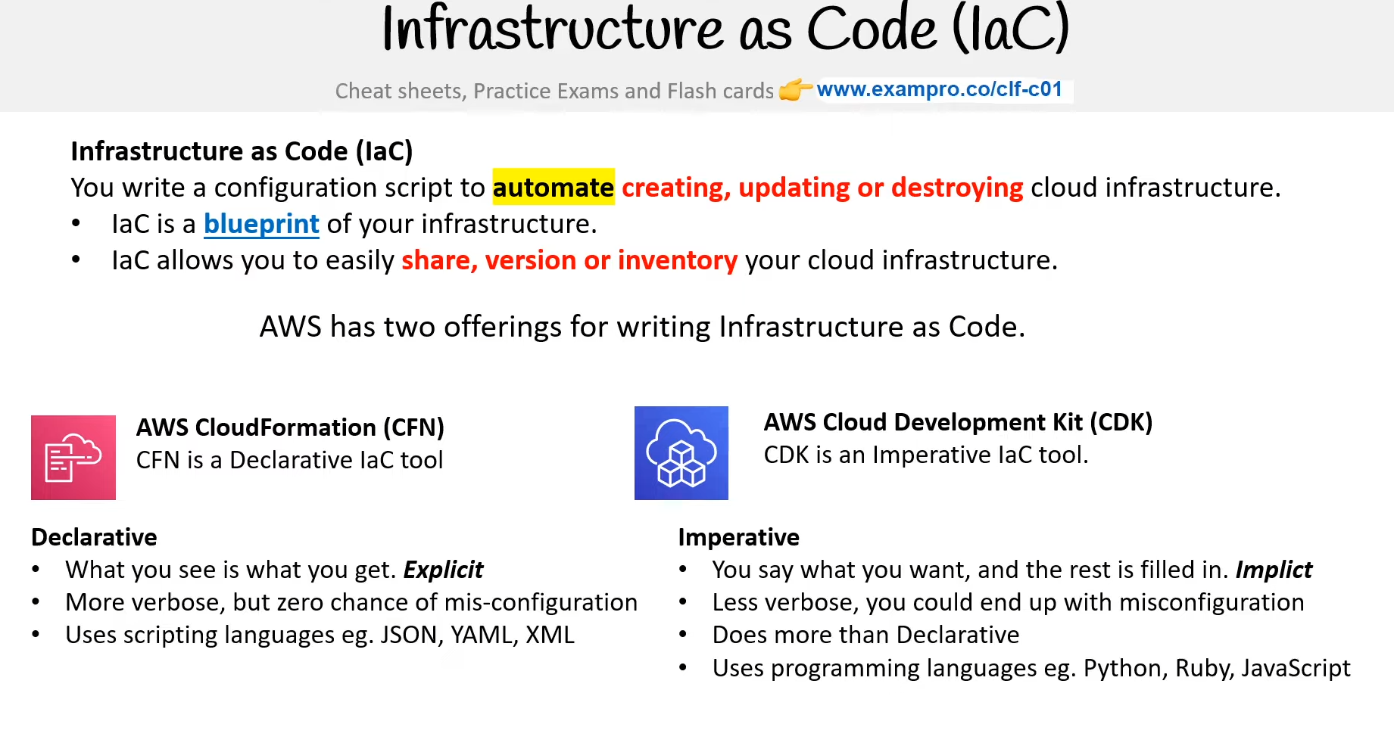

You write a configuration script to automate creating, updating, or destroying cloud infrastructure.

* IaC is a blueprint of your infrastructure.
* IaC allows you to easily share, version, or inventory your cloud infrastructure.

AWS has two offerings for writing Infrastructure as Code. **AWS CloudFormation (CFN)** - CFN is a Declarative IaC tool. **AWS Cloud Development Kit (CDK)** - CDK is an Imperative IaC tool.

**Declarative**

* You say what you want, and the rest is filled in. Implicit
* More verbose, but zero chance of misconfiguration
* Uses scripting languages eg. JSON, YAML, XML

**Imperative**

* What you see is what you get. Explicit
* Less verbose, you could end up with misconfiguration
* Does more than Declarative
* Uses programming languages eg. Python, Ruby, JavaScript

**Reference** - [Infrastructure as code](https://en.wikipedia.org/wiki/Infrastructure_as_code) | [Declarative programming](https://en.wikipedia.org/wiki/Declarative_programming) | [Imperative programming](https://en.wikipedia.org/wiki/Imperative_programming)

# **CloudFormation**

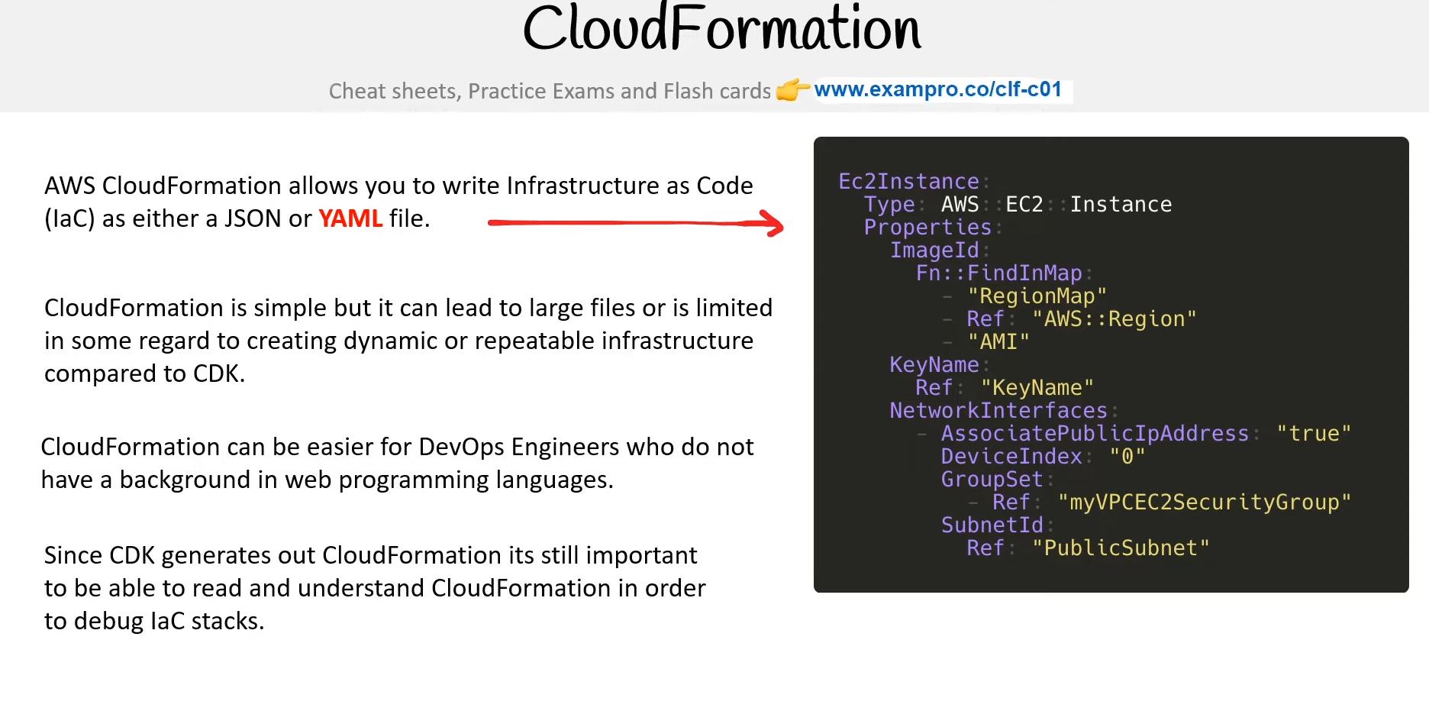

AWS CloudFormation allows you to write Infrastructure as Code (IaC) as either a JSON or **YAML** file. CloudFormation is simple but it can lead to large files or is limited in some regard to creating dynamic or repeatable infrastructure compared to CDK. CloudFormation can be easier for DevOps Engineers who do not have a background in web programming languages. Since CDK generates out CloudFormation it's still important to be able to read and understand CloudFormation in order to debug IaC stacks.

# **Cloud Development Kit**

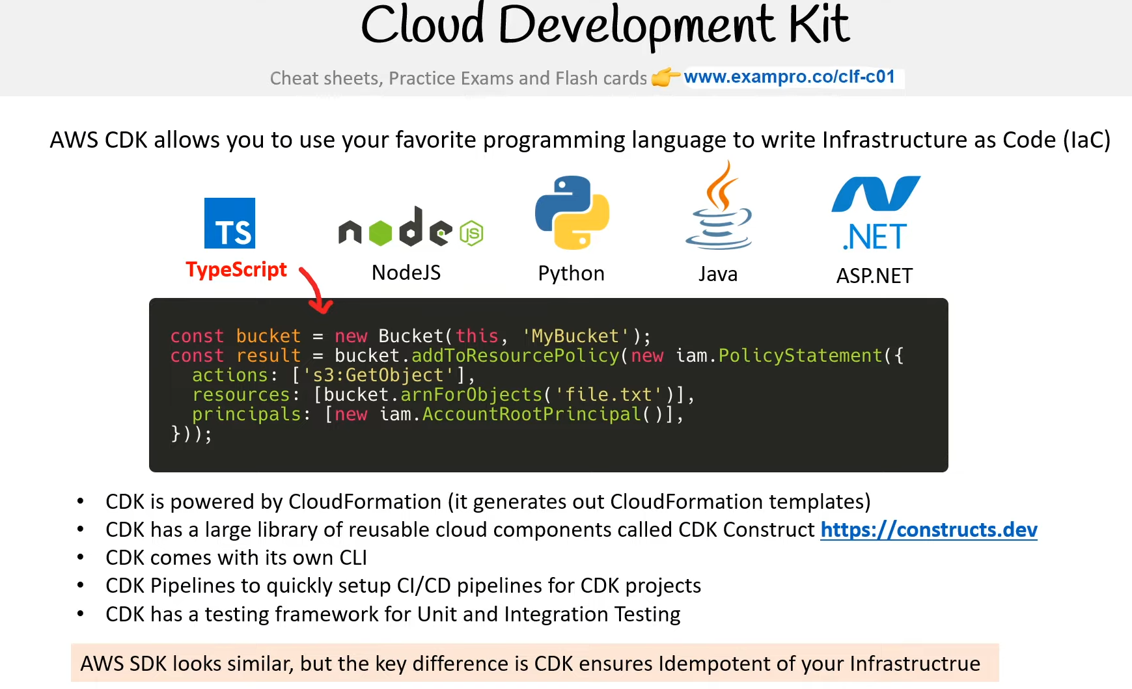

AWS CDK allows you to use your favorite programming language to write Infrastructure as Code (IaC). TypeScript NodeJS Python Java ASP.NET

* CDK is powered by CloudFormation (it generates out CloudFormation templates)
* CDK has a large library of reusable cloud components called CDK Construct [https://constructs.dev](https://constructs.dev/)
* CDK comes with its own CLI
* CDK Pipelines to quickly set up CI/CD pipelines for CDK projects
* CDK has a testing framework for Unit and Integration Testing

AWS SDK looks similar, but the key difference is CDK ensures Idempotent of your Infrastructure

Reference - [Construct Hub](https://constructs.dev/) | [CDK Pipelines: Continuous delivery for AWS CDK applications](https://aws.amazon.com/blogs/developer/cdk-pipelines-continuous-delivery-for-aws-cdk-applications/)

# **AWS Toolkit for VSCode**

AWS Toolkit is an open-source plugin for VSCode to create, debug, deploy AWS resources

**1. AWS Explorer** - Explore a wide range of AWS resources to your linked AWS Account

**2. AWS CDK Explorer** - Allows you to explore your stacks defined by CDK.

**3. Amazon Elastic Container Service** - Provides IntelliSense for ECS task-definitions files

**4. Serverless Applications** - Create, debug and deploy serverless applications via SAM and CFN

**Reference** - [Working with AWS Services](https://docs.aws.amazon.com/toolkit-for-vscode/latest/userguide/working-with-aws.html)

# **Access Keys**

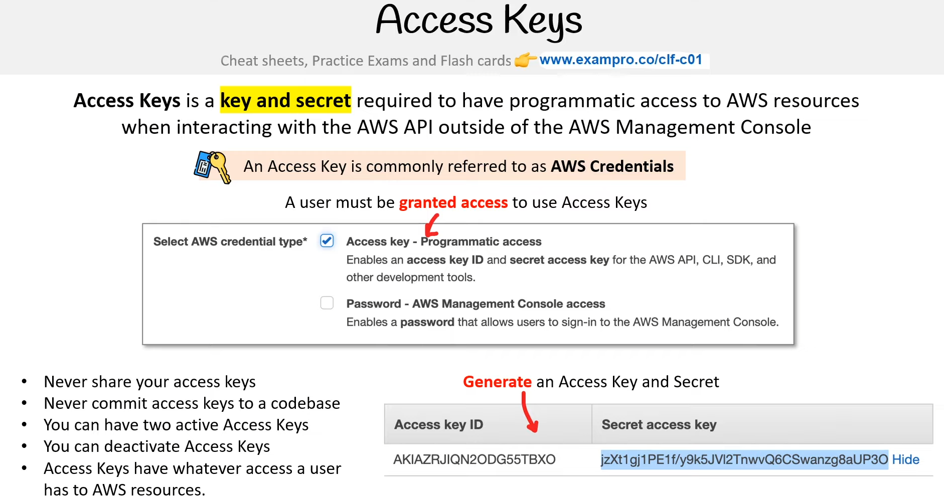

**Access Keys** is a **key and secret** required to have programmatic access to AWS resources when interacting with the AWS API outside of the AWS Management Console. An Access Key is commonly referred to as **AWS Credentials**. A user must be **granted access** to use Access Keys

* Never share your access keys
* Never commit access keys to a codebase
* You can have two active Access Keys
* You can deactivate Access Keys
* Access Keys have whatever access a user has to AWS resources.

Access Keys are to be store in ~/.aws/credentials and follow a TOML file format **Default** will be the access key used when no profile is specified. You can store multiple access keys by giving the **profile** names. You can use the **aws configure** CLI command to populate the credential file. The AWS SDK will automatically read from these environment variables. This is the safe way of using an Access Key within your code.

Reference - [Configuration and credential file settings](https://docs.aws.amazon.com/cli/latest/userguide/cli-configure-files.html) | [Environment variables to configure the AWS CLI](https://docs.aws.amazon.com/cli/latest/userguide/cli-configure-envvars.html)

# **AWS Documentation**

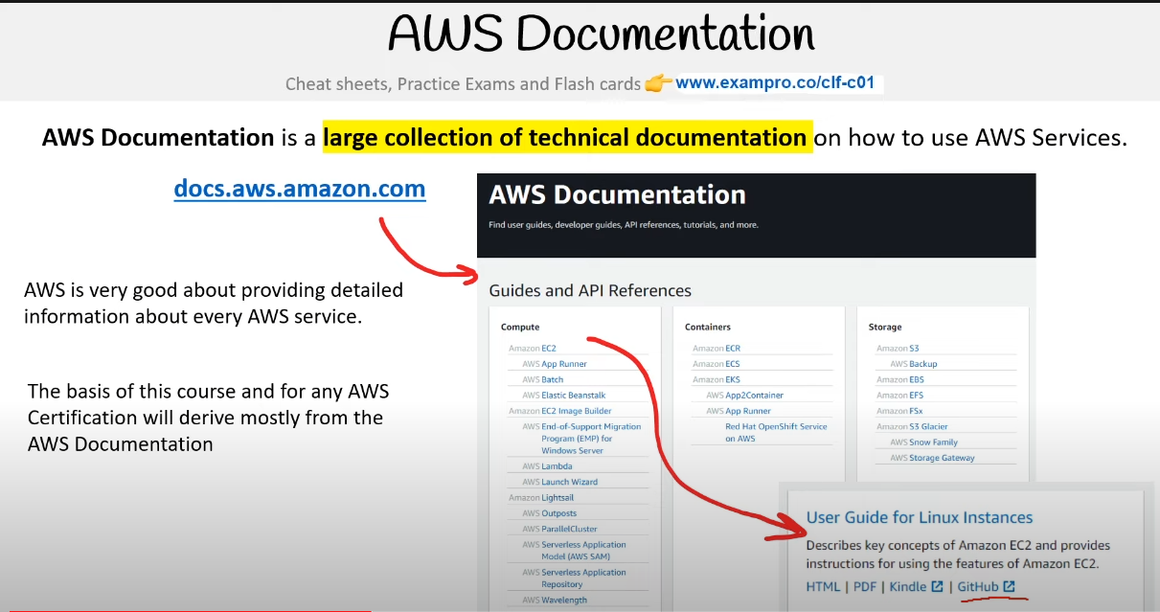

**AWS Documentation** is a **large collection of technical documentation** on how to use AWS Services.

docs.aws.amazon.com

AWS is very good about providing detailed information about every AWS service. The basis of this course and for any AWS Certification will derive mostly from the AWS Documentation

# **Shared Responsibility Model**

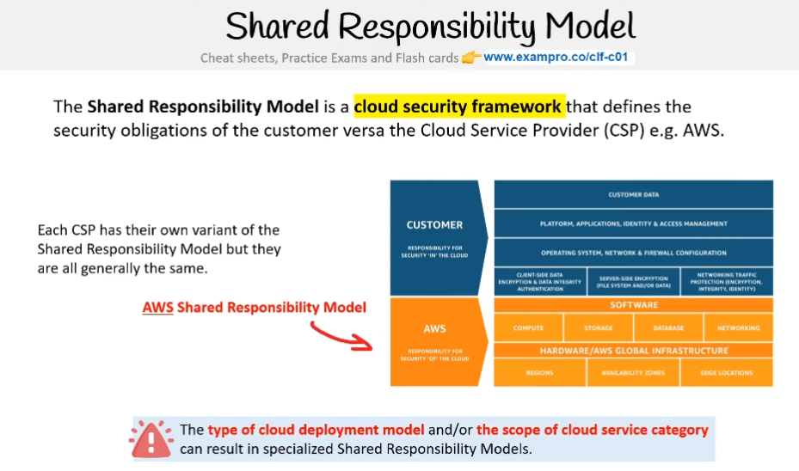

**The Shared Responsibility Model** is a **cloud security framework** that defines the security obligations of the customer versa for the Cloud Service Provider (CSP) e.g. AWS. Each CSP has its own variant of the Shared Responsibility Model but they are all generally the same.

**AWS Shared Responsibility Model** - The **type of cloud deployment model** and/or **the scope of the cloud service category** can result in specialized Shared Responsibility Models.

**Reference** - [Shared Responsibility Model](https://aws.amazon.com/compliance/shared-responsibility-model/)

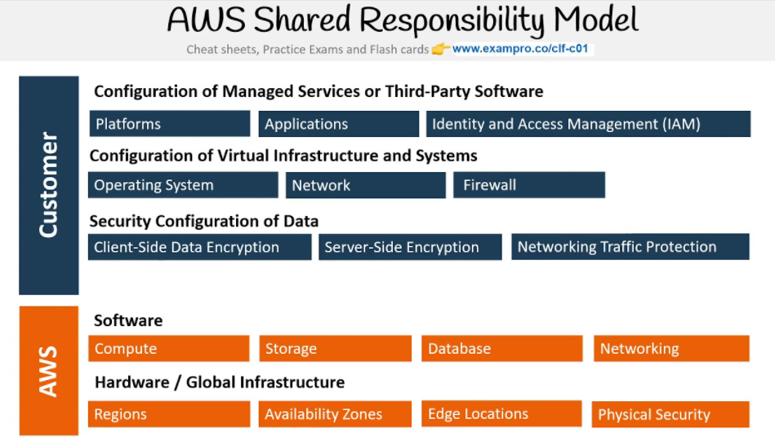

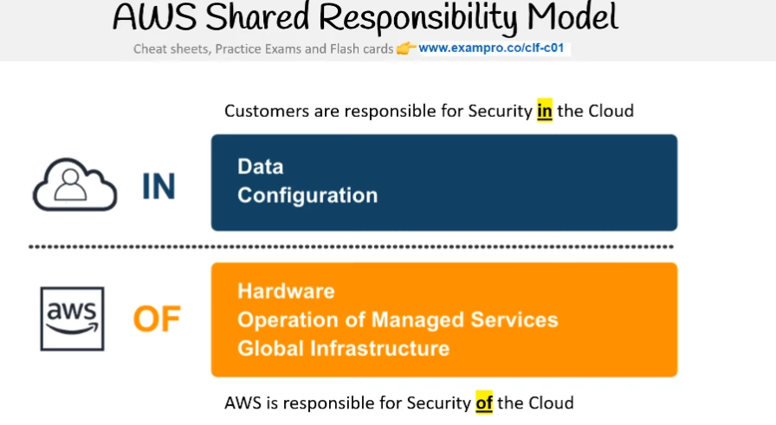

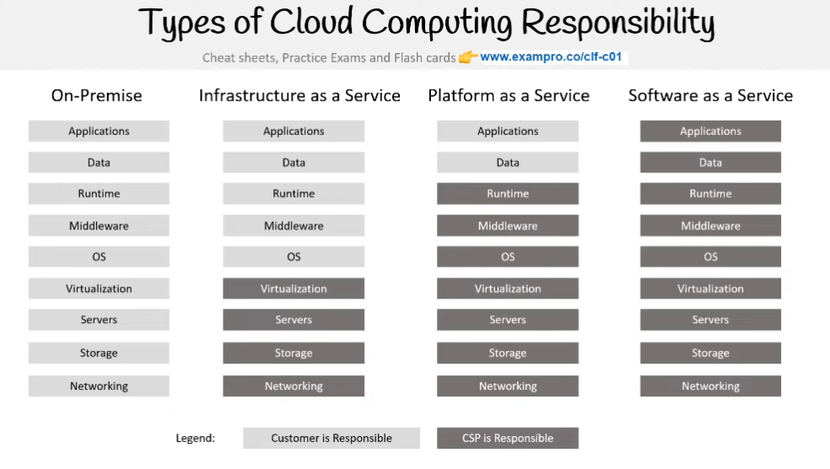

# **Shared Responsibility Model - Compute**

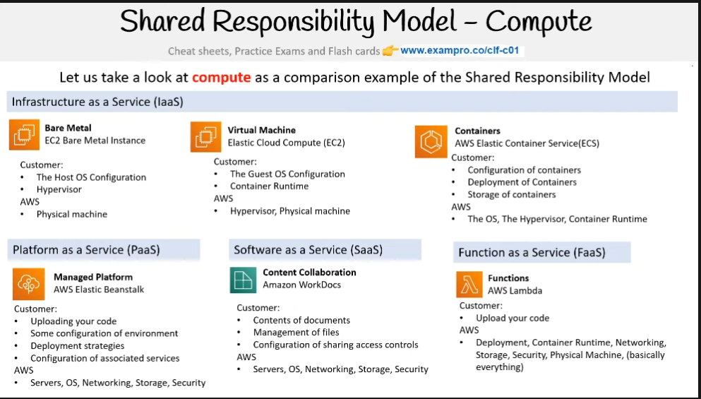

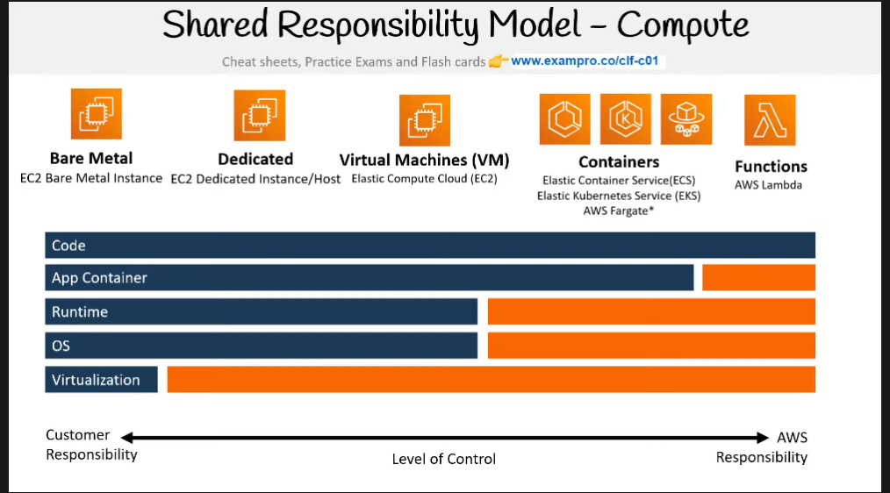

Let us take a look at **compute** as a comparison example of the Shared Responsibility Model

**Infrastructure as a Service (IaaS)** - **Bare Metal** - EC2 Bare Metal Instance

Customer:

* The Host OS Configuration
* Hypervisor

AWS

* Physical machine

**Virtual Machine** - Elastic Cloud Compute (EC2)

Customer:

* The Guest OS Configuration
* Container Runtime

AWS

* Hypervisor, Physical machine

**Containers** - AWS Elastic Container Service(ECS)

Customer:

* Configuration of containers
* Deployment of Containers
* Storage of containers

AWS

* The OS, The Hypervisor, Container Runtime

**Platform as a Service (PaaS)** - **Managed Platform**

AWS Elastic Beanstalk

Customer:

* Uploading your code
* Some configuration of environment
* Deployment strategies
* Configuration of associated services

AWS

* Servers, OS, Networking, Storage, Security

**Software as a Service (SaaS)** - **Content Collaboration**

Amazon WorkDocs

Customer:

* Contents of documents
* Management of files
* Configuration of sharing access controls

AWS

* Servers, OS, Networking, Storage, Security

**Function as a Service (FaaS)** - **Functions**

* AWS Lambda

Customer:

* Upload your code

AWS

* Deployment, Container Runtime, Networking, Storage, Security, Physical Machine, (basically everything)

Reference

[Shared Responsibility: What This Means for You as a CISO (Cloud Next '19)](https://www.youtube.com/watch?v=D2zf0SgNdUw)

[Exploring container security: the shared responsibility model in GKE](https://cloud.google.com/blog/products/containers-kubernetes/exploring-container-security-the-shared-responsibility-model-in-gke-container-security-shared-responsibility-model-gke)

[Google Cloud Platform: Shared Responsibility Matrix](https://services.google.com/fh/files/misc/gcp_pci_srm__apr_2019.pdf)

# **Shared Responsibility Model**

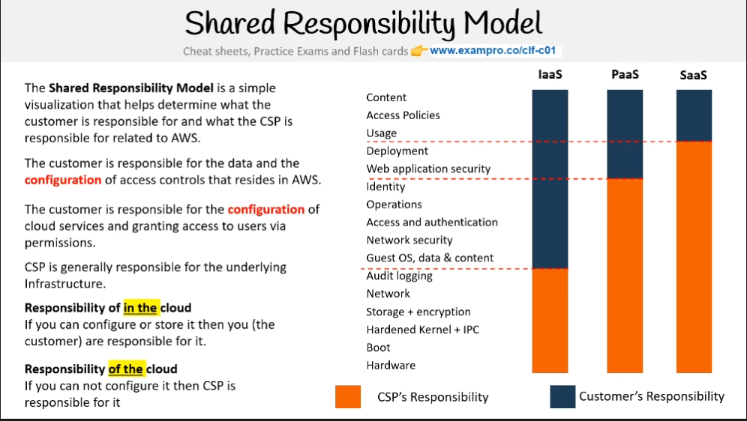

The **Shared Responsibility Model** is a simple visualization that helps determine what the customer is responsible for and what the CSP is responsible for related to AWS. The customer is responsible for the data and the **configuration** of access controls that reside in AWS. The customer is responsible for the **configuration** of cloud services and granting access to users via permissions. CSP is generally responsible for the underlying Infrastructure.

**Responsibility of in the cloud** - If you can configure or store it then you (the customer) are responsible for it.

**Responsibility of the cloud** - If you can not configure it then CSP is responsible for it

# **Shared Responsibility Model - Architecture**

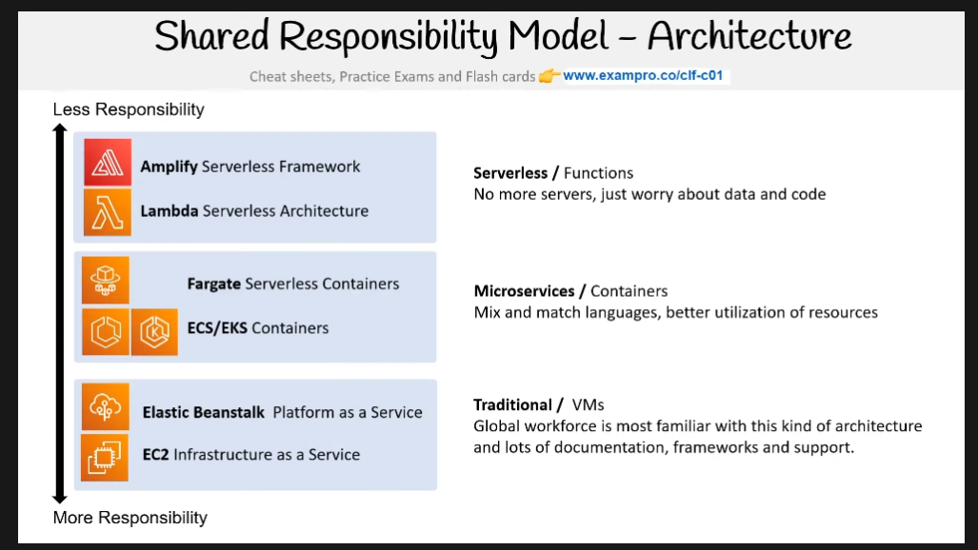

**Less Responsibility** ↑

**Amplify** Serverless Framework

**Lambda** Serverless Architecture

**Fargate** Serverless Containers - **ECS/EKS** Containers

**Elastic Beanstalk**  Platform as a Service  - **EC2** Infrastructure as a Service

**More Responsibility** ↓

**Serverless** / Functions - No more servers, just worry about data and code

**Microservices** / Containers - Mix and match languages, better utilization of resources

**Traditional** / VMs - Global workforce is most familiar with this kind of architecture and lots of documentation, frameworks, and support.

# **Computing Services**

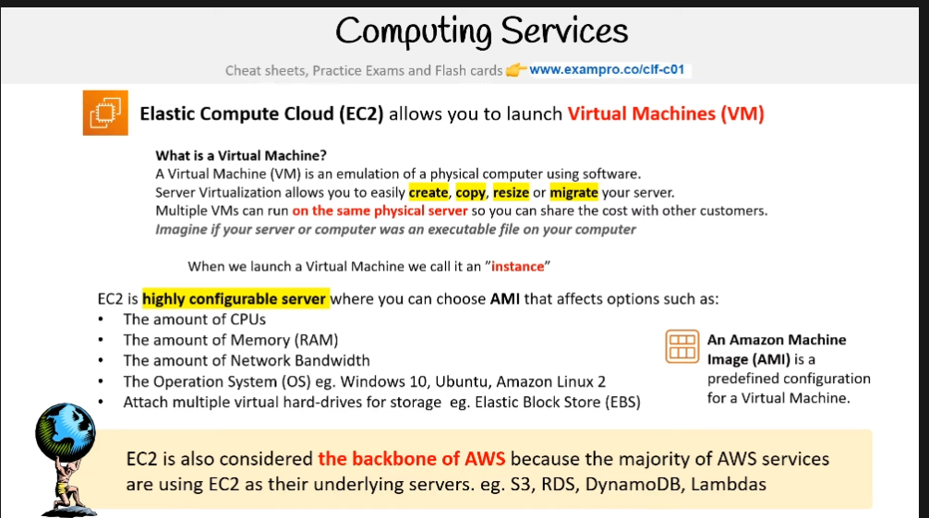

[**Elastic Compute Cloud (EC2)**](https://docs.aws.amazon.com/AWSEC2/latest/UserGuide/concepts.html) allows you to launch Virtual Machines (VM)​. When we launch a Virtual Machine we call it an ”instance”​.

**What is a Virtual Machine?​** - A Virtual Machine (VM) is an emulation of a physical computer using software. ​Server Virtualization allows you to easily **create**, **copy**, **resize** or **migrate** your server.​ Multiple VMs can run on the same physical server so you can share the cost with other customers.​ Imagine if your server or computer was an executable file on your computer

An **Amazon Machine Image (AMI)** is a predefined configuration for a Virtual Machine.

EC2 is considered the backbone of AWS because the majority of AWS services are using EC2 as their underlying servers. eg. S3, RDS, DynamoDB, Lambdas. EC2 is a highly configurable server where you can choose AMI that affects options such as:​

* The amount of CPUs​
* The amount of Memory (RAM)​
* The amount of Network Bandwidth​
* The Operation System (OS) eg. Windows 10, Ubuntu, Amazon Linux 2​
* Attach multiple virtual hard-drives for storage eg. Elastic Block Store (EBS)​

# **Containers**

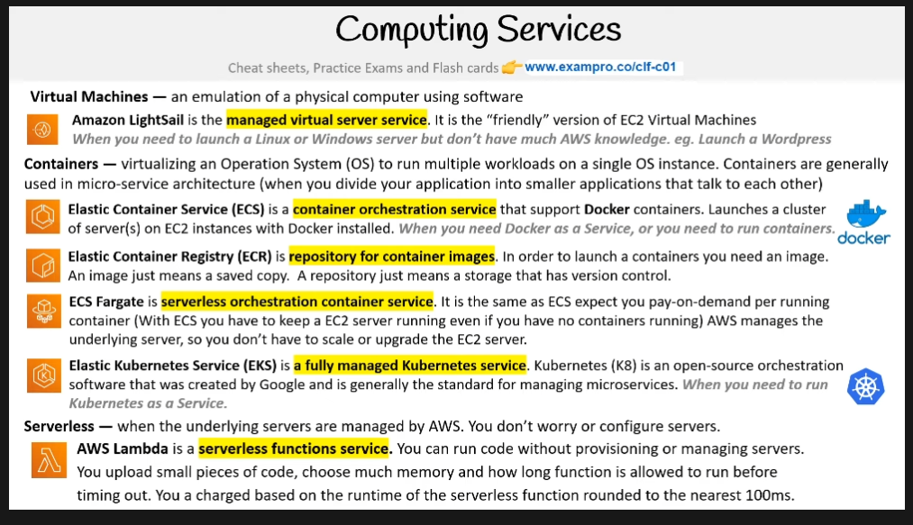

* virtualizing an Operation System (OS) to run multiple workloads on a single OS instance. Containers are generally used in micro-service architecture (when you divide your application into smaller applications that talk to each other)

[**Elastic Container Service (ECS)**](https://docs.aws.amazon.com/AmazonECS/latest/developerguide/Welcome.html) - is a container orchestration service that support Docker containers. Launches a cluster of server(s) on EC2 instances with Docker installed. When you need Docker as a Service, or you need to run containers.​

[**Elastic Container Registry (ECR)**](https://docs.aws.amazon.com/AmazonECR/latest/userguide/Registries.html) - is repository for container images. In order to launch a containers you need an image.​ An image just means a saved copy. A repository just means a storage that has version control.​

[**ECS Fargate**](https://docs.aws.amazon.com/AmazonECS/latest/developerguide/AWS_Fargate.html) - is a serverless orchestration container service. It is the same as ECS expect you pay-on-demand per running container (With ECS you have to keep a EC2 server running even if you have no containers running) AWS manages the underlying server, so you don’t have to scale or upgrade the EC2 server.

[**Elastic Kubernetes Service (EKS)**](https://docs.aws.amazon.com/eks/latest/userguide/what-is-eks.html) - is a fully managed Kubernetes service. Kubernetes (K8) is an open-source orchestration software that was created by Google and is generally the standard for managing microservices. When you need to run Kubernetes as a Service.​

**Serverless**

* when the underlying servers are managed by AWS. You don’t worry or configure servers.

[**AWS Lambda**](https://docs.aws.amazon.com/lambda/latest/dg/welcome.html)is a serverless functions service. You can run code without provisioning or managing servers. You upload small pieces of code, choose much memory and how long function is allowed to run before timing out. You a charged based on the runtime of the serverless function rounded to the nearest 100ms.​

**Virtual Machines**

* an emulation of a physical computer using software

[**Amazon LightSail**](https://aws.amazon.com/lightsail/) - is the managed virtual server service. It is the “friendly” version of EC2 Virtual Machines

# **Higher Performance Computing**

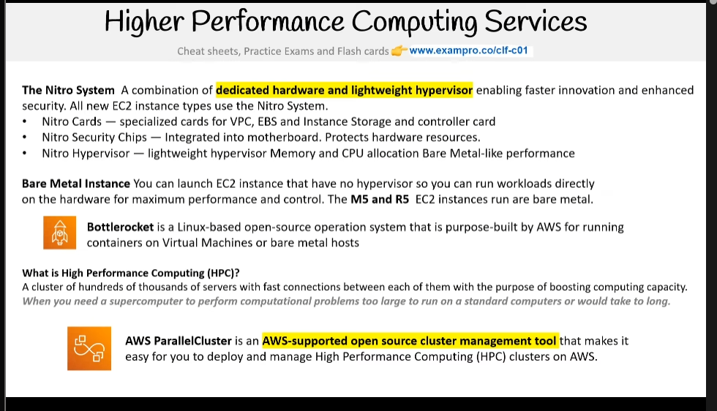

[**The Nitro System**](https://aws.amazon.com/ec2/nitro/) - A combination of dedicated hardware and lightweight hypervisor enabling faster innovation and enhanced security. All new EC2 instance types use the Nitro System.​

* **Nitro Cards** — specialized cards for VPC, EBS and Instance Storage and controller card​
* **Nitro Security Chips** — Integrated into motherboard. Protects hardware resources.​
* **Nitro Hypervisor** — lightweight hypervisor Memory and CPU allocation Bare Metal-like performance​

[**Bare Metal Instance**](https://docs.aws.amazon.com/AWSEC2/latest/WindowsGuide/instance-types.html)- You can launch EC2 instance that have no hypervisor so you can run workloads directly​ on the hardware for maximum performance and control. The M5 and R5 EC2 instances run are bare metal.​

* **Bottlerocket** is a Linux-based open-source operation system that is purpose-built by AWS for running containers on Virtual Machines or bare metal hosts

[**What is High Performance Computing (HPC)?​**](https://aws.amazon.com/hpc/) - A cluster of hundreds of thousands of servers with fast connections between each of them with the purpose of boosting computing capacity. When you need a supercomputer to perform computational problems to large to fix on a standard computers or would take to long.

* **AWS ParallelCluster** is an AWS-supported open source cluster management tool that makes it easy for you to deploy and manage High Performance Computing (HPC) clusters on AWS.

# **What is Edge Computing?​**

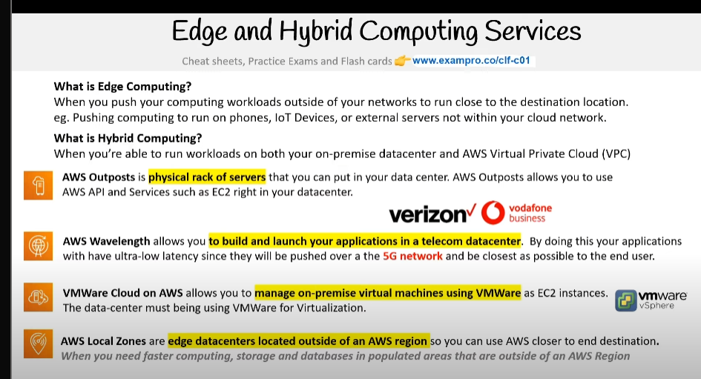

When you push your computing workloads outside of your networks to run close to the destination location.​ eg. Pushing computing to run on phones, IoT Devices, or external servers not within your cloud network.​

What is Hybrid Computing?​- When you’re able to run workloads on both your on-premise datacenter and AWS Virtual Private Cloud (VPC)

[AWS Outposts](https://aws.amazon.com/outposts/) - is physical rack of servers that you can put in your data center. AWS Outposts allows you to use AWS API and Services such as EC2 right in your datacenter.

[AWS Wavelength](https://aws.amazon.com/wavelength/) - AWS Wavelength allows you to build and launch your applications in a telecom datacenter. By doing this your applications with have ultra-low latency since they will be pushed over a the 5G network and be closest as possible to the end user.

[VMWare Cloud on AWS](https://docs.vmware.com/en/VMware-Cloud-on-AWS/index.html) - allows you to manage on-premise virtual machines using VMWare as EC2 instances.​ The data-center must being using VMWare for Virtualization.

[AWS Local Zones](https://aws.amazon.com/about-aws/global-infrastructure/localzones/) - are edge datacenters located outside of an AWS region so you can use AWS closer to end destination.​ When you need faster computing, storage and databases in populated areas that are outside of an AWS Region​

# **Cost managemant**

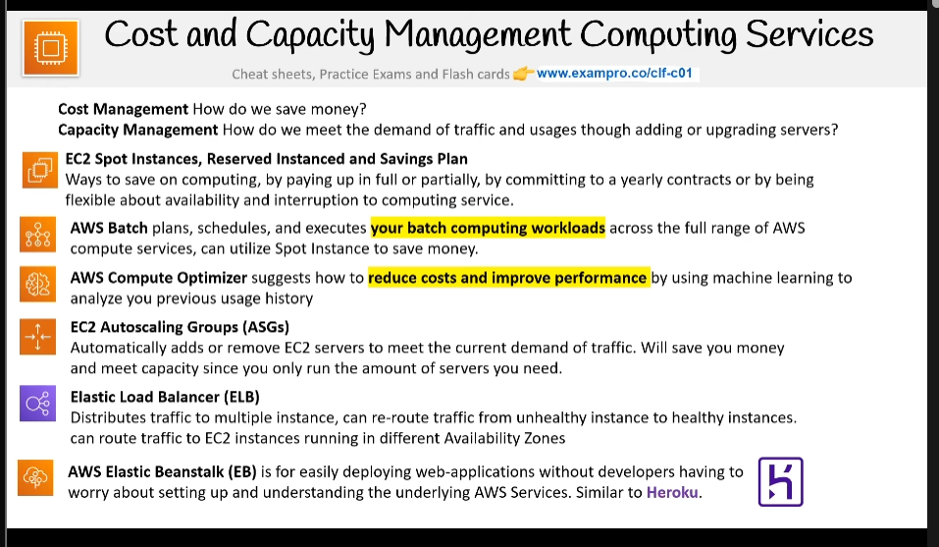

**Cost Management** - How do we save money?​ **Capacity Management** - How do we meet the demand of traffic and usages though adding or upgrading servers?

[**EC2 Spot Instances, Reserved Instanced and Savings Plan​**](https://aws.amazon.com/ec2/pricing/) - Ways to save on computing, by paying up in full or partially, by committing to a yearly contracts or by being flexible about availability and interruption to computing service.

[**AWS Batch**](https://docs.aws.amazon.com/batch/latest/userguide/what-is-batch.html) - plans, schedules, and executes your batch computing workloads across the full range of AWS compute services, can utilize Spot Instance to save money.​

[**AWS Compute Optimizer**](https://aws.amazon.com/compute-optimizer/) - Suggests how to reduce costs and improve performance by using machine learning to analyze you previous usage history

[**EC2 Autoscaling Groups (ASGs)**​](https://docs.aws.amazon.com/autoscaling/ec2/userguide/AutoScalingGroup.html) - Automatically adds or remove EC2 servers to meet the current demand of traffic. Will save you money and meet capacity since you only run the amount of servers you need.​

[**Elastic Load Balancer (ELB)​**](https://aws.amazon.com/elasticloadbalancing/) - Distributes traffic to multiple instance, can re-route traffic from unhealthy instance to healthy instances.​ Can route traffic to EC2 instances running in different Availability Zones ​

[**Elastic Beanstalk (EB)**](https://docs.aws.amazon.com/elasticbeanstalk/latest/dg/Welcome.html) - is for easily deploying web-applications without developers having to worry about setting up and understanding the underlying AWS Services. Similar to Heroku. ​

# **Types of Storage Services**

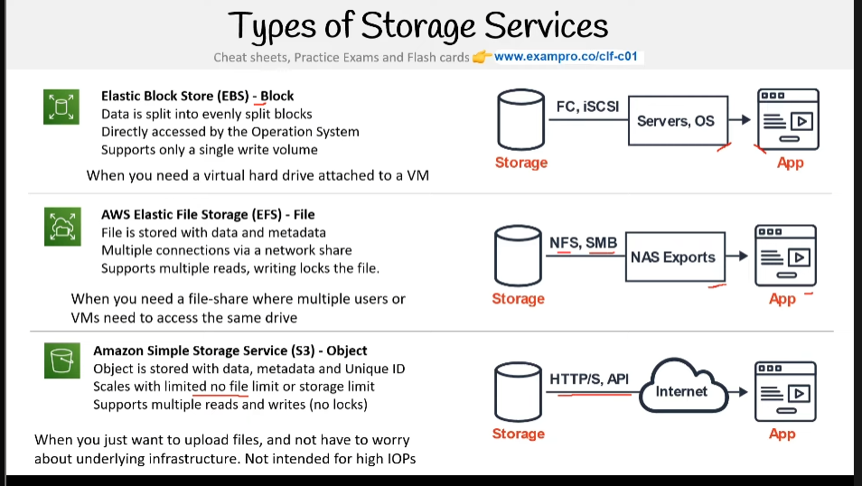

**Elastic Block Store (EBS) - Block**

* Data is split into evenly split blocks
* Directly accessed by the Operation System
* Supports only a single write volume

When you need a virtual hard drive attached to a VM

**AWS Elastic File Storage (EFS) - File**

* File is stored with data and metadata
* Multiple connections via a network share
* Supports multiple reads, writing locks the file.

When you need a file-share where multiple users or VMs need to access the same drive

**Amazon Simple Storage Service (S3) - Object**

* Object is stored with data, metadata, and Unique ID
* Scales with limited no file limit or storage limit
* Supports multiple reads and writes (no locks)

When you just want to upload files, and not have to worry about the underlying infrastructure. Not intended for high IOPs

**Introduction to S3 - What is Object Storage (Object-based Storage)?** - Data storage architecture that manages data as objects, **as opposed** to other storage architectures:

* file systems which manage data as files and fire hierarchy, and
* block storage which manages data as blocks within sectors and tracks.

S3 provides you with **unlimited storage**. You don’t need to think about the underlying infrastructure. The S3 Console provides an interface for you to upload and access your data

# **S3 Object**

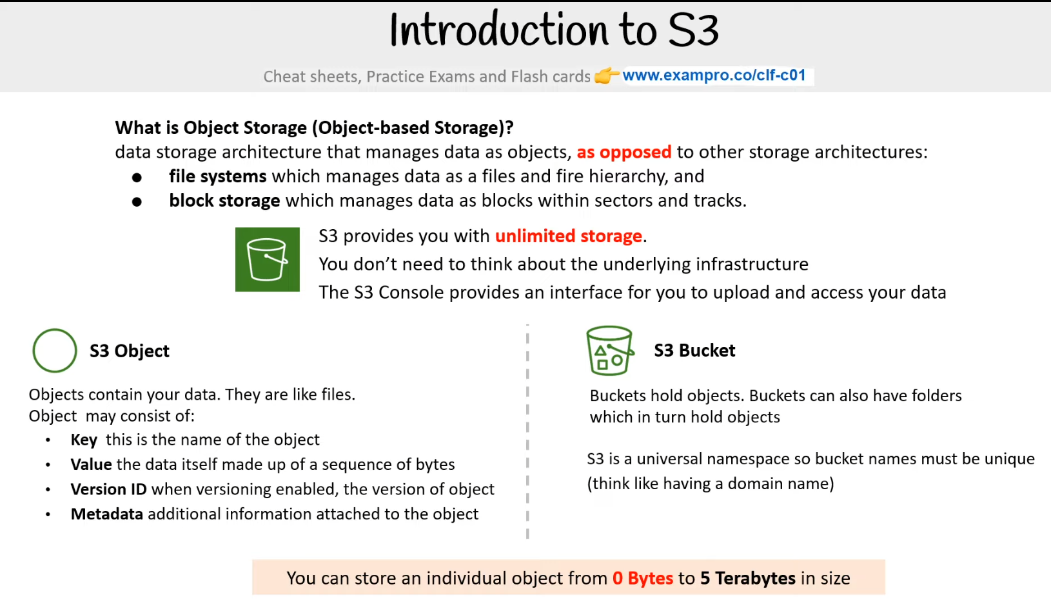

Objects contain your data. They are like files. Object may consist of:

* **Key** this is the name of the object
* **Value** the data itself made up of a sequence of bytes
* **Version ID** when versioning enabled, the version of object
* **Metadata** additional information attached to the object

**S3 Bucket** - Buckets hold objects. Buckets can also have folders which in turn hold objects. S3 is a universal namespace so bucket names must be unique (think like having a domain name). You can store an individual object from **0 Bytes to 5 Terabytes** in size

Reference - [Object storage](https://en.wikipedia.org/wiki/Object_storage)

# **S3 Storage Classes**

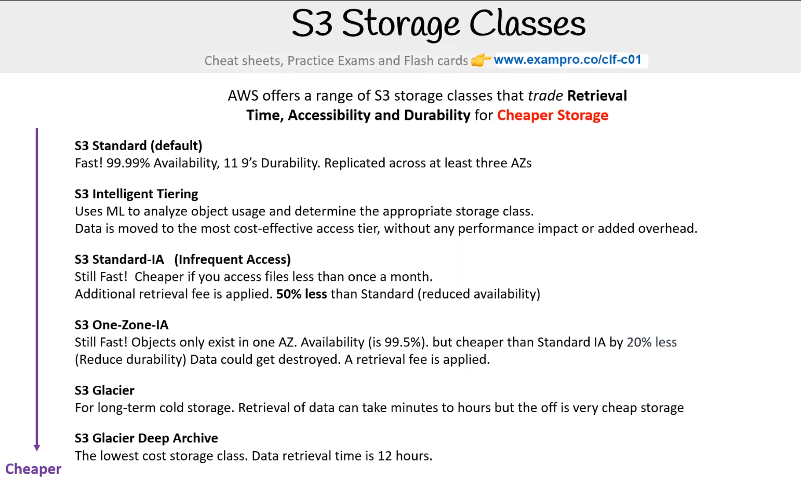

AWS offers a range of S3 storage classes that trade **Retrieval Time, Accessibility and Durability** for **Cheaper Storage**

**S3 Standard (default)** - Fast! 99.99% Availability, 11 9’s Durability. Replicated across at least three AZs

**S3 Intelligent Tiering** - Uses ML to analyze object usage and determine the appropriate storage class. Data is moved to the most cost-effective access tier, without any performance impact or added overhead.

**S3 Standard-IA (Infrequent Access)** - Still Fast! Cheaper if you access files less than once a month. Additional retrieval fee is applied. 50% less than Standard (reduced availability)

**S3 One-Zone-IA** - Still Fast! Objects only exist in one AZ. Availability (is 99.5%). but cheaper than Standard IA by 20% less  
(Reduce durability) Data could get destroyed. A retrieval fee is applied.

**S3 Glacier** - For long-term cold storage. Retrieval of data can take minutes to hours but the off is very cheap storage

**S3 Glacier Deep Archive** - The lowest cost storage class. Data retrieval time is 12 hours.

Cheaper ↓

S3 Outposts has its own storage class.

**Reference** - [Storage classes](https://activate-next.workshop.aws/002_services/002_storage/003_s3.html)

# **AWS Snow Family**

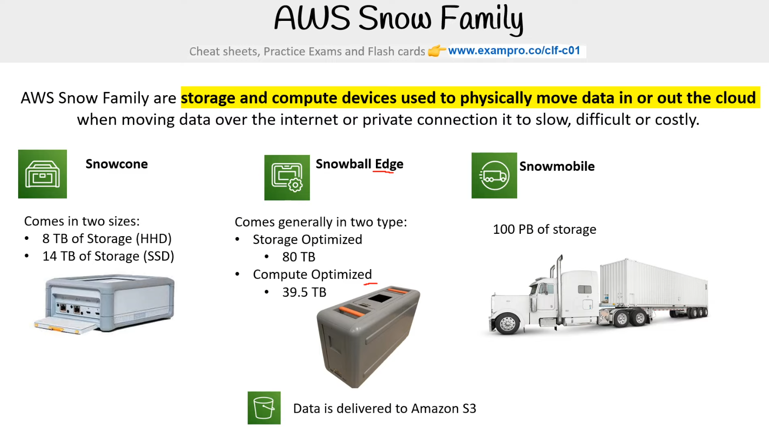

AWS Snow Family are **storage and compute devices used to physically move data in or out the cloud** when moving data over the internet or private connection it to slow, difficult or costly.

**Snowcone** - Comes in two sizes:

* 8 TB of Storage (HHD)
* 14 TB of Storage (SSD)

**Snowball Edge** - Comes generally in two type:

* Storage Optimized
  + 80 TB
* Compute Optimized
  + 39.5 TB

**Snowmobile** - 100 PB of storage. Data is delivered to Amazon S3

**Reference**

[AWS re:Invent recap: Optimize your data migration with AWS Snow Family](https://aws.amazon.com/blogs/storage/aws-reinvent-recap-optimize-your-data-migration-with-aws-snow-family/)

[AWS Snowball Edge Device Differences](https://docs.aws.amazon.com/snowball/latest/developer-guide/device-differences.html)

# **Storage Services:**

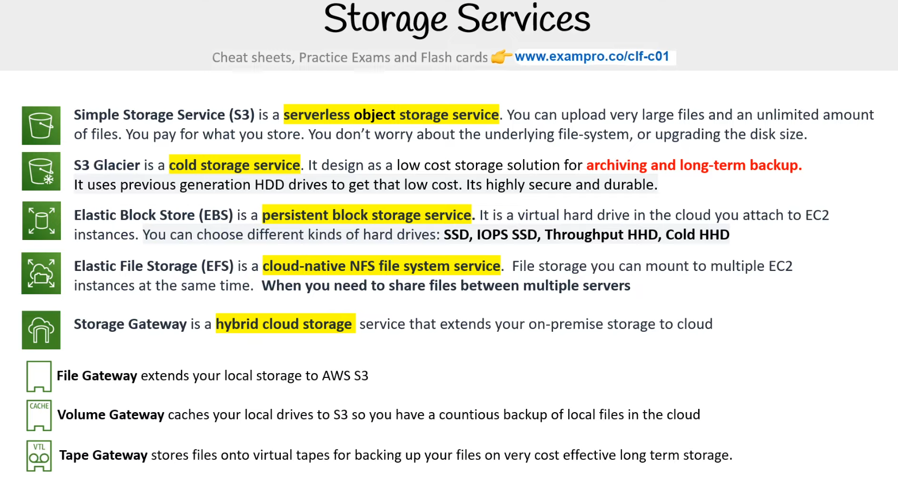

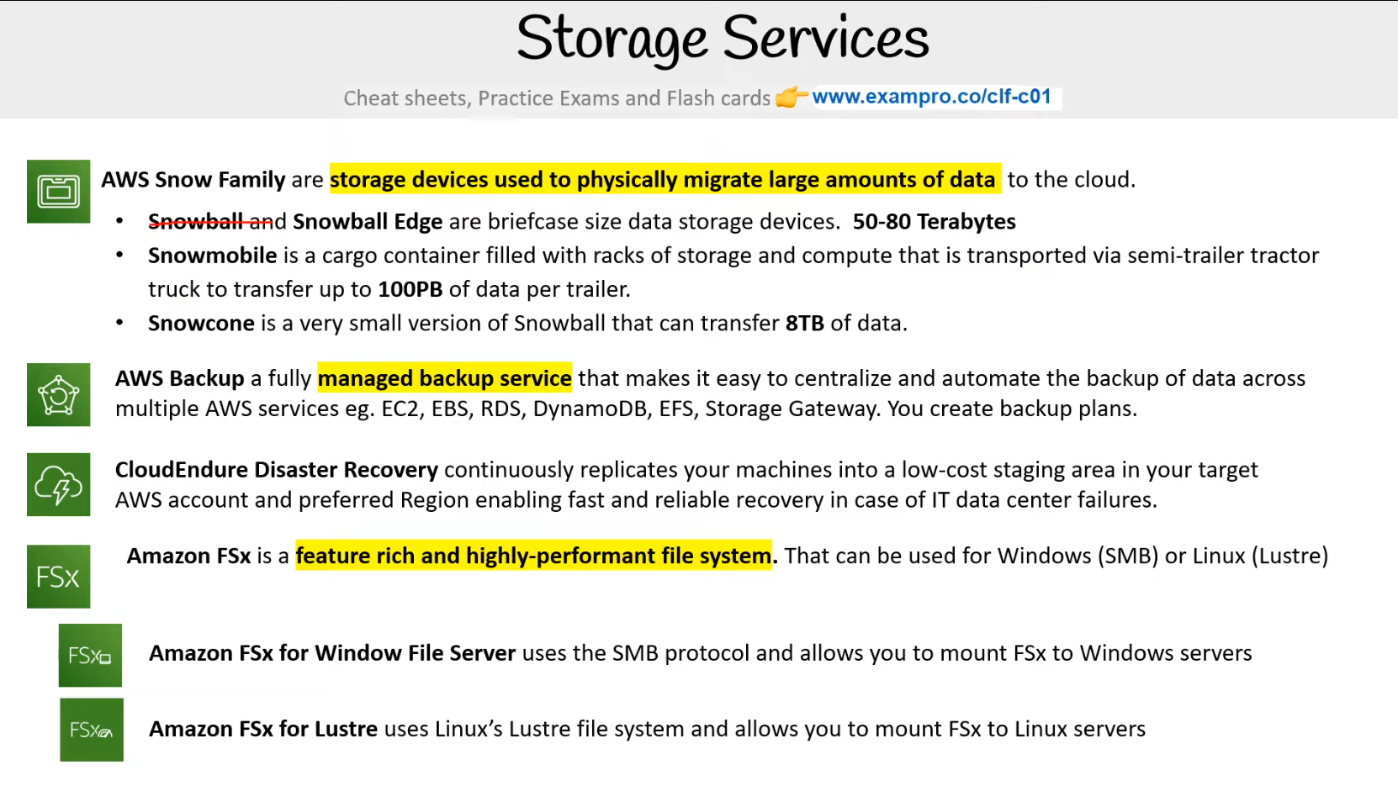

Provide scalable cloud-based storage solutions for your workloads on AWS.

* [**S3 (Simple Storage Service)**](https://aws.amazon.com/s3/?nc2=type_a) - is an object storage service that offers industry-leading scalability, data availability, security, and performance. Think of it as a "hard drive in the cloud" with a lot of available space.
* [**S3 Glacier**](https://docs.aws.amazon.com/amazonglacier/latest/dev/introduction.html) - low cost storage for archiving and long-term backup Trade-off: You may have to wait several hours to access data stored here. Use case: for data that you must hold on to but are unlikely to look at often. Example: an enterprise company that must store records for many years under a litigation hold.
* [**EBS**](https://aws.amazon.com/ebs/?nc2=type_a&ebs-whats-new.sort-by=item.additionalFields.postDateTime&ebs-whats-new.sort-order=desc) - `Elastic Block Storage- is a persistent block storage service. It is a virtual hard drive in the cloud you attach to EC2 instances. You can choose different kinds of hard drives: **SSD, IOPS SSD, Throughput HHD, Cold HHD​**
* [**EFS**](https://aws.amazon.com/efs/?nc2=type_a) - Elastic File Storage- file storage mountable to multiple EC2 instances at the same time
* [**Storage Gateway**](https://aws.amazon.com/storagegateway/?nc2=type_a&whats-new-cards.sort-by=item.additionalFields.postDateTime&whats-new-cards.sort-order=desc) - hybrid cloud storage with local caching. Expand your on-premises storage capacity into the cloud.
* **File Gateway** extends your local storage to AWS S3
* **Volume Gateway** caches your local drives to S3 so you have a continuous backup of local files in the cloud
* **Tape Gateway** stores files onto virtual tapes for backing up your files on very cost-effective long-term storage.
* [**AWS Snow Family**](https://aws.amazon.com/snowball/) are storage devices used to physically migrate large amounts of data to the cloud.
* Snowball and Snowball Edge are briefcase-size data storage devices. 50-80 Terabytes
* [**Snowball edge**](https://aws.amazon.com/snow/) - A version of Snowball for even larger sets of data - 100 TB
* [**Snowmobile**](https://aws.amazon.com/snowmobile/) is a cargo container filled with racks of storage and compute that is transported via semi-trailer tractor truck to transfer up to 100PB of data per trailer.
* **Snowcone** is a very small version of Snowball that can transfer 8TB of data.

# **What is a Database?**

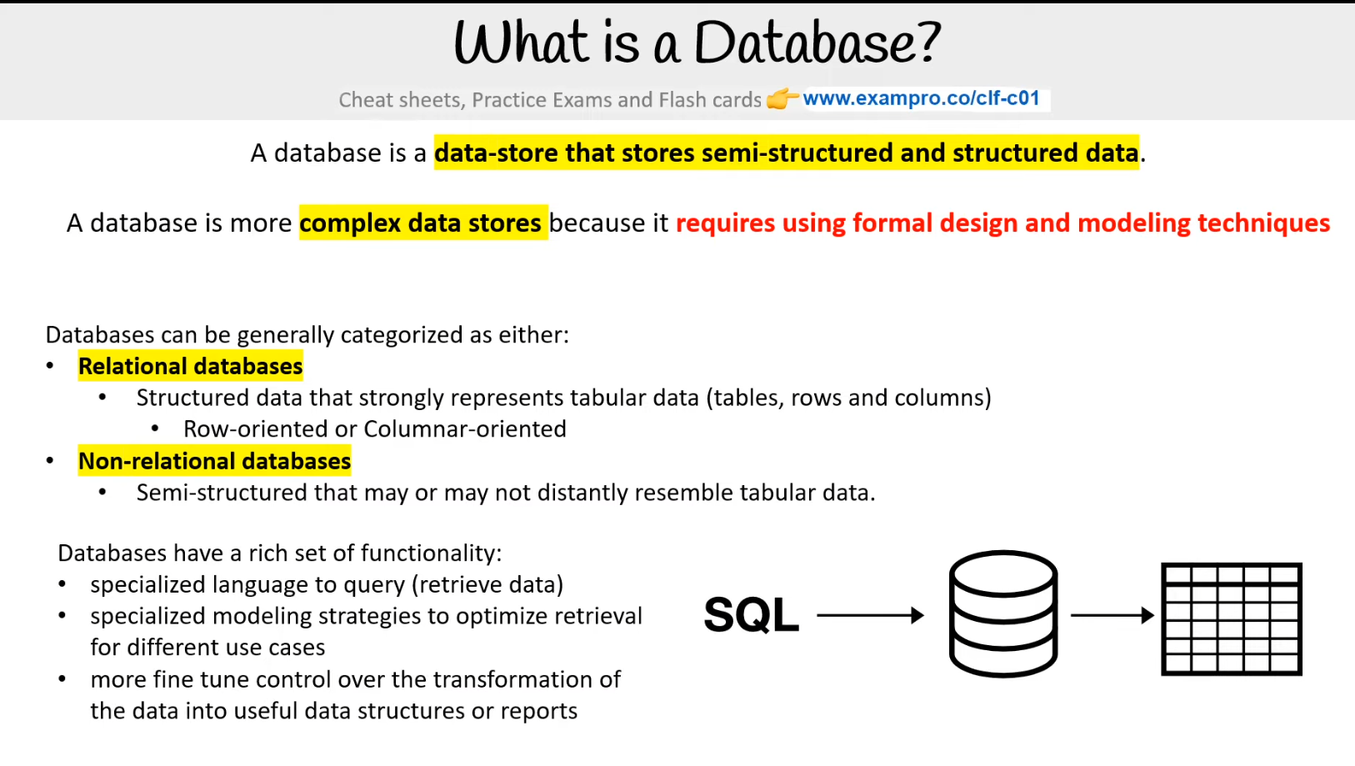

A database is a data store that stores semi-structured and structured data. A database is a more complex data stores because it requires using formal design and modeling techniques

Databases can be generally categorized as either:

**Relational databases**

* Structured data that strongly represents tabular data (tables, rows, and columns)
  + Row-oriented or Columnar-oriented

**Non-relational databases**

* Semi-structured that may or may not distantly resemble tabular data.

Databases have a rich set of functionality:

* specialized language to query (retrieve data)
* specialized modeling strategies to optimize retrieval for different use cases
* more fine-tune control over the transformation of the data into useful data structures or reports

Normally, a database infers someone is using a **relational row-oriented datastore**

**Reference** - [Database](https://en.wikipedia.org/wiki/Database)

# **What is Data Warehouse?**

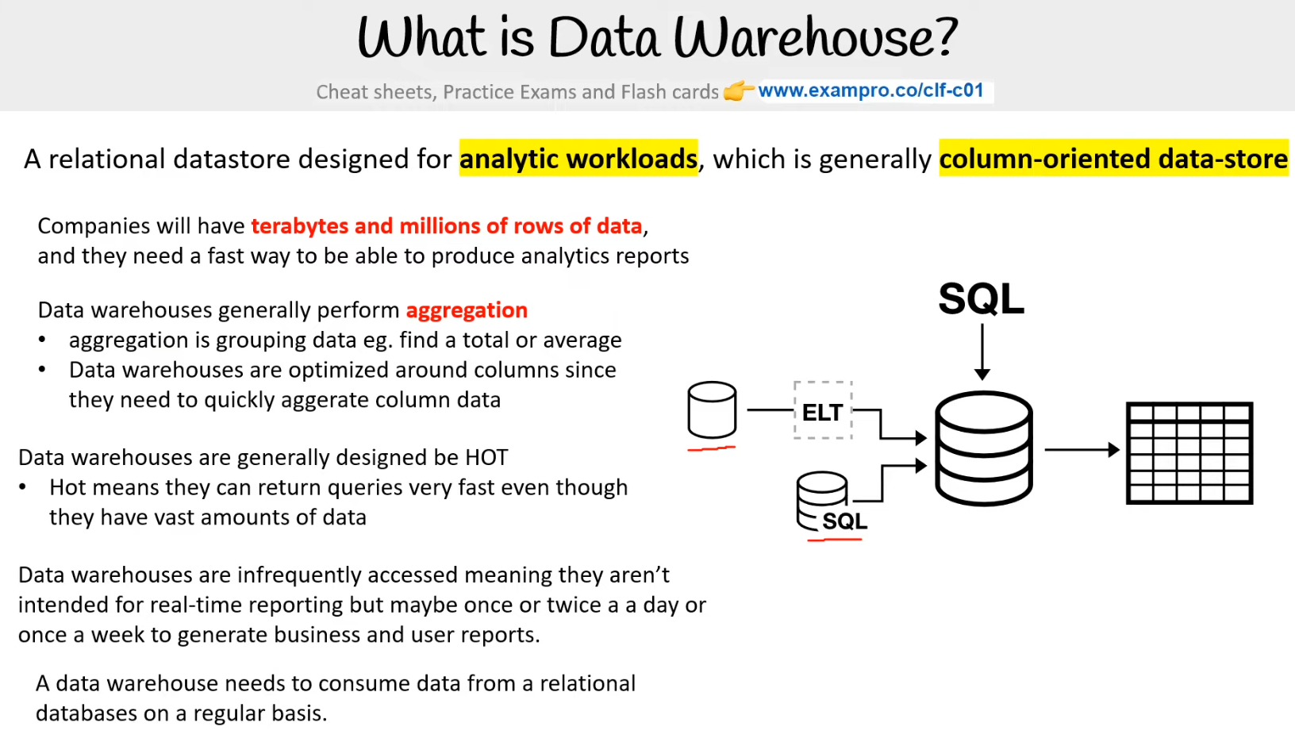

A relational data store designed for analytic workloads, which is generally column-oriented data-store. Companies will have terabytes and millions of rows of data, and they need a fast way to be able to produce analytics reports

**Data warehouses generally perform aggregation**

* aggregation is grouping data eg. find a total or average
* Data warehouses are optimized around columns since they need to quickly aggerate column data

**Data warehouses are generally designed to be HOT**

* Hot means they can return queries very very fast even though they have vast amounts of data

Data warehouses are infrequently accessed meaning they aren’t intended for real-time reporting but maybe once or twice a day or once a week to generate business and user reports. A data warehouse needs to consume data from a relational database on a regular basis.

**Reference** - [What is Data Warehouse? Types, Definition & Example](https://www.guru99.com/data-warehousing.html)

# **What is a Key / Value store?**

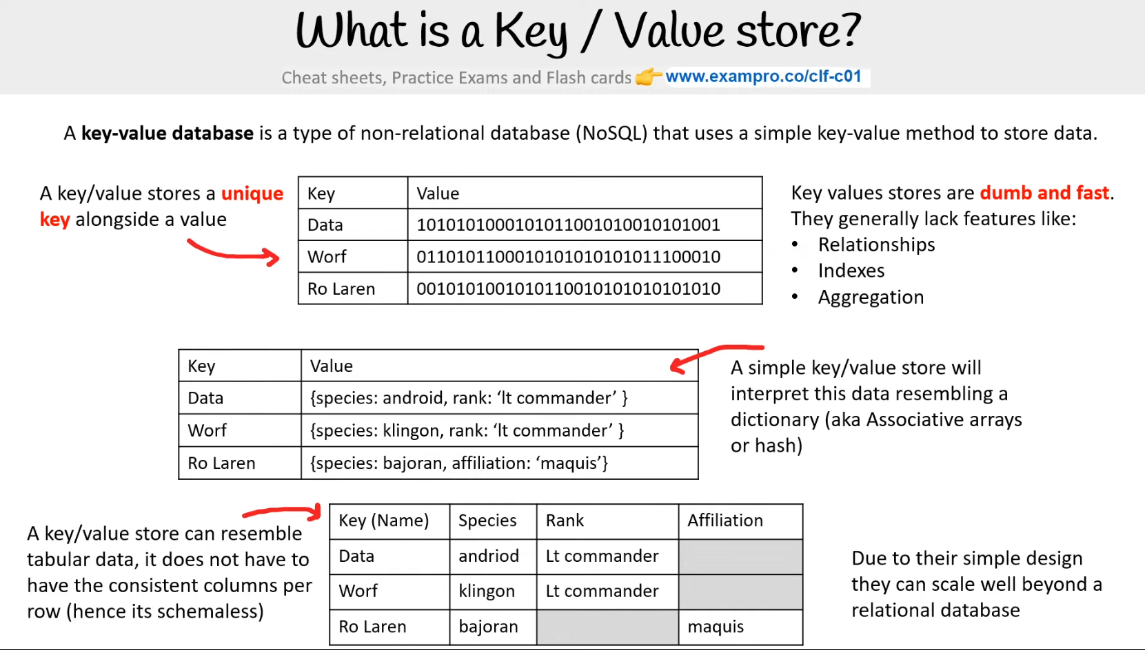

A key/value stores a unique key alongside a value. Key values stores are dumb and fast.. They generally lack features like:

* Relationships
* Indexes
* Aggregation

A simple key/value store will interpret this data resembling a dictionary (aka Associative arrays or hash). A key/value store can resemble tabular data, it does not have to have consistent columns per row (hence its schemaless). Due to their simple design, they can scale well beyond a relational database

# **What is a Document store?**

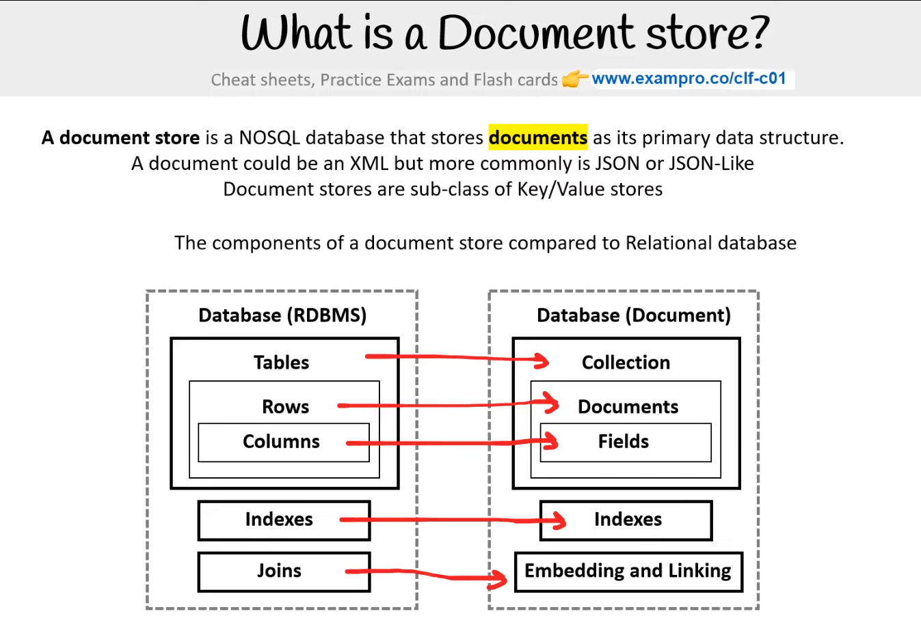

**A document store** is a NoSQL database that stores **documents** as its primary data structure. A document could be an XML but more commonly is JSON or JSON-Like Document stores are a sub-class of Key/Value stores. The components of a document store compared to a Relational database

**Reference** - [Document-oriented database](https://en.wikipedia.org/wiki/Document-oriented_database)

# **NoSQL**

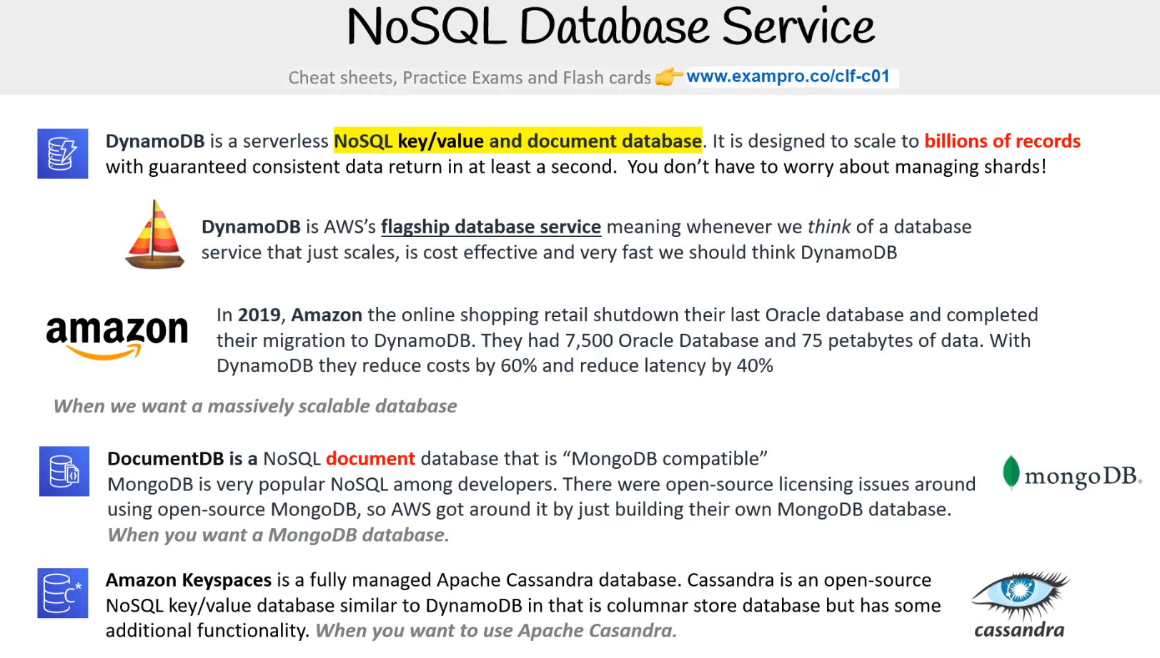

[**DynamoDB**](https://docs.aws.amazon.com/amazondynamodb/latest/developerguide/Introduction.html) - is a serverless NoSQL key/value and document database. It is designed to scale to billions of records with guaranteed consistent data return in at least a second. You don’t have to worry about managing shards!​

* DynamoDB is AWS’s flagship database service meaning whenever we think of a database service that just scales, is cost effective and very fast we should think DynamoDB

[**DocumentDB**](https://aws.amazon.com/documentdb/) - is a NoSQL document database that is “MongoDB compatible”​

* MongoDB is very popular NoSQL among developers. There were open-source licensing issues around using open-source MongoDB, so AWS got around it by just building their own MongoDB database.​

[**Amazon Keyspaces**](https://docs.aws.amazon.com/keyspaces/latest/devguide/what-is-keyspaces.html) - is a fully managed Apache Cassandra database. Cassandra is an open-source NoSQL key/value database similar to DynamoDB in that is columnar store database but has some additional functionality. When you want to use Apache Casandra.

# [**Relational Database Service (RDS)**](https://docs.aws.amazon.com/AmazonRDS/latest/UserGuide/Welcome.html)

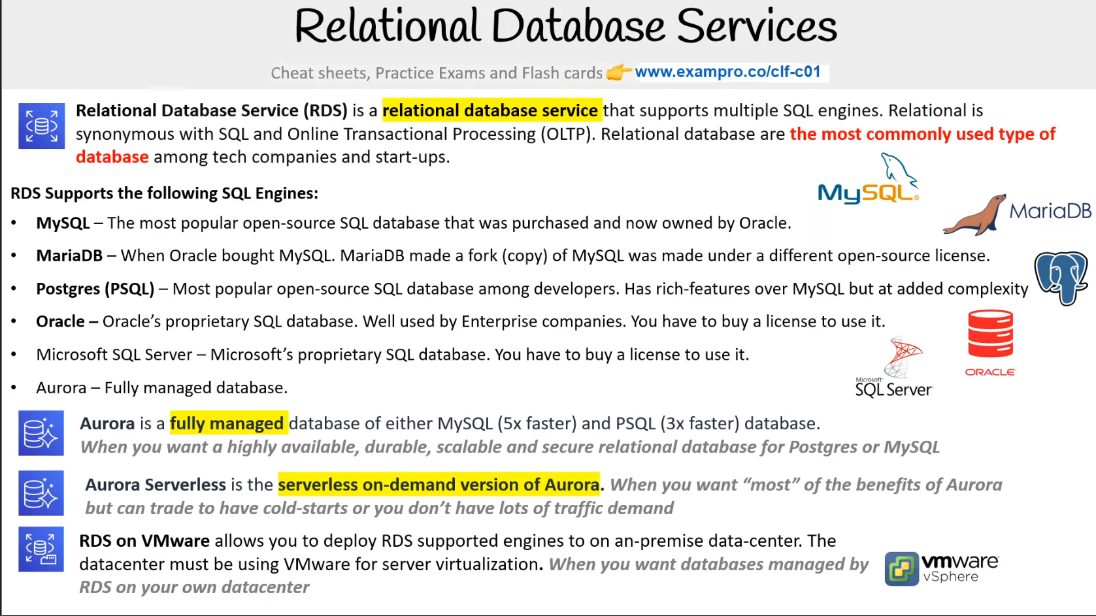

 - is a relational database service that supports multiple SQL engines. Relational is synonymous with SQL and Online Transactional Processing (OLTP). Relational database are the most commonly used type of database among tech companies and start-ups. ​

**RDS Supports the following SQL Engines:** ​

* **MySQL** – The most popular open-source SQL database that was purchased and now owned by Oracle.​
* **MariaDB** – When Oracle bought MySQL a fork (copy) of MySQL was made under a different open-source license.​
* **Postgres (PSQL)** – Most popular open-source SQL database among developers. Has rich-features over MySQL but at added complexity​
* **Oracle** – Oracle’s proprietary SQL database. Well used by Enterprise companies. You have to buy a license to use it.​
* Microsoft SQL Server – Microsoft’s proprietary SQL database. You have to buy a license to use it.​
* Aurora – Fully managed database.

[**Aurora**](https://docs.aws.amazon.com/AmazonRDS/latest/AuroraUserGuide/CHAP_AuroraOverview.html) - is a fully managed database of either MySQL (5x faster) and PSQL (3x faster) database.​ When you want a highly available, durable, scalable and secure relational database for Postgres or MySQL​

[**Aurora Serverless**](https://docs.aws.amazon.com/AmazonRDS/latest/AuroraUserGuide/aurora-serverless.html) - is the serverless on-demand version of Aurora. When you want “most” of the benefits of Aurora but can trade to have cold-starts or you don’t have lots of traffic demand​

[**RDS on VMware**](https://aws.amazon.com/rds/vmware/) - allows you to deploy RDS supported engines to on an-premise data-center. The datacenter must be using VMware for server virtualization. When you want databases managed by RDS on your own datacenter​

# **Other databases**

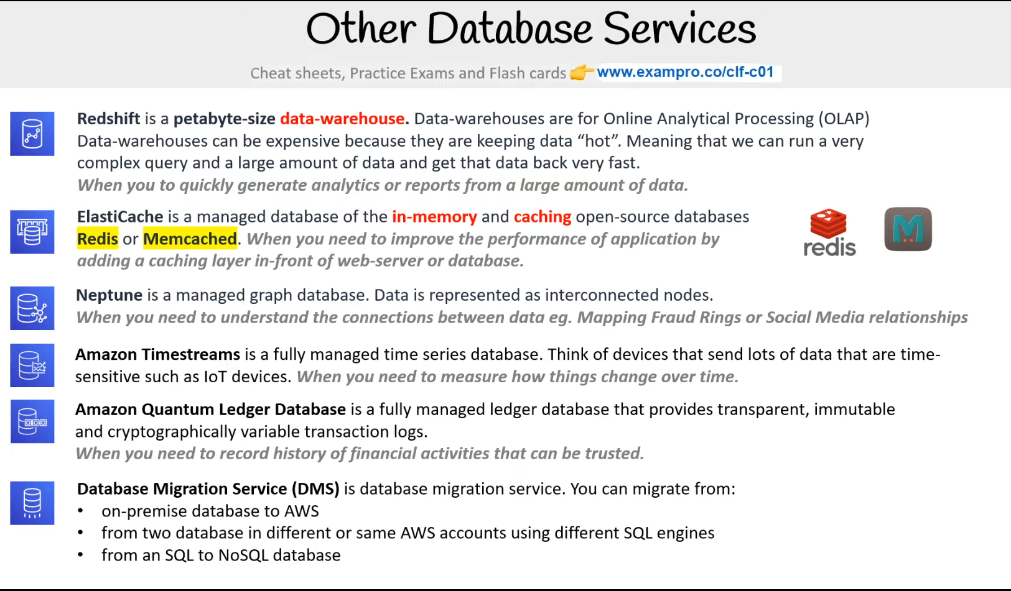

[**Redshift**](https://docs.aws.amazon.com/redshift/latest/gsg/getting-started.html) - is a petabyte-size data-warehouse. Data-warehouses are for Online Analytical Processing (OLAP)​ Data-warehouses can be expensive because they are keeping data “hot”. Meaning that we can run a very complex query and a large amount of data and get that data back very fast.​ When you want to quickly generate analytics or reports from a large amount of data.​

[**ElastiCache**](https://aws.amazon.com/elasticache/) - is a managed database of the in-memory and caching open-source databases Redis or Memcached. When you need to improve the performance of application by adding a caching layer in-front of web-server or database.​

[**Neptune**](https://aws.amazon.com/neptune/) - is a managed graph database. Data is represented as interconnected nodes.​ When you need to understand the connections between data eg. Mapping Fraud Rings or Social Media relationships​.

[**Amazon Timestreams**](https://aws.amazon.com/timestream/) - is a fully managed time series database. Think of devices that send lots of data that are time-sensitive such as IoT devices. When you need to measure how things change over time.​

[**Amazon Quantum Ledger Database**](https://aws.amazon.com/qldb/) - is a fully managed ledger database that provides transparent, immutable and cryptographically variable transaction logs. ​

[**Database Migration Service (DMS**](https://aws.amazon.com/dms/) - is database migration service. You can us it to migrate from:​

* on-premise database to AWS​
* from two database in different or the same AWS accounts using different SQL engines​
* from an SQL to NoSQL database​

# **Cloud-Native Networking Services**

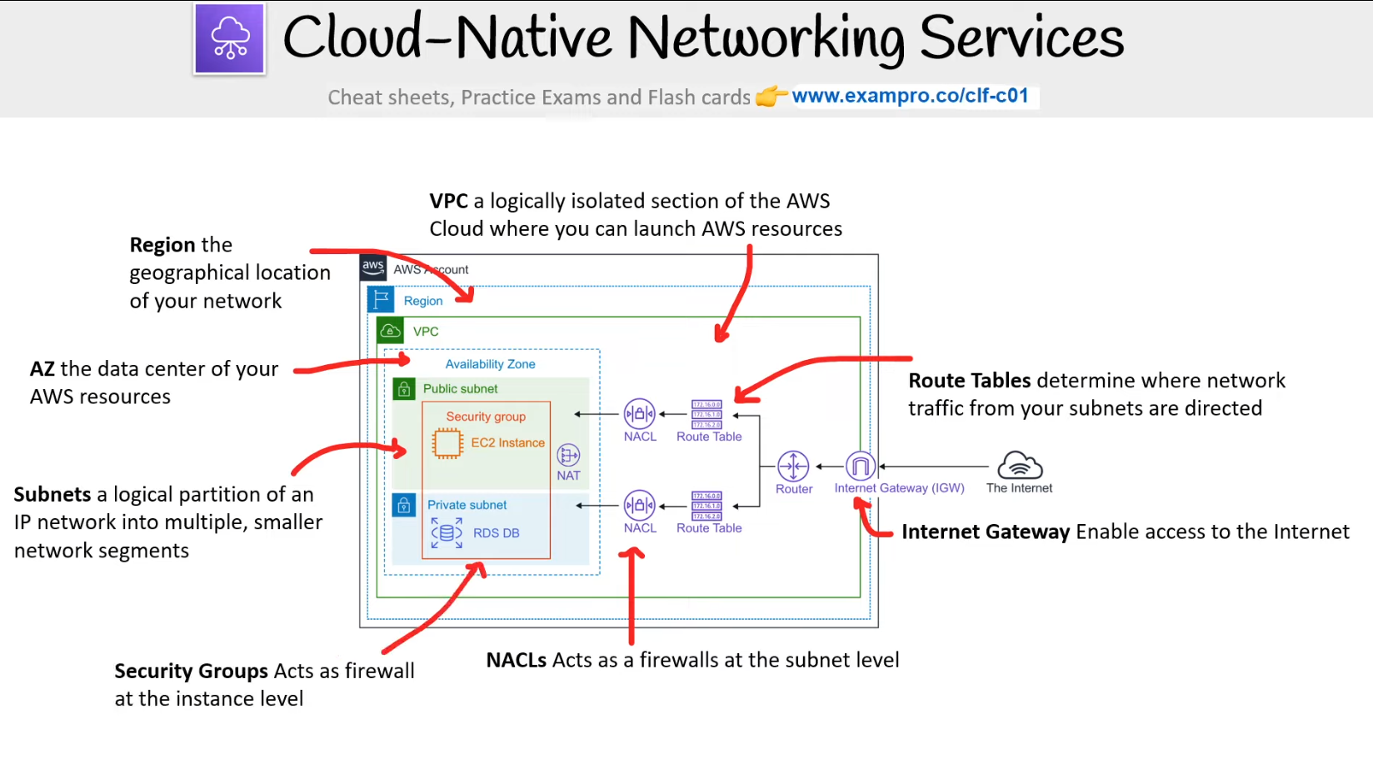

**Key definitions:**

[**Region**](https://aws.amazon.com/about-aws/global-infrastructure/regions_az/) - the geographical location of your network

[**Availability Zone** (**AZ)**](https://aws.amazon.com/about-aws/global-infrastructure/regions_az/) - a data center containing your AWS resources

[**Virtual Private Cloud (VPC)**](https://docs.aws.amazon.com/vpc/latest/userguide/how-it-works.html)- a logically isolated section of the AWS Cloud where you can launch AWS resources

[**Internet Gateway**](https://docs.aws.amazon.com/vpc/latest/userguide/VPC_Internet_Gateway.html)- enables access to the Internet for your VPC

[**Route Tables**](https://docs.aws.amazon.com/vpc/latest/userguide/VPC_Route_Tables.html)- determines where network traffic from your subnets are directed

[**NACLs**](https://docs.aws.amazon.com/vpc/latest/userguide/vpc-network-acls.html)- Network Access Control Lists. Act as a firewall at the subnet level

[**Security Groups**](https://docs.aws.amazon.com/vpc/latest/userguide/VPC_SecurityGroups.html)- Act as firewall at the instance level

[**Subnets**](https://docs.aws.amazon.com/vpc/latest/userguide/VPC_Subnets.html)- a logical partition of an IP network into multiple, smaller network segments

**Availability Zones:** Availability Zones are the **data centers** where you launch your AWS resources into. Each AZs is associated with a specific region

**Key VPC Components:** A virtual private cloud (VPC) network is your own personal isolated section of the AWS cloud. A route table contains a set of rules (called routes), that are used to determine where network traffic from your subnet or gateway is directed.

**Internet Gateway**- Allows you to grant internet access to resources inside of your VPC. But you also need a **route table** which routes the traffic from the VPC network out to the IGW

You can think of it as a door from your VPC outward.

**Reference -** [Internetwork traffic privacy in Amazon VPC](https://docs.aws.amazon.com/vpc/latest/userguide/VPC_Security.html) | [VPC networking components](https://docs.aws.amazon.com/vpc/latest/userguide/VPC_Networking.html)

# **Enterprise/Hybrid Networking Services**

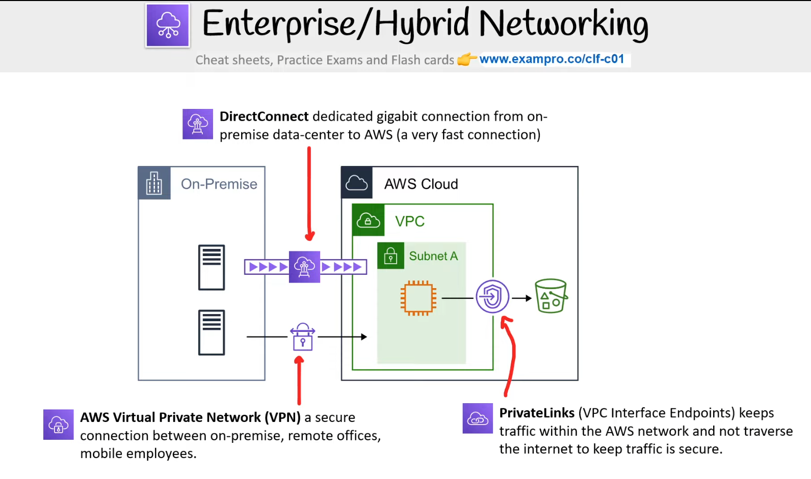

[**Direct Connect**](https://aws.amazon.com/directconnect/?nc2=type_a) - is a dedicated Gigabit network connection from your premises location to AWS. Provides a direct fiber optic cable running straight to the AWS network

[**VPN**](https://aws.amazon.com/vpn/) - establishes a secure connection to your AWS network

* Site-to-Site VPN - connecting your on-premise to your AWS network
* Client VPN - connecting a Client (ie users laptop) to your AWS network

[**PrivateLinks (VPC Interface Endpoints)**](https://aws.amazon.com/privatelink/) - keeps traffic within the AWS network and not traverse the internet to keep traffic is secure.​

# **Virtual Private Cloud (VPC) & Subnets**

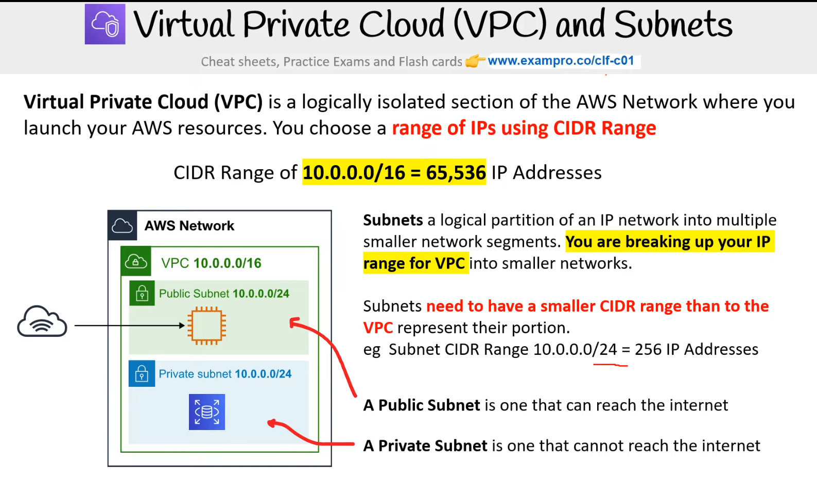

[**Virtual Private Cloud (VPC)**](https://docs.aws.amazon.com/vpc/latest/userguide/how-it-works.html) is a logically isolated section of the AWS Network where you launch your AWS resources. You choose a **range of IPs using CIDR Range**

CIDR Range of 10.0.0.0/16 = 65,536 IP Addresses

[**Subnets**](https://docs.aws.amazon.com/vpc/latest/userguide/VPC_Subnets.html) a logical partition of an IP network into multiple smaller network segments. You are breaking up your IP range for VPC into smaller networks.

* Subnets need to have a smaller CIDR range than to the VPC represent their portion.​ eg Subnet CIDR Range 10.0.0.0/24 = 256 IP Addresses

**Public vs Private Subnets:** - Public subnets are generally used for placing resources which are accessible on the internet. Private subnets are used when you need resources to be more secured and only accessible through tightly filtered traffic into the subnet

# **Security Groups vs NACLs**

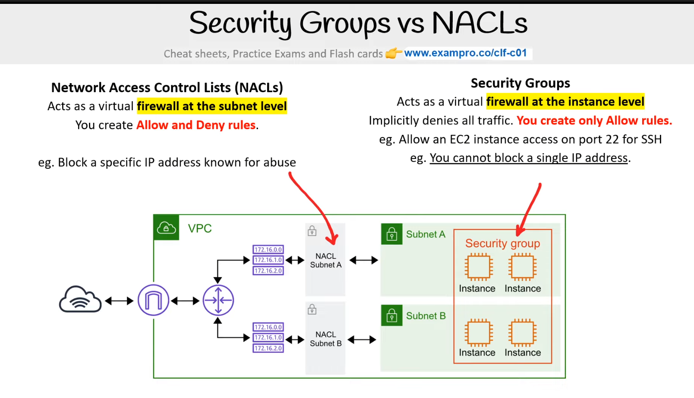

**Network Access Control Lists (NACLs)** - Acts as a virtual **firewall at the subnet level**. You create **Allow and Deny rules**. eg. Block a specific IP address known for abuse

**Security Groups**. Acts as a virtual **firewall at the instance level**. Implicitly denies all traffic. **You create only Allow rules**.. eg. Allow EC2 instance access on port 22 for SSH. eg. You cannot block a single IP address.

Reference- [Security groups for your VPC](https://docs.aws.amazon.com/vpc/latest/userguide/VPC_SecurityGroups.html)

# **Introduction to EC2**

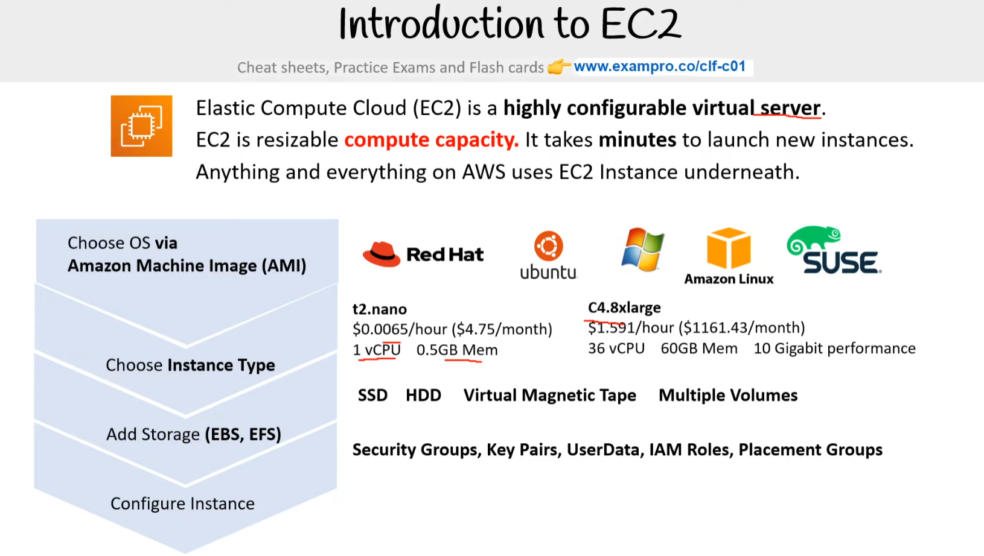

Elastic Compute Cloud (EC2) is a **highly configurable virtual server**.. EC2 is a resizable **compute capacity**. It takes **minutes** to launch new instances.. Anything and everything on AWS uses EC2 Instance underneath.

Choose **OS via Amazon Machine Image (AMI)**

* Red Hat
* ubuntu
* Microsoft Windows
* Amazon Linux
* Suse

Choose **Instance Type**

* **t2.nano**
* $0.0065/hour ($4.75/month)
* 1 vCPU 0.5GB Mem
* **C4.8xlarge**
* $1.591/hour ($1161.43/month)
* 36 vCPU 60GB Mem 10 Gigabit performance

Add Storage **(EBS, EFS)**

* **SSD, HDD, Virtual Magnetic Tape, Multiple Volumes**

**Configure Instance**

* Security Groups, Key Pairs, UserData, IAM Roles, Placement Groups

# **EC2 Instance Families**

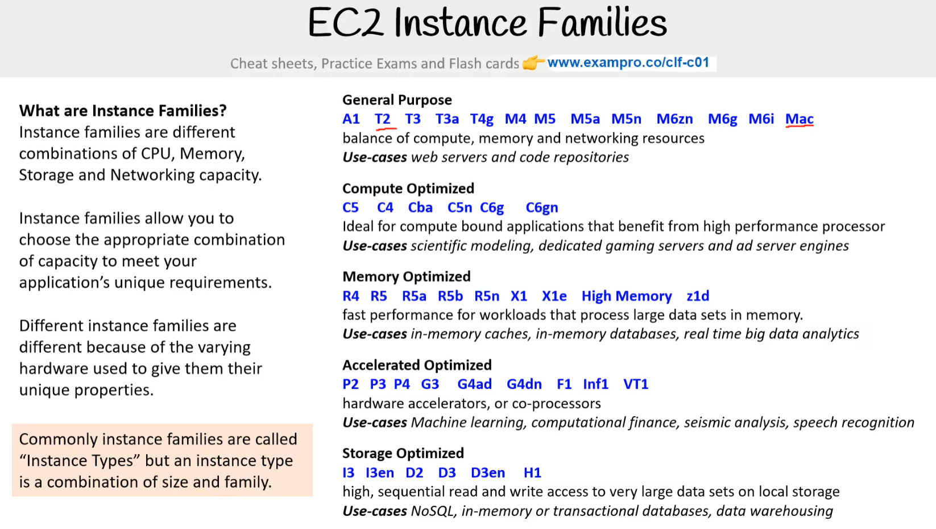

**What are Instance Families?** - Instance families are different combinations of CPU, Memory, Storage and Networking capacity. Instance families allow you to choose the appropriate combination of capacity to meet your application’s unique requirements. Different instance families are different because of the varying hardware used to give them their unique properties. Commonly instance families are called “Instance Types” but an instance type is a combination of size and family.

**General Purpose** - A1 T2 T3 T3a T4g M4 M5 M5a M5n M6zn M6g M6i Mac  
balance of compute, memory and networking resources  
**Use-cases** web servers and code repositories

**Compute Optimized** - C5 C4 Cba C5n C6g C6gn  
Ideal for compute-bound applications that benefit from high-performance processor  
**Use-cases** scientific modeling, dedicated gaming servers, and ad server engines

**Memory Optimized** - R4 R5 R5a R5b R5n X1 X1e High Memory z1d  
fast performance for workloads that process large data sets in memory.  
**Use-cases** in-memory caches, in-memory databases, real time big data analytics

**Accelerated Optimized** - P2 P3 P4 G3 G4ad G4dn F1 Inf1 VT1  
hardware accelerators, or co-processors  
**Use-cases** Machine learning, computational finance, seismic analysis, speech recognition

**Storage Optimized** - I3 I3en D2 D3 D3en H1  
high, sequential read and write access to very large data sets on local storage  
**Use-cases** NoSQL, in-memory or transactional databases, data warehousing

**Reference** - [Amazon EC2 Instance Types](https://aws.amazon.com/ec2/instance-types/#:%7E:text=Instance%20types%20comprise%20varying%20combinations,of%20resources%20for%20your%20applications.)

# **EC2 Instance Types**

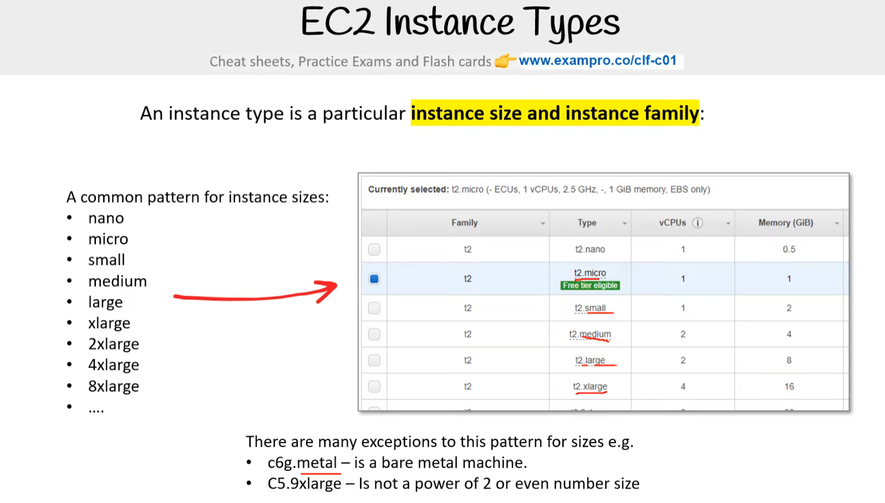

An instance type is a particular **instance size and instance family**: A common pattern for instance sizes:

* nano
* micro
* small
* medium
* large
* xlarge
* 2xlarge
* 4xlarge
* 8xlarge
* ….

There are many exceptions to this pattern for sizes e.g.

* c6g.metal – is a bare metal machine.
* C5.9xlarge – Is not a power of 2 or even number size

**EC2 Instance Sizes -** EC2 Instance Sizes generally double in price and key attributes

| **Name** | **vCPU** | **RAM (GIB)** | **On-Demand per hour** | **On-Demand per month** |
| --- | --- | --- | --- | --- |
| t2.small | 1 | 12 | $0.023 | $16.79 |
| t2.medium | 2 | 24 | $0.0464 | $33.87 |
| t2.large | 2 | 36 | $0.0928 | $67.74 |
| t2.xlarge | 4 | 54 | $0.1856 | $135.48 |

# **EC2 – Dedicated Host**

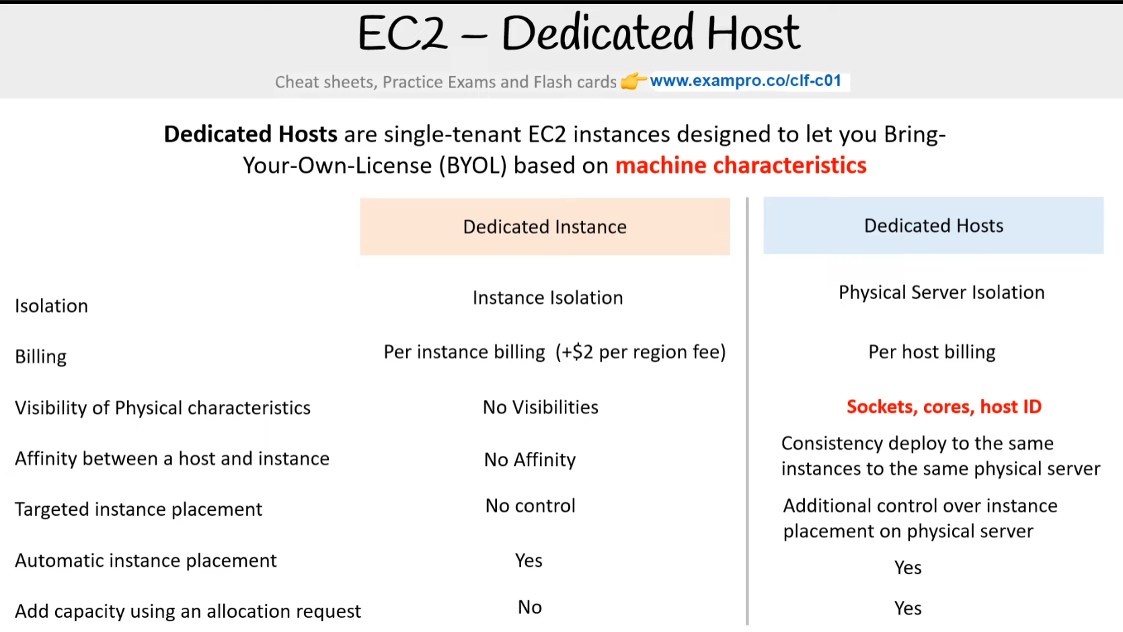

# **EC2 Tenancy**

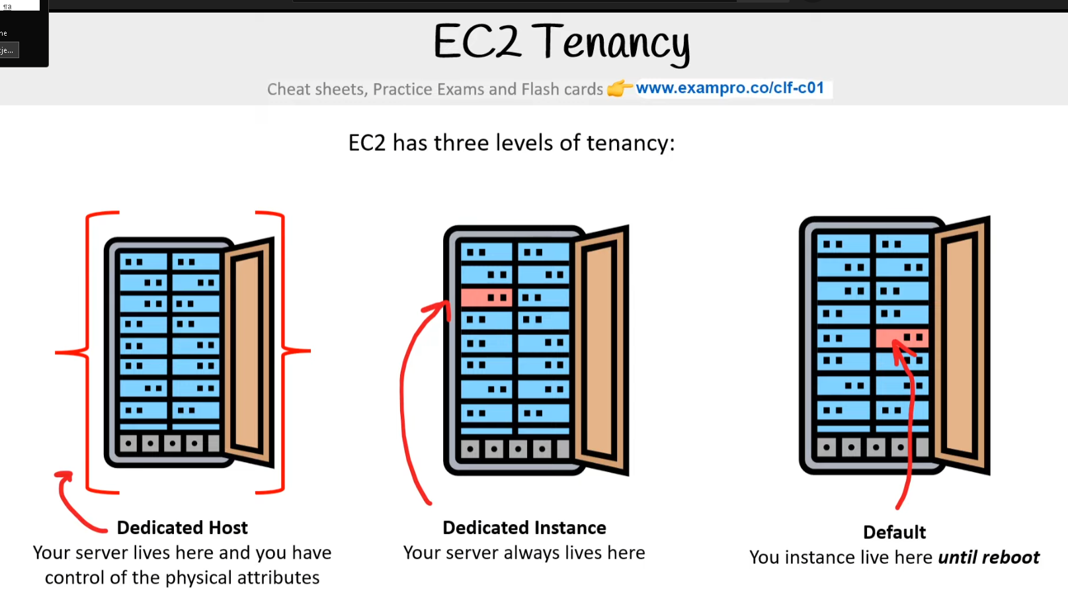

EC2 has three levels of tenancy:

**Dedicated host** - Your server lives here and you have control of the physical attributes

**Dedicated Instance** - Your server lives here

**Default** - Your instance lives here until reboot

# **EC2 - Pricing Model**

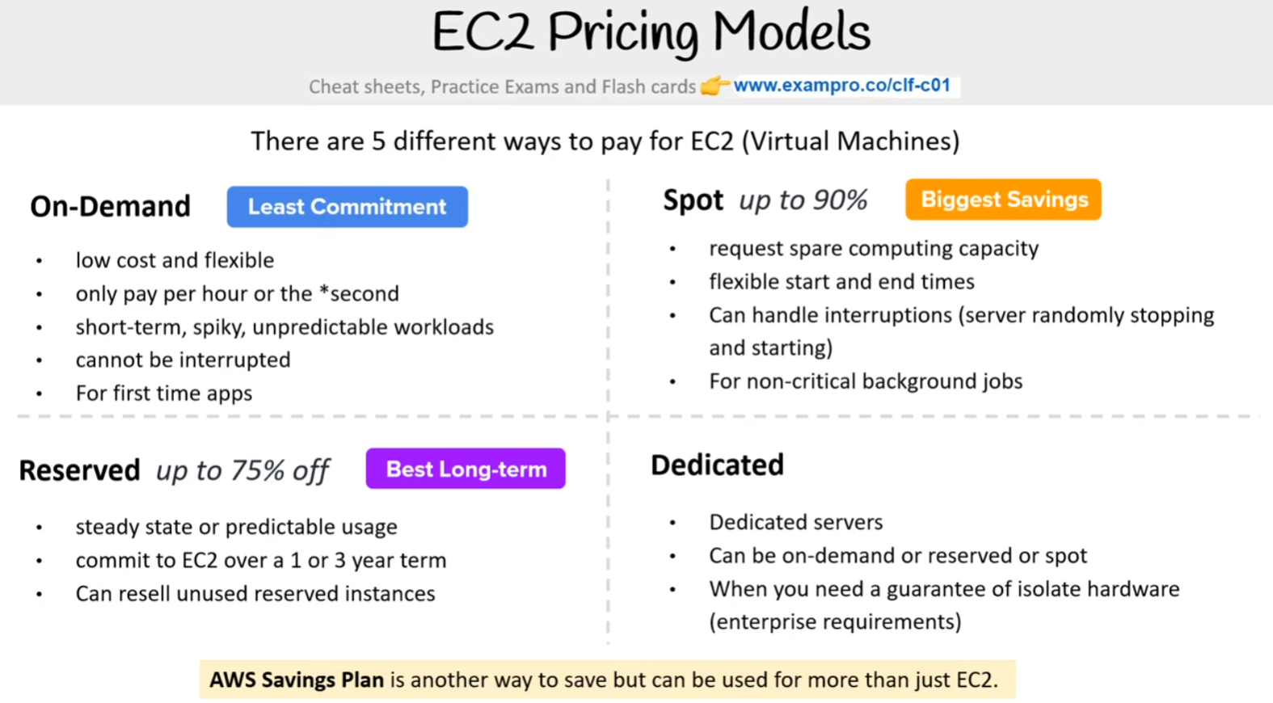

**On-Demand**(Least Commitment)

* Low cost and flexible
* Only pay per hour
* Short-term, spiky, unpredictable workloads
* Cannot be interrupted
* For first-time apps

**Reserved** up to 75% off (Best Long-term)

* Steady-state or predictable usage
* Commit to EC2 over a 1 or 3 year
* Can resell unused reserved instances

**Spot up to 90% (Biggest Savings)**

* Request spare computing capacity
* Flexible start and end times
* Can handle interruptions (server randomly stopping and starting)
* For non-critical background jobs

**Dedicated** (Most Expensive)

* Dedicated servers
* Can be on-demand or reserved (up to 75% off)
* When you need a guarantee of isolate hardware (enterprise requirements)

# **On Demand**

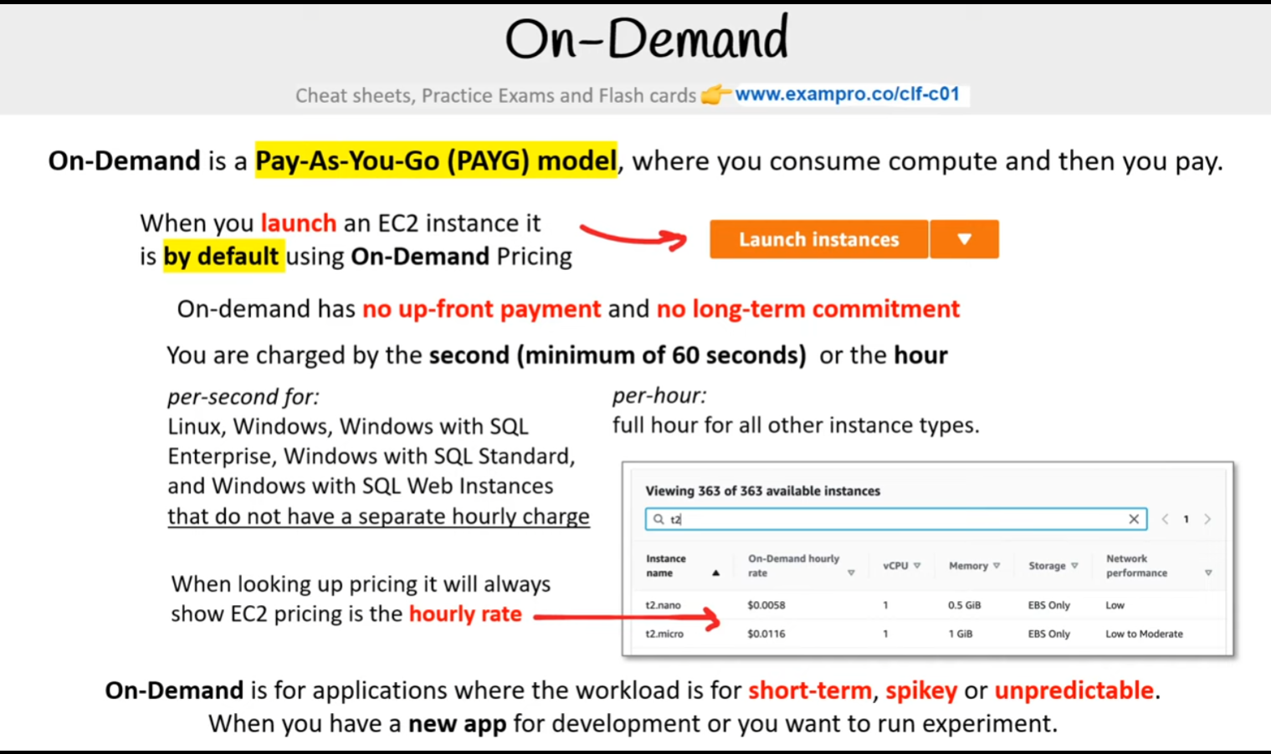

On-Demand is a Pay-As-You-Go (PAYG) model, where you consume compute and then you pay.. When you launch an EC2 instance it is by default [On-Demand](https://docs.aws.amazon.com/AWSEC2/latest/UserGuide/ec2-on-demand-instances.html) Pricing

**Key Points:**

* On-Demand has no up-front payment and no long-term commitment
* You are charged by the **hour** or by the **minute** (varies based on EC2 Instance Types

**per-second for:**

* Linux, Windows, Windows with SQL Enterprise, Windows with SQL Standard, and Windows with SQL Web Instances that do not have a separate hourly charge

**per-hour**:

* full hour for all other instance types.

**When looking up pricing it will always show EC2 pricing is the hourly rate**

* On-Demand is for applications where the workload is for **short-term, spikey,** or **unpredictable.**
* Used for when you have a **new app** for development or you want to run an experiment

**Reference -** [Amazon EC2 On-Demand Pricing](https://aws.amazon.com/ec2/pricing/on-demand/)

[New – Per-Second Billing for EC2 Instances and EBS Volumes](https://aws.amazon.com/blogs/aws/new-per-second-billing-for-ec2-instances-and-ebs-volumes/)

[On-Demand Instances](https://docs.aws.amazon.com/AWSEC2/latest/UserGuide/ec2-on-demand-instances.html)

# **EC2- Reserved Instances (RI)**

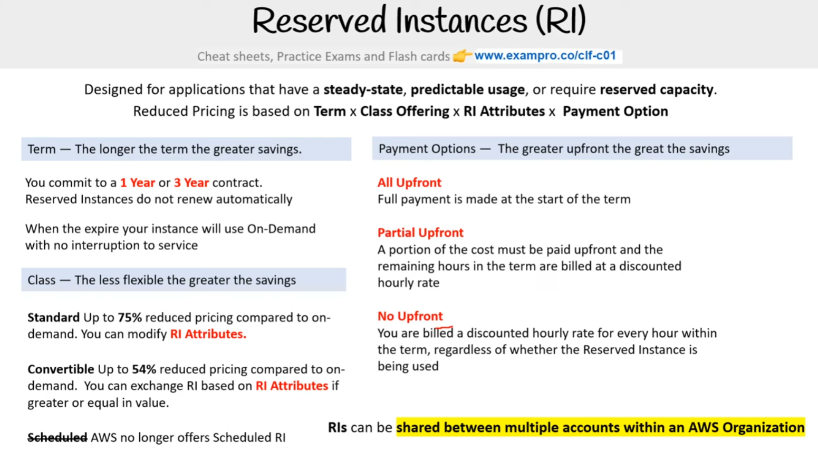

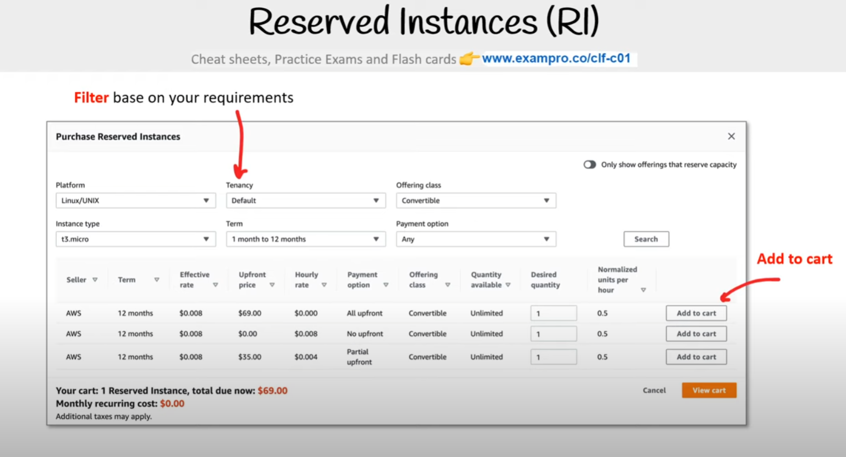

Designed for applications that have a steady-state, predictable usage, or require reserved capacity. Reduced Pricing is based on **Term x Class Offering x RI Attributes x Payment Option**

**Terms** - You commit to a 1 year or 3-year contract. The longer the term the greater savings. You commit to a 1 Year or 3 Year contract.. Reserved Instances do not renew automatically. When they expire your instance will use On-Demand with no interruption to service

**Class** — The less flexible the greater the savings

**Standard:** Up to **75%** reduced pricing compared to on-demand. You can modify RI Attributes.

**Convertible:** Up to **54%** reduced pricing compared to on-demand. You can exchange RI based on RI Attributes if greater or equal in value.

**Scheduled:** AWS no longer offers Scheduled RI

**Payment Options** — The greater upfront the great the savings

**All Upfront** - Full payment is made at the start of the term

**Partial Upfront** - A portion of the cost must be paid upfront and the remaining hours in the term are billed at a discounted hourly rate

**No Upfront** - You are billed a discounted hourly rate for every hour within the term, regardless of whether the Reserved Instance is being used

* RIs can be shared between multiple accounts within an organization
* Unused RIs can be sold in the **Reserved Instance Marketplace**.

Reference - [Amazon EC2 Reserved Instances](https://aws.amazon.com/ec2/pricing/reserved-instances/) | [Types of Reserved Instances (offering classes)](https://docs.aws.amazon.com/AWSEC2/latest/UserGuide/reserved-instances-types.html)

# **Reserved Instances (RI) — RI Attributes**

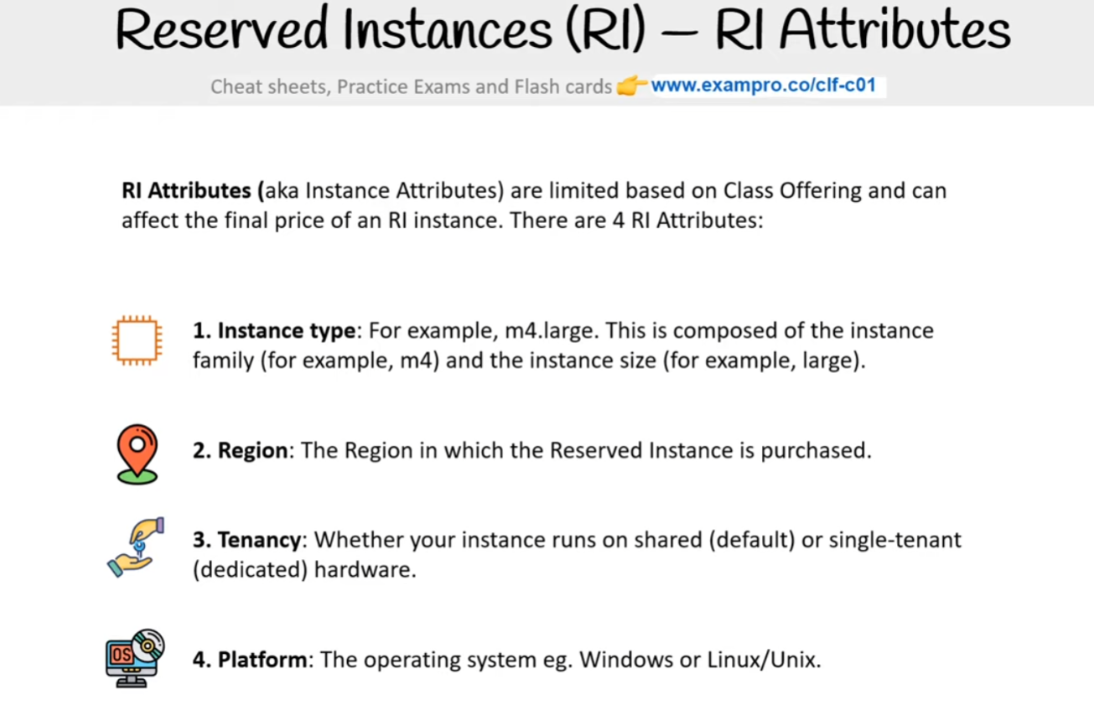

**RI Attributes** (aka Instance Attributes) are limited based on Class Offering and can affect the final price of an RI instance. There are 4 RI Attributes:

**1. Instance type**: For example, m4.large. This is composed of the instance family (for example, m4) and the instance size (for example, large).

**2. Region**: The Region in which the Reserved Instance is purchased.

**3. Tenancy**: Whether your instance runs on shared (default) or single-tenant (dedicated) hardware.

**4. Platform**: The operating system eg. Windows or Linux/Unix.

# **Regional and Zonal RI**

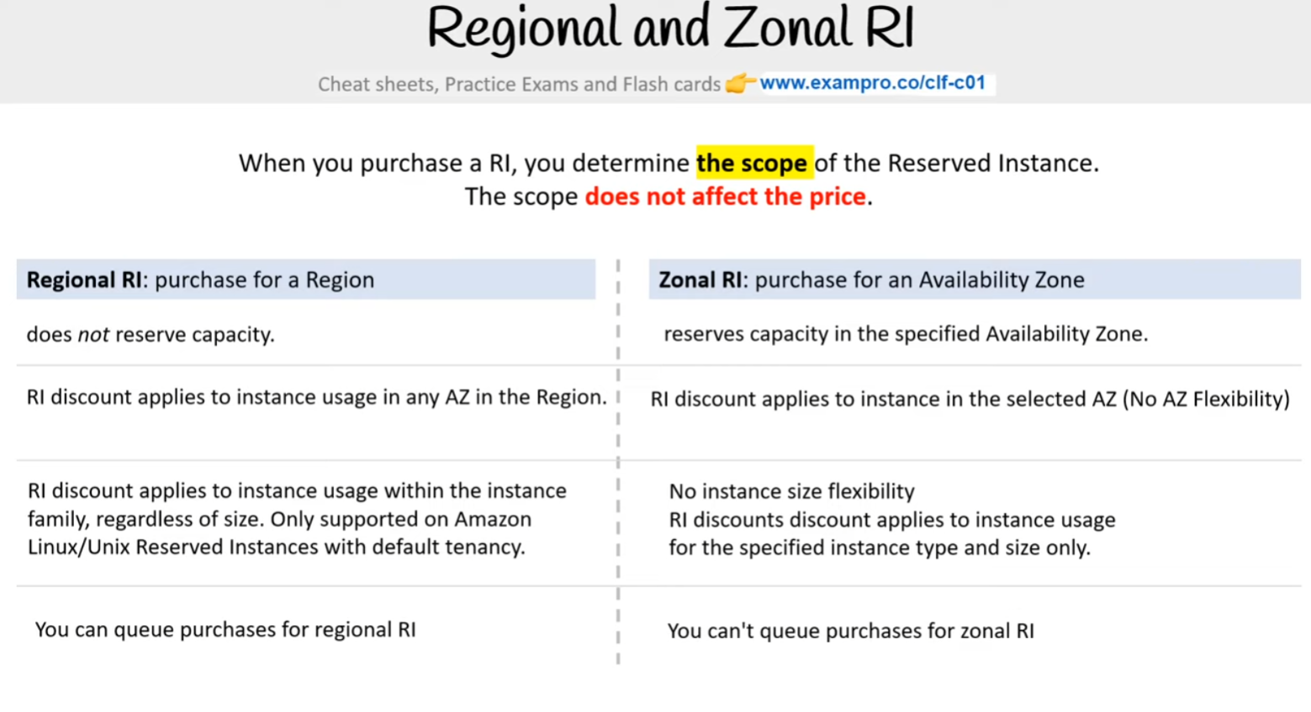

When you purchase a RI, you determine the **scope** of the Reserved Instance. The scope **does not affect the price**. **Regional RI**: purchase for a Region does not reserve capacity. RI discount applies to instance usage in any AZ in the Region. RI discount applies to instance usage within the instance family, regardless of size. Only supported on Amazon Linux/Unix Reserved Instances with default tenancy. You can queue purchases for regional RI

**Zonal RI**: purchase for an Availability Zone reserves capacity in the specified Availability Zone. RI discount applies to instance in the selected AZ (No AZ Flexibility) No instance size flexibility RI discounts discount applies to instance usage for the specified instance type and size only. You can't queue purchases for zonal RI

**Reference -** [Regional and zonal Reserved Instances (scope)](https://docs.aws.amazon.com/AWSEC2/latest/UserGuide/reserved-instances-scope.html) | [Work with Capacity Reservations](https://docs.aws.amazon.com/AWSEC2/latest/UserGuide/capacity-reservations-using.html)

# **RI Limits**

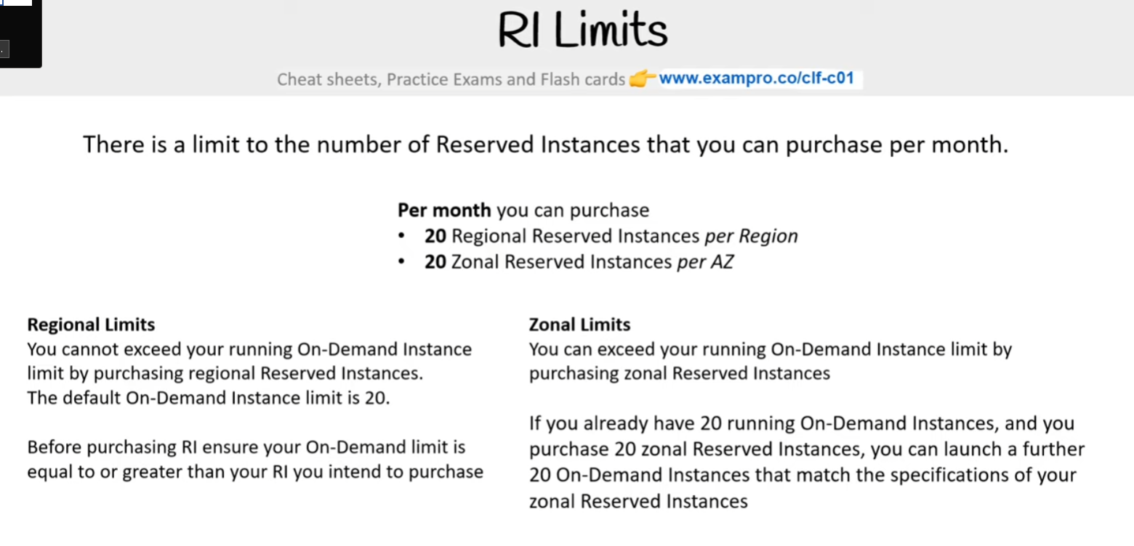

There is a limit to the number of Reserved Instances that you can purchase per month. **Per month** you can purchase

* **20** Regional Reserved Instances per Region
* **20** Zonal Reserved Instances per AZ

**Regional Limits** - You cannot exceed your running On-Demand Instance limit by purchasing regional Reserved Instances. The default On-Demand Instance limit is 20. Before purchasing RI ensure your On-Demand limit is equal to or greater than your RI you intend to purchase

**Zonal Limits** - You can exceed your running On-Demand Instance limit by purchasing zonal Reserved Instances. If you already have 20 running On-Demand Instances, and you purchase 20 zonal Reserved Instances, you can launch a further 20 On-Demand Instances that match the specifications of your zonal Reserved Instances

**Reference** - [Reserved Instances](https://docs.aws.amazon.com/AWSEC2/latest/UserGuide/ec2-reserved-instances.html)

# **Capacity Reservations**

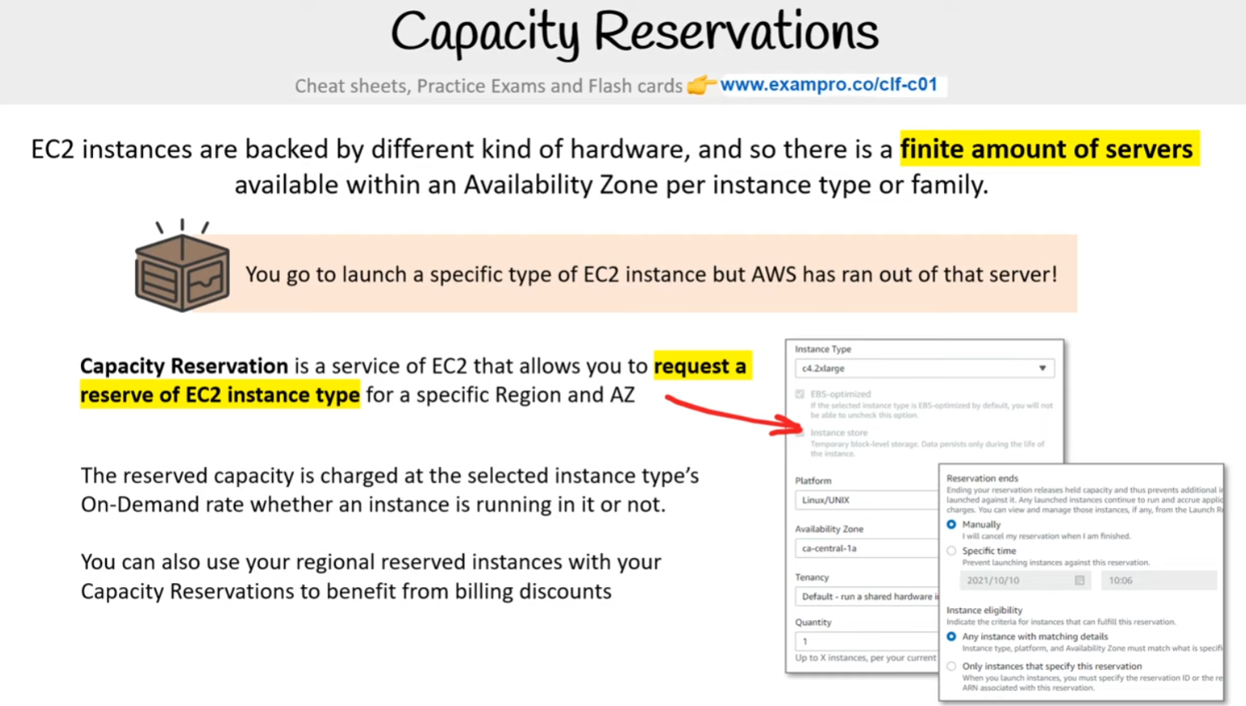

EC2 instances are backed by a different kind of hardware, and so there is a **finite amount of servers** available within an Availability Zone per instance type or family. You go to launch a specific type of EC2 instance but AWS has run out of that server!

**Capacity Reservation** is a service of EC2 that allows you to **request a reserve of EC2 instance type** for a specific Region and AZ. The reserved capacity is charged at the selected instance type’s On-Demand rate whether an instance is running in it or not.. You can also use your regional reserved instances with your Capacity Reservations to benefit from billing discounts

**Reference**- [Work with Capacity Reservations](https://docs.aws.amazon.com/AWSEC2/latest/UserGuide/capacity-reservations-using.html)

# **Standard vs Convertible RI**

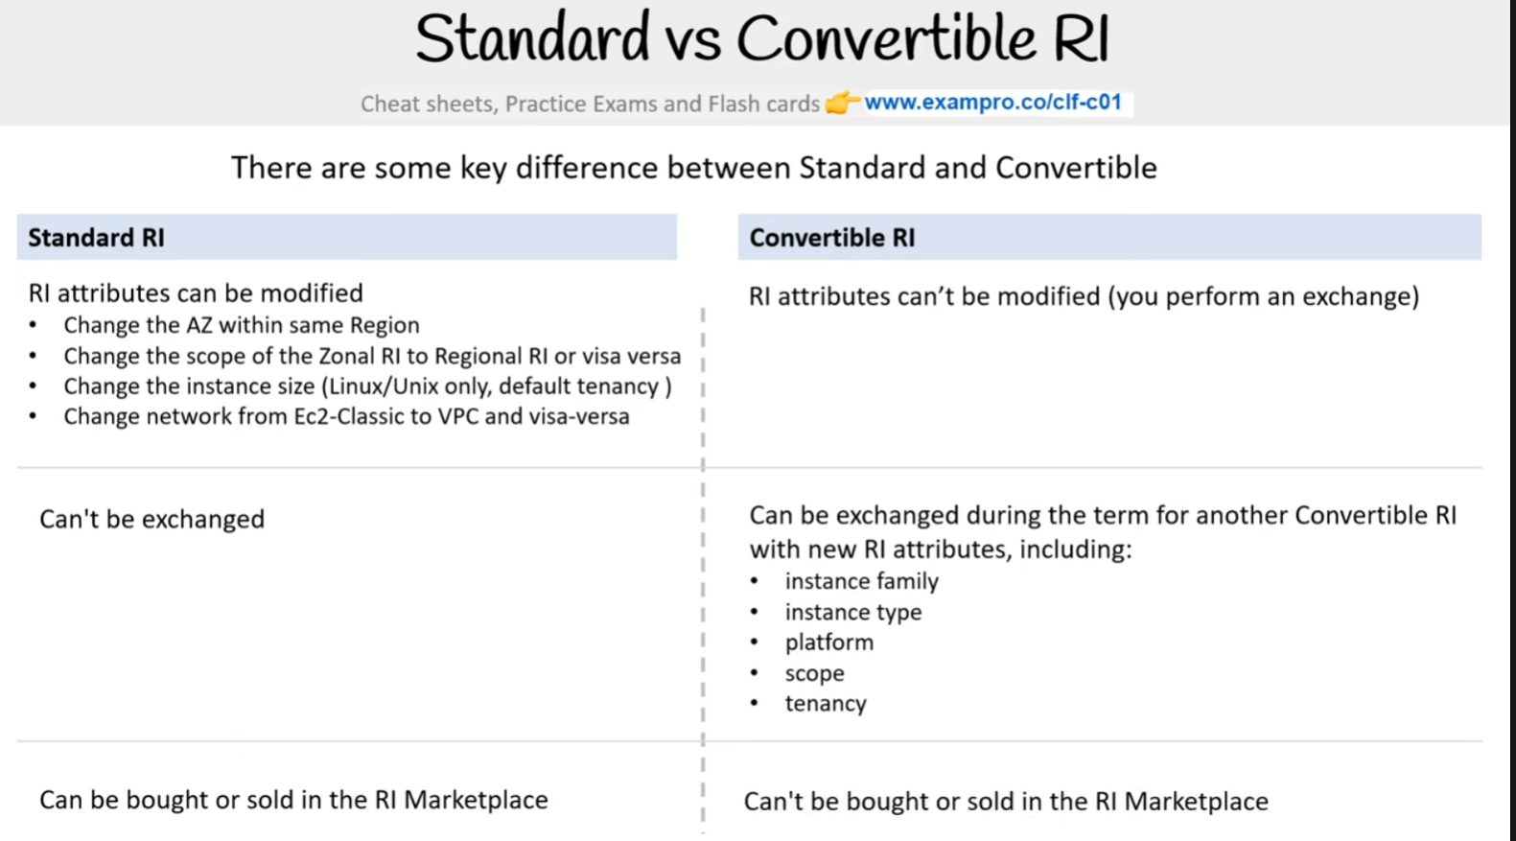

**There are some key differences between Standard and Convertible**

**Standard RI**- RI attributes can be modified

* Change the AZ within the same Region
* Change the scope of the Zonal RI to Regional RI or visa versa
* Change the instance size (Linux/Unix only, default tenancy )
* Change network from Ec2-Classic to VPC and visa-versa

Can't be exchanged. Can be bought or sold in the RI Marketplace

**Convertible RI** - RI attributes can’t be modified (you perform an exchange)

Can be exchanged during the term for another Convertible RI with new RI attributes, including:

* instance family
* instance type
* platform
* scope
* tenancy

Can't be bought or sold in the RI Marketplace

Reference - [Types of Reserved Instances (offering classes)](https://docs.aws.amazon.com/AWSEC2/latest/UserGuide/reserved-instances-types.html) | [Modify Reserved Instances](https://docs.aws.amazon.com/AWSEC2/latest/UserGuide/ri-modifying.html)

# **RI Marketplace**

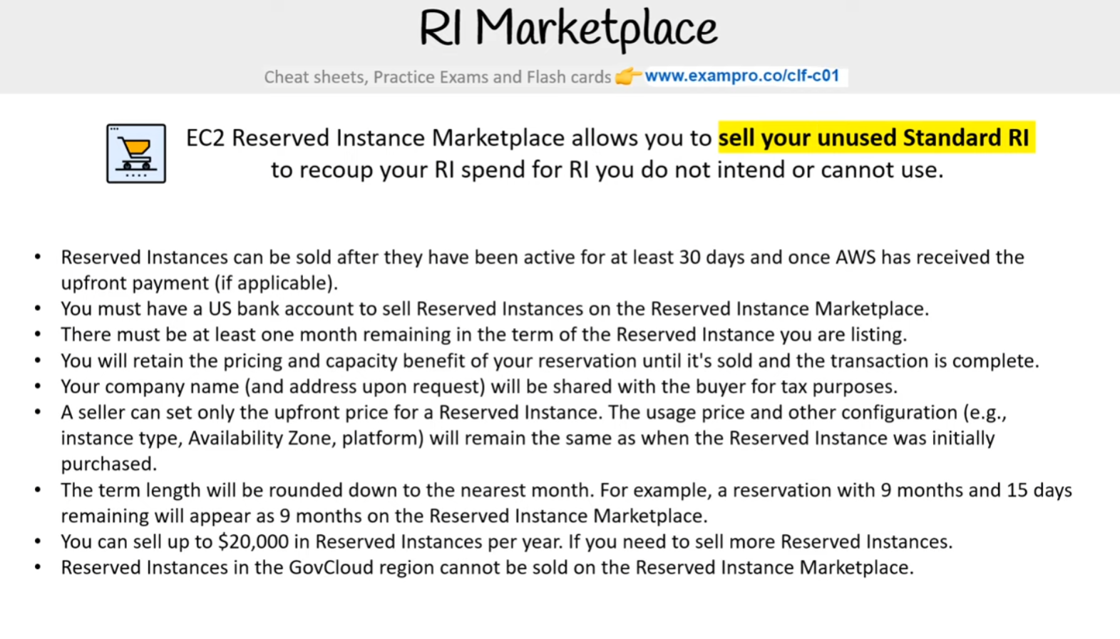

EC2 Reserved Instance Marketplace allows you to **sell your unused Standard RI** to recoup your RI spend for RI you do not intend or cannot use.

* Reserved Instances can be sold after they have been active for at least 30 days and once AWS has received the upfront payment (if applicable).
* You must have a US bank account to sell Reserved Instances on the Reserved Instance Marketplace.
* There must be at least one month remaining in the term of the Reserved Instance you are listing.
* You will retain the pricing and capacity benefit of your reservation until it's sold and the transaction is complete.
* Your company name (and address upon request) will be shared with the buyer for tax purposes.
* A seller can set only the upfront price for a Reserved Instance. The usage price and other configuration (e.g., instance type, Availability Zone, platform) will remain the same as when the Reserved Instance was initially purchased.
* The term length will be rounded down to the nearest month. For example, a reservation with 9 months and 15 days remaining will appear as 9 months on the Reserved Instance Marketplace.
* You can sell up to $20,000 in Reserved Instances per year. If you need to sell more Reserved Instances.
* Reserved Instances in the GovCloud region cannot be sold on the Reserved Instance Marketplace.

# **Spot Instances**

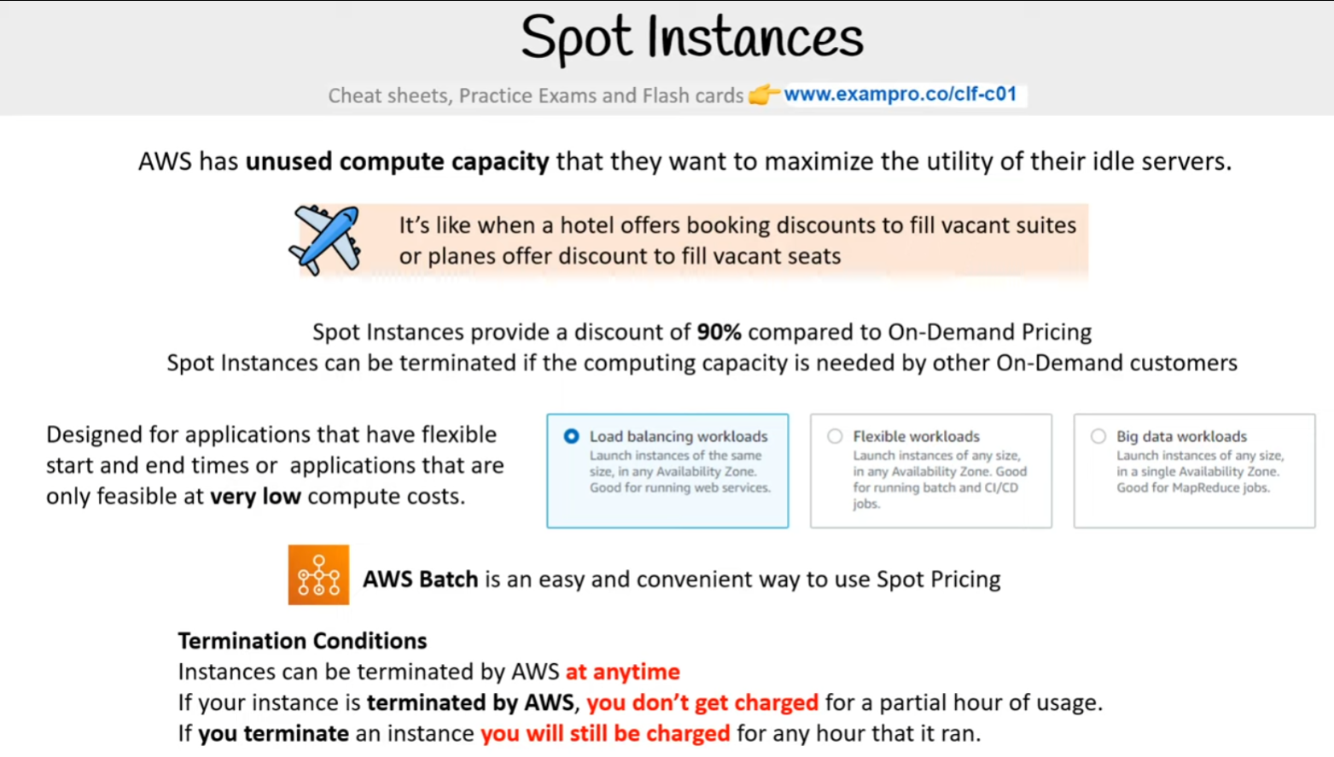

AWS has unused compute capacity that they want to maximize the utility of their idle servers. It’s like when a hotel offers booking discounts to fill vacant suites or planes offer discounts to fill vacant seats

[Amazon EC2 Spot Instances](https://aws.amazon.com/ec2/spot/) provide a discount of 90% compared to On-Demand Pricing. Spot Instances can be terminated if the computing capacity is needed by other On-Demand customers. Amazon EC2 Spot Instances let you take advantage of **unused EC2 capacity** in the AWS cloud.. Designed for applications that have flexible start and end times or applications that are only feasible at **very low** compute costs.

[AWS Batch](https://aws.amazon.com/batch/) is an easy and convenient way to use Spot Pricing

**Termination Conditions:**

* Instances can be terminated by AWS **at any time.**
* If your instance is terminated by AWS, **you don't get charged** for a partial hour of usage.
* If you terminate an instance **you will still be charged** for an hour that it ran.

# Dedicated Host Instances

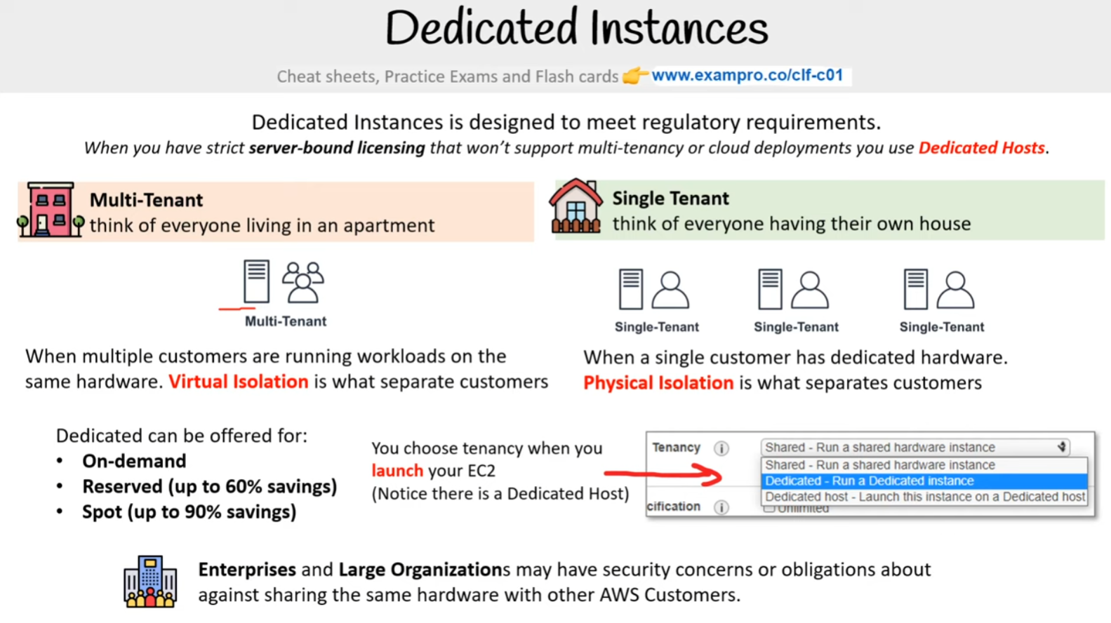

[Dedicated Host Instances](https://aws.amazon.com/ec2/dedicated-hosts/) are designed to meet regulatory requirements. When you have strict server-bound licensing that won’t support multi-tenancy or cloud deployments you use Dedicated Hosts.

**Multi-tenant:** (Think of everyone living in an apartment). When multiple customers are running workloads on the same hardware. **Virtual Isolation** is what separate customers ( Like a multi-tenant apartment)

**Single Tenant:** (Think of everyone having their own house). When a single customer has dedicated hardware. **Physical Isolation** is what separates customers( Like a single-family home)

* Most expensive
* Use when you have strict **server-bound licensing** that won't support multi-tenancy or cloud deployments

Dedicated can be offered for:

* On-demand
* Reserved (up to 60% savings)
* Spot (up to 90% savings)

**Enterprises** and **Large Organizations** my have security concerns or obligations against sharing the same hardware with other AWS Customers

Reference - [Amazon EC2 Dedicated Instances](https://aws.amazon.com/ec2/pricing/dedicated-instances/)

# AWS Savings Plan

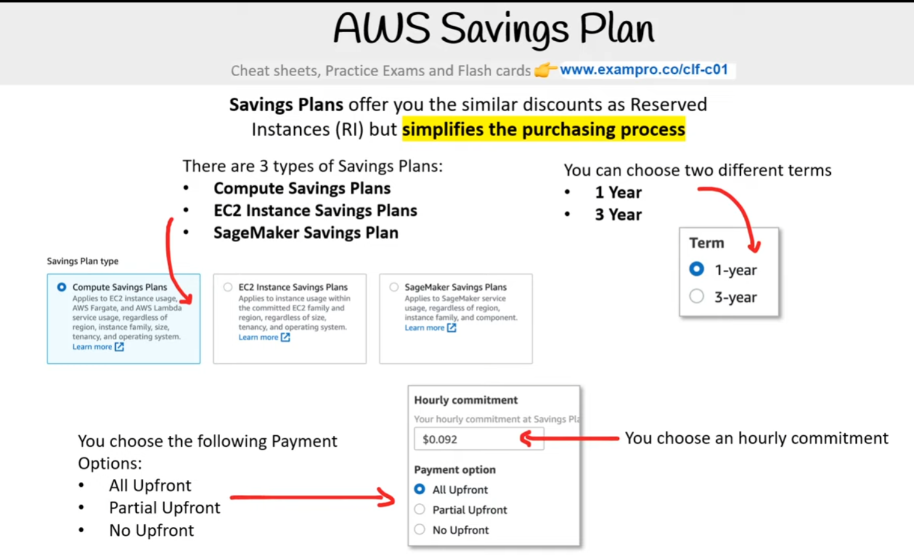

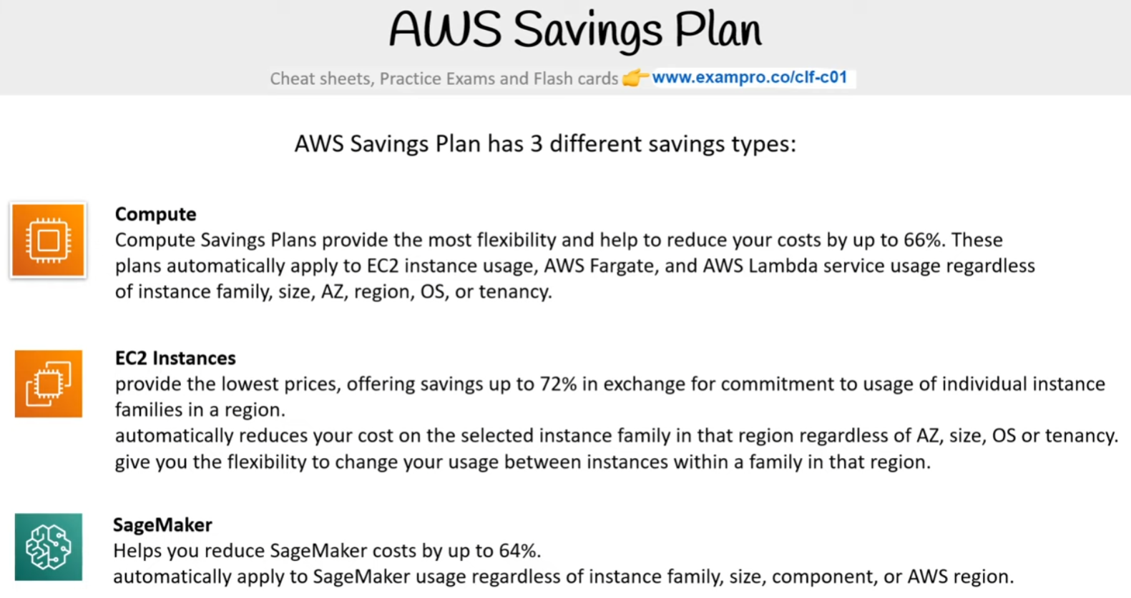

**Savings Plans** offer you similar discounts as Reserved Instances (RI) **but simplifies the purchasing process**

There are 3 types of Savings Plans:

* **Compute Savings Plans**
* **EC2 Instance Savings Plans**
* **SageMaker Savings Plan**

You can choose two different terms

* **1 Year**
* **3 Year**

You choose the following Payment Options:

* All Upfront
* Partial Upfront
* No Upfront

AWS Savings Plan has 3 different savings types:

**Compute** - Compute Savings Plans provide the most flexibility and help to reduce your costs by up to 66%. These plans automatically apply to EC2 instance usage, AWS Fargate, and AWS Lambda service usage regardless of instance family, size, AZ, region, OS, or tenancy.

**EC2 Instances**- provide the lowest prices, offering savings up to 72% in exchange for commitment to usage of individual instance families in a region. automatically reduces your cost on the selected instance family in that region regardless of AZ, size, OS or tenancy. give you the flexibility to change your usage between instances within a family in that region.

**SageMaker**- Helps you reduce SageMaker costs by up to 64%. automatically apply to SageMaker usage regardless of instance family, size, component, or AWS region.

Reference

[Savings Plans](https://aws.amazon.com/savingsplans/)

[New – Savings Plans for AWS Compute Services](https://aws.amazon.com/blogs/aws/new-savings-plans-for-aws-compute-services/)

[The Ultimate Guide To Reserved Instance And AWS Savings Plan](https://medium.com/@Totalcloudio/the-ultimate-guide-to-reserved-instance-and-aws-savings-plan-cf2b3c27bdc6)

# **Cheat Sheet**

* [**EC2 has 4 pricing models**](https://aws.amazon.com/ec2/pricing/)
  1. On-Demand
  2. Spot
  3. Reserved Instances (RI)
  4. Dedicated
* [**On-Demand**](https://aws.amazon.com/ec2/pricing/on-demand/) (Least commitment)
  1. Low cost and flexible
  2. Only pay per hour
  3. Use Case: short-term, spiky, unpredictable workloads, and first time apps
  4. Ideal when your workloads cannot be interrupted.
* [**Reserved Instances**](https://aws.amazon.com/ec2/pricing/reserved-instances/)- up to 75% off (Best long-term value)
  1. **Use case:** steady state or predictable usage
  2. Can resell unused reserved instances (Reserved Instance Marketplace)
  3. Reduced Pricing is based on **Term x Class Offering x Payment Option**
  4. **Payment Terms:** 1 year or 3 years
  5. **Payment Options:** All Upfront, Partial Upfront, No Upfront
  6. **Class Offerings:**
     + Standard: Up to 75% reduced pricing compared to on-demand. Cannot change RI attributes
     + Convertible: Up to 54% reduced pricing compared to on-demand. Allows you to change RI Attributes if greater than or equal in value.
     + Scheduled: You reserve instances for specific times periods. Savings vary.
* [**Spot Pricing**](https://aws.amazon.com/ec2/spot/)- up to 90% off (Biggest Savings)
  1. Request spare computing capacity
  2. Flexible start and end times
  3. **Use case:** Can handle interruptions like a server randomly stopping and starting
  4. **Use case:** For non-critical background jobs
  5. Instances can be terminated by AWS **at anytime**
  6. If your instance is **terminated by AWS**, you don't get charged for a partial hour of usage.
  7. If **you terminate** an instance you will still be charged for any hour that it ran.
* [**Dedicated Hosting**](https://aws.amazon.com/ec2/dedicated-hosts/) (Most Expensive)
  1. Dedicated servers
  2. Can be on-demand or reserved (up to 70% off)
  3. **Use case**: When you need a guarantee of isolated hardware (enterprise requirements)

# **Zero Trust Model**

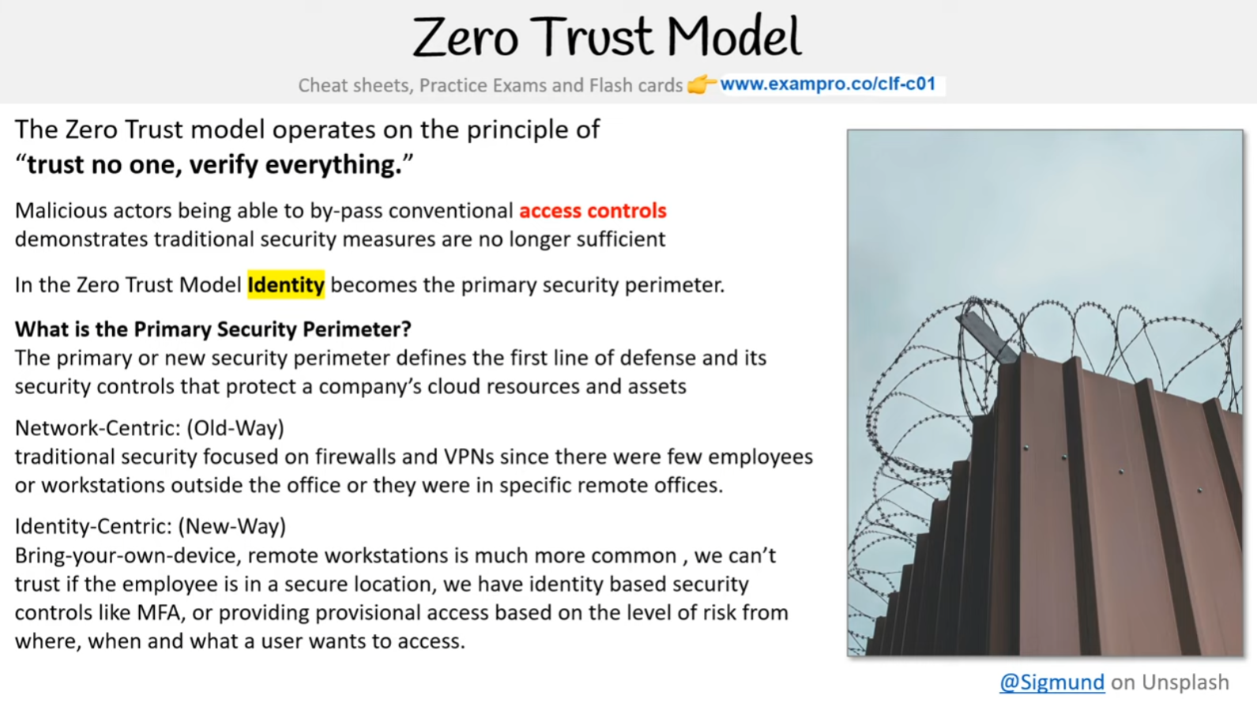

The Zero Trust model operates on the principle of **“trust no one, verify everything.”**. Malicious actors being able to by-pass conventional **access controls** demonstrates traditional security measures are no longer sufficient. In the Zero Trust Model **Identity** becomes the primary security perimeter.

**What is the Primary Security Perimeter?** - The primary or new security perimeter defines the first line of defense and its security controls that protect a company’s cloud resources and assets

**Network-Centric: (Old-Way) -** traditional security-focused on firewalls and VPNs since there were few employees or workstations outside the office or they were in specific remote offices.

**Identity-Centric: (New-Way) -** Bring-your-own-device, remote workstations are much more common, we can’t trust if the employee is in a secure location, we have identity-based security controls like MFA, or providing provisional access based on the level of risk from where, when, and what a user wants to access.

Identity-Centric does not replace but **augments** Network-Centric Security

**Reference** - [Zero Trust on AWS](https://aws.amazon.com/security/zero-trust/)

# **Zero Trust on AWS**

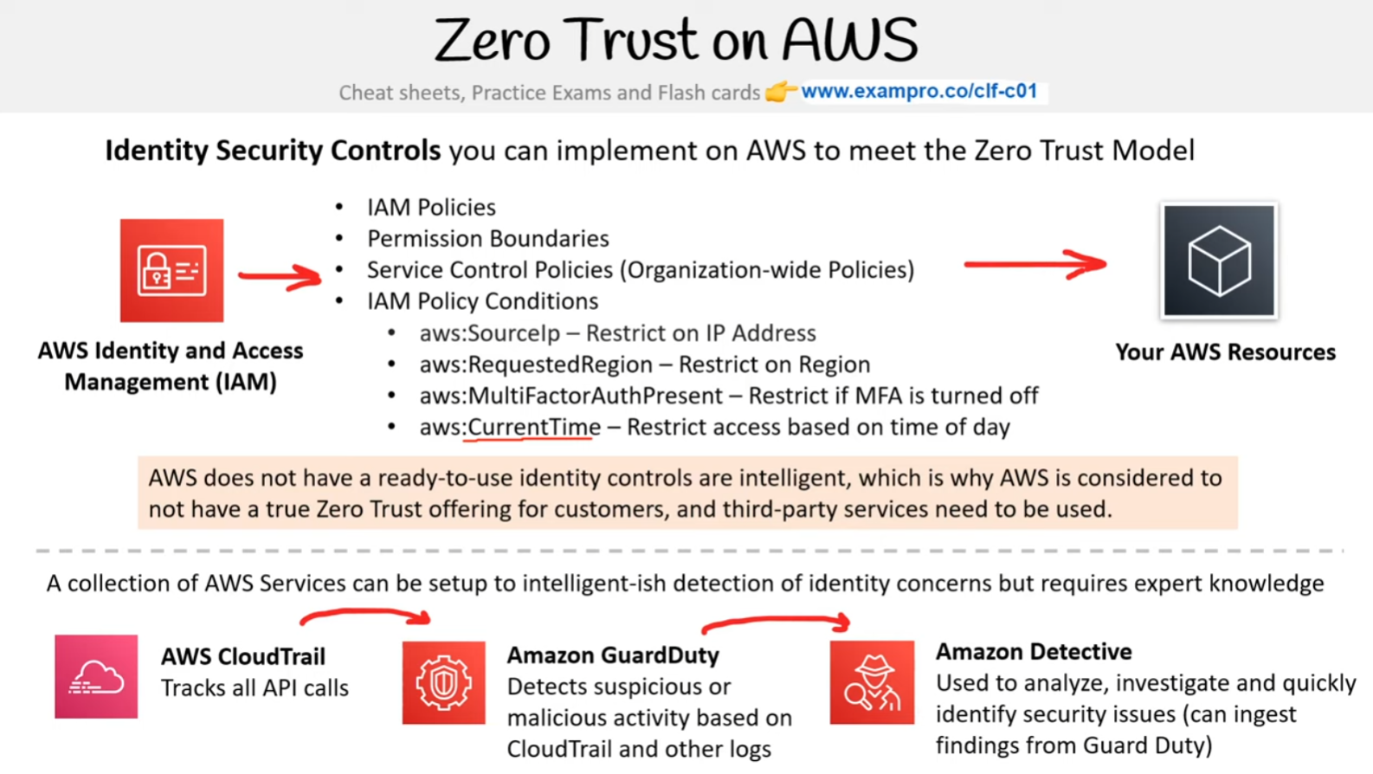

**Identity Security Controls** you can implement on AWS to meet the Zero Trust Model

**AWS Identity and Access Management (IAM)**

* IAM Policies
* Permission Boundaries
* Service Control Policies (Organization-wide Policies)
* IAM Policy Conditions
  + aws:SourceIp – Restrict on IP Address
  + aws:RequestedRegion – Restrict on Region
  + aws:MultiFactorAuthPresent – Restrict if MFA is turned off
  + aws:CurrentTime – Restrict access based on time of day

**Your AWS Resources**- AWS does not have ready-to-use identity controls that are intelligent, which is why AWS is considered to not have a true Zero Trust offering for customers, and third-party services need to be used. A collection of AWS Services can be setup to intelligent-ish detection of identity concerns but requires expert knowledge

**AWS CloudTrail** - Tracks all API calls

**Amazon GuardDuty** - Detects suspicious or malicious activity based on CloudTrail and other logs

**Amazon Detective** - Used to analyze, investigate and quickly identify security issues (can ingest findings from Guard Duty)

Reference - [Zero Trust on AWS](https://aws.amazon.com/security/zero-trust/) | [AWS re:Invent 2020: Zero Trust: An AWS perspective](https://www.youtube.com/watch?v=O33LPy4M4vA)

# **Zero Trust on AWS with Third Parties**

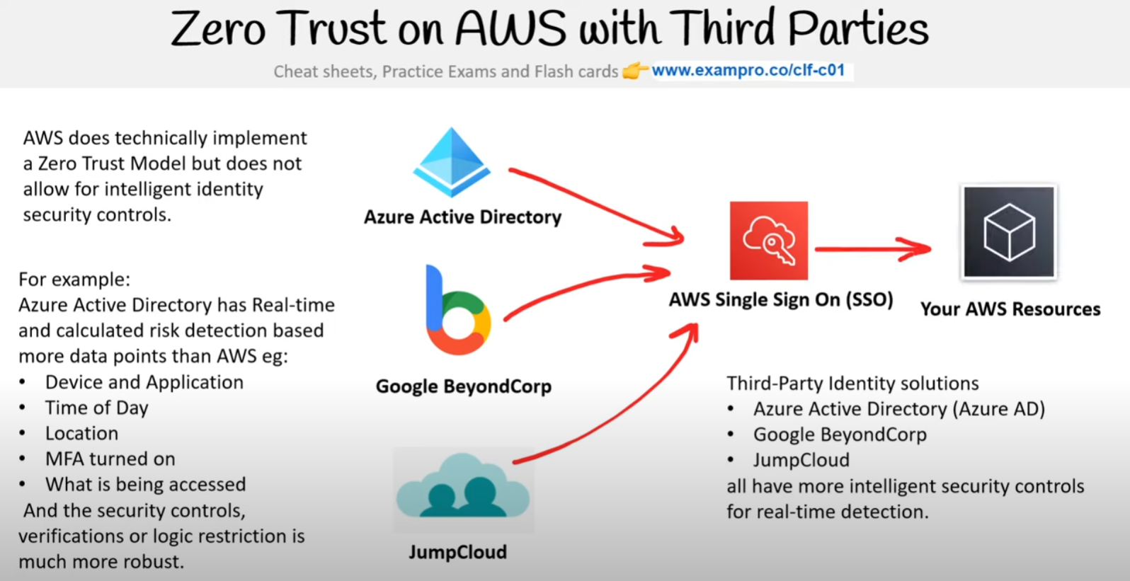

AWS does technically implement a Zero Trust Model but does not allow for intelligent identity security controls. For example:

Azure Active Directory has Real-time and calculated risk detection based on more data points than AWS eg:

* Device and Application
* Time of Day
* Location
* MFA turned on
* What is being accessed

And the security controls, verifications, or logic restriction is much more robust.

**Azure Active Directory** | **Google BeyondCorp** | **JumpCloud** | **AWS Single Sign-On (SSO)**

**Your AWS Resources**

Third-Party Identity solutions

* Azure Active Directory (Azure AD)
* Google BeyondCorp
* JumpCloud

all have more intelligent security controls for real-time detection.

# **Directory Service**

**What is a directory service?** - A directory service maps the **names of network resources to their network addresses**.

A directory service is shared information infrastructure for **locating, managing, administering, and organizing** resources:

* Volumes
* Folders
* Files
* Printers
* Users
* Groups
* Devices
* Telephone numbers
* other objects

A directory service is a critical component of a network operating system. A directory server (name server) is a server that provides a directory service. Each resource on the network is considered an object by the directory server. Information about a particular resource is stored as a collection of attributes associated with that resource or object

Well-known directory services:

* Domain Name Service (DNS)
  + the directory service for **the internet**
* **Microsoft Active Directory**
  + Azure Active Directory
* Apache Directory Server
* Oracle Internet Directory (OID)
* OpenLDAP
* Cloud Identity
* JumpCloud

**Reference -** [About Google Cloud Directory Sync](https://support.google.com/a/answer/106368?hl=en)